GeoTracking Of Waste

DBMS-IGT PROJECT

SY IT BATCH D

GROUP 19

RITIKA MANGLA

KHUSHI JAGAD

SALVIN KAJAR

PRARTHANA SHAHAPURKAR

MANSI MISHRA

**EXECUTIVE SUMMARY**

Solid Waste is a major environmental threat in India. According to the press information bureau , India generates 62 billion tons of waste every year with an average annual growth of 4%. Due to rapid increase in urbanization, industrialization and population, the generation rate of solid waste in Indian cities and towns is also increased.

We do have unplanned waste lying in cities which makes it hard for cleaning staff to know which area requires attention with respect to it's management. Today garbage is seen strewn on roads which increases the chances of disease transmission and hampers the overall sanitation of the locality, hence setting breeding grounds for medical ailments. The mismanagement of municipal solid waste can not only cause public health risks but also adverse environmental impacts, and other socio-economic problems for the nation.

Hence there arises a need to devise an effective mechanism to not only collect as much waste, but also to dispose the same with ease. This can be done by Geo-tracking of waste, which involves collecting information of unclean localities which require attention of waste management authorities of the concerned area, and arranging well equipped suitable transportation systems for the collection and disposal of waste from that area.

To make this waste management system more transparent practically, the vehicles should be tracked using geo-tracking devices that use GPS modules which shall help the authorities to keep a track of localities that have been attended to and that require priority attention.

Through this project we have tried to present the current status of Solid Waste Management in India and propose a solution for the same, which can help the competent authorities responsible for municipal Solid Waste Management in an efficient way.

**CURRENT SYSTEM**

There are three types of garbage pickup trucks that collect the waste from different areas.

1.L 1. LARGE TRUCKS- These trucks are used to pick up garbage from larger areas and it has a capacity of 6 metric ton of garbage.These trucks take only one trip during each shift and have a fixed route to reach the pickup points.

2.MINI TRUCKS- These trucks are used to pick up garbage from comparatively smaller areas and has a capacity of 2.5 metric ton of waste.These trucks take 2 trips in each shift and have a fixed route to reach the pickup spots.

3.SMALL CLOSED VEHICLE(SCV)- These trucks have a capacity of 500 kg of waste.These trucks take any number of trips during a shift as they don’t have a fixed route to reach a certain point.They unload the garbage collected from different areas in the Large or the Mini trucks.

The department has a vehicle tracking and monitoring system (VTMS) installed in all its garbage collection, transportation and transfer vehicles, compactors and dumpers. The tracking system was first introduced after the desilting scam in the BMC, and was replicated in many departments, including SWM.

The vehicle tracking and monitoring system includes a GPS module fitted inside the trucks which is used by the government to track these trucks and get their current location and the path the drivers use to reach a particular point.

Each garbage truck is equipped with a RFID reader,GPS and GPRS module .Each container is equipped with a RFID tag having unique identification code. Low frequency passive tags are proposed because they offer long term low cost solution and are operational in extreme conditions resistible to environment hazards. Geocoding of containers is done manually by field visiting them and noting the locations using GPS receiver. When the container gets loaded onto the truck, the reader reads serial no. of the tag on the container. At the same time, GPS receiver on the truck calculates its location from the satellite data. The serial no. of the tag, location, date, time is transmitted real time via GSM network to communication gateway of control server. After data processing, it is transferred to GIS terminal. The real time information can be shared with clients via web based solution.

**KEY CHALLENGES**

* The first challenge is to receive the signals of the location from our GPS device on the vehicle and to use it in our system.
* Since, all the existing GPS trackers come with their own software or website, so its a challenge to use the data from that software in our system.
* Data integration is an issue in the current system. The status of the vehicle does not get updated immediately. Apart from this, the bins that have been attended to do not get updated in the system promptly.
* The routes of the large trucks have been fixed. However, there is scope for more efficient and better routes to ensure optimum waste collection.
* Lack of machinery provided to the wards handling SWM. A thorough survey of the area will ensure that the requirements are met.
* In the current system, only few people are appointed to look into the functioning and maintenance of the hardware behind the tracking system.
* Better and more efficient hardware components to be installed like bin level sensors which will help to identify how full the bin is.

**HARDWARE REQUIREMENTS**

1.GPS TRACKER

Company Name: Akari

Features:

This GPS tracker will provide us the real time location of the trucks which are carrying the waste. The device also features tracking the previous month’s history route, total number of kms , route details on Google Maps.

2.RFID TAGS

We are going to use RFID Tags on the bins so that when that bin is attended the RFID Reader can scan the tag and at real time we can get the status whether bin is attended or not. RFID Tag is comprised of two parts – an antenna for transmitting and receiving signals and RFID chip to store the tag ID and other information.

3.RFID READER

A RFID READER is the brain of the RFID system and is necessary for any system to function. This device transmit and receive radio waves to communicate with RFID tags. There are two types of Readers.

1.Fixed RFID Readers

2.Mobile RFID Readers

We are going to use mobile RFID readers because mobile readers are handheld devices that allow flexibility when readig RFID tags while still being communicating with host computer or smart device.

**PROPOSED SOLUTION**

The Global Position System (GPS) mounted as part of the Vehicle Mounted Unit in the Solid Waste Management vehicles will receive the Positional Information (longitude and latitude coordinates) from the Satellite through a process of triangulation. This information is then sent across to the Data Centre (DC) through the wireless communication link – GSM / GPRS. The GPS data to be integrated with a GIS map for identifying location of Solid Waste Management vehicles on real time basis. The system will also have facility to identify functional status of the Solid Waste Management vehicles (en-route, garaged etc.) in the form of interactive user friendly querying tool and also through reporting tool.

This is typically achieved by incorporating GPS-GSM-GPRS, data collection and communication devices installed in the vehicle and a back office management tool. This solution is the perfect add-on to the vehicle management system, enabling real time tracking and alerts on any irregularities.

This device is integrated with GPS, to track the position of the vehicles and to send the GPS data to the server using GPRS technology. This product provides great feasibility for vehicles location to stay connected, which otherwise would not have been possible for Tracking, Monitoring and Controlling. The vehicle tracking management system will be developed using web based technology which will provide easy interface to manage the vehicle tracking process.

The GPS-GSM based Automated Vehicle Tracking System will have the following functionalities:

* Exact location of the vehicle can be viewed anytime on real time basis.
* Speed of the vehicle can be viewed as per GPS.
* Engine operating and stoppage time can be generated for defined period of time.
* Alerts can be set to predefined E-mail Id’s.
* Vehicle History
* Work-Hours Summary
* Stop Hour calculation
* Geo Fencing
* Speed Violation
* Summary of the Entire Trip
* Alert on route deviation
* Harsh braking
* Harsh Acceleration
* All location to be covered by the vehicle will be marked on the local map with indication. Whenever the vehicle cross the scheduled location the indication colour will change automatically and report the system as desired. The indication color changes because the RFID Tag on the bin is read by the RFID Reader on the truck which indicates that it has been attended to.
* The actual movement of the vehicle to be displayed with a marker / indicator from source to destination along with location names in the local map.
* The administrator will be provided with an interface to update telephone numbers and other data as per the requirement.
* Vehicle Fleet Summary Dashboard report.

In addition to this, a CRM Style Dashboard will be created which would have the following salient features:

* Total Registered vehicles
* Total Tracking Vehicle
* Total Non tracking vehicles
* Pie Chart detailing tracking and non tracking vehicles

Tracking Vehicles

The Total tracking vehicles is divided into sub categories

* Total vehicles on Halt
* Total vehicles running
* Total vehicles running which are in NO GPS area
* Total vehicles running on secondary battery

The user can choose the desired option; based up his choice the list of vehicles will get automatically gets loaded.

Non Tracking Vehicles

Non tracking vehicles is also divided into sub categories

* No data received from vehicles
* Idle vehicles
* No GPS vehicles
* Offline Vehicles (data not received from more than half hour during the day)
* Device Dead combination of Secondary idle and No GPS secondary vehicles

**EXPERIMENT 2**

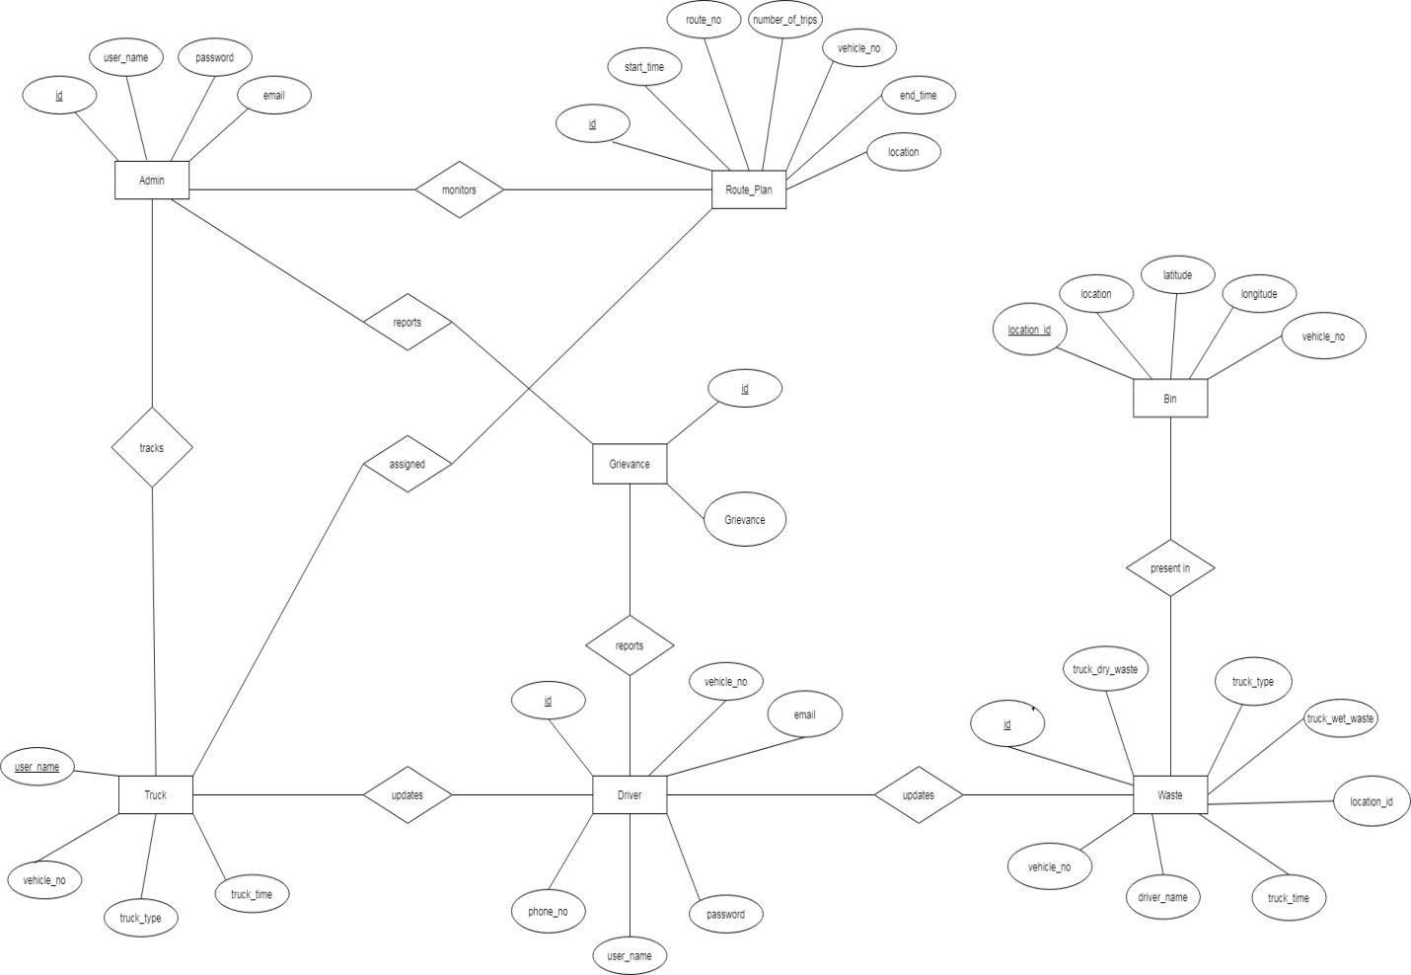

**EXPERIMENT 3**

**EXECUTIVE SUMMARY**

Solid Waste is a major environmental threat in India. According to the press information bureau , India generates 62 billion tons of waste every year with an average annual growth of 4%. Due to rapid increase in urbanization, industrialization and population, the generation rate of solid waste in Indian cities and towns is also increased.

We do have unplanned waste lying in cities which makes it hard for cleaning staff to know which area requires attention with respect to it's management. Today garbage is seen strewn on roads which increases the chances of disease transmission and hampers the overall sanitation of the locality, hence setting breeding grounds for medical ailments. The mismanagement of municipal solid waste can not only cause public health risks but also adverse environmental impacts, and other socio-economic problems for the nation.

Hence there arises a need to devise an effective mechanism to not only collect as much waste, but also to dispose the same with ease. This can be done by Geo-tracking of waste, which involves collecting information of unclean localities which require attention of waste management authorities of the concerned area, and arranging well equipped suitable transportation systems for the collection and disposal of waste from that area.

To make this waste management system more transparent practically, the vehicles should be tracked using geo-tracking devices that use GPS modules which shall help the authorities to keep a track of localities that have been attended to and that require priority attention.

Through this project we have tried to present the current status of Solid Waste Management in India and propose a solution for the same, which can help the competent authorities responsible for municipal Solid Waste Management in an efficient way.

**CURRENT SYSTEM**

There are three types of garbage pickup trucks that collect the waste from different areas.

1.L 1. LARGE TRUCKS- These trucks are used to pick up garbage from larger areas and it has a capacity of 6 metric ton of garbage.These trucks take only one trip during each shift and have a fixed route to reach the pickup points.

2.MINI TRUCKS- These trucks are used to pick up garbage from comparatively smaller areas and has a capacity of 2.5 metric ton of waste.These trucks take 2 trips in each shift and have a fixed route to reach the pickup spots.

3.SMALL CLOSED VEHICLE(SCV)- These trucks have a capacity of 500 kg of waste.These trucks take any number of trips during a shift as they don’t have a fixed route to reach a certain point.They unload the garbage collected from different areas in the Large or the Mini trucks.

The department has a vehicle tracking and monitoring system (VTMS) installed in all its garbage collection, transportation and transfer vehicles, compactors and dumpers. The tracking system was first introduced after the desilting scam in the BMC, and was replicated in many departments, including SWM.

The vehicle tracking and monitoring system includes a GPS module fitted inside the trucks which is used by the government to track these trucks and get their current location and the path the drivers use to reach a particular point.

Each garbage truck is equipped with a RFID reader, GPS and GPRS module .Each container is equipped with a RFID tag having unique identification code. Low frequency passive tags are proposed because they offer long term low cost solution and are operational in extreme conditions resistible to environment hazards. Geocoding of containers is done manually by field visiting them and noting the locations using GPS receiver. When the container gets loaded onto the truck, the reader reads serial no. of the tag on the container. At the same time, GPS receiver on the truck calculates its location from the satellite data. The serial no. of the tag, location, date, time is transmitted real time via GSM network to communication gateway of control server. After data processing, it is transferred to GIS terminal. The real time information can be shared with clients via web based solution.

**KEY CHALLENGES**

* There is a need to maintain two separate login pages one for the driver and other for

the admin so that the driver doesn’t have the access to the essential data.

* There is a need to make sure that the location updated by the driver gets reflected

on the admin side.

* The admin should be able to view and download daily and monthly reports and

should be able to see details of all the registered trucks.

* The admin should be able to see the recently updated location of all the trucks on

the map.

* The drivers should be able to see their route plan for the day on the map so that

they can easily travel to the desired location.

* The details updated by the driver should be stored in the database and the last

updated location should be visible to the admin side on a map.

* There should be a provision for the admin to see the history of the drivers and

contact them in case of any emergency.

* All the locations of the bins in Matunga should be pinned on the map.
* Both the driver and the admin should be able to convey their grievances to the

technical team.

* A clear analysis should be generated so that a record can be maintained about the

efficiency of the trucks and drivers.

* The routes of the large trucks have been fixed. However, there is scope for more efficient and better routes to ensure optimum waste collection.
* Lack of machinery provided to the wards handling SWM. A thorough survey of the

area will ensure that the requirements are met.

* In the current system, only few people are appointed to look into the functioning and maintenance of the hardware behind the tracking system.

**PROPOSED SOLUTION**

The system designed by us included two sides: Admin side and Driver Side.

1)Admin side:

The admin is the official at BMC. Each admin is given a separate login id and password before hand.

* He can see the status of all the vehicles on the status page.
* He can track the vehicle progress. He can view the most updated position of the vehicle. He can also view all the bins under his jurisdiction and their respective routes.
* He can view which driver is assigned to which vehicle and can contact the driver in case of need.
* He can view the daily and monthly reports of any vehicle. He can export it to an excel sheet and save it.

2)Driver Side:

The driver is the truck driver that collects waste from specified bin locations. Each driver is given a separate login id and password before hand

* As soon as you login as a driver, you will see the route plan page wherein you can enter the vehicle number and see the route plan of the vehicle. A map is displayed with markers for the bins in the route.
* You can click on the update button and update the current bin id you are at, the wet waste and dry waste collected. The updated time is stored in the database and can be seen by the admin on his status page.
* Every driver has a driver id. Drivers may be allotted different trucks every day. Hence to track his own progress, The driver can see his own history.

A consumer grievance page is provided so that we can know what troubles the user is facing while using our website.

This page displays all the bins and their corresponding routes.

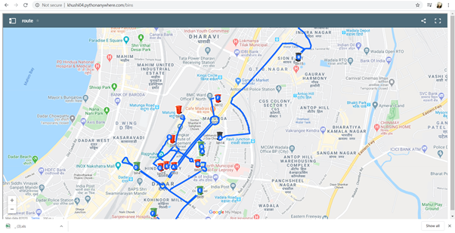

We have made use of Google Maps in order to embed maps in the website and to display markers.

The following image shows the most updated position of the vehicle entered.

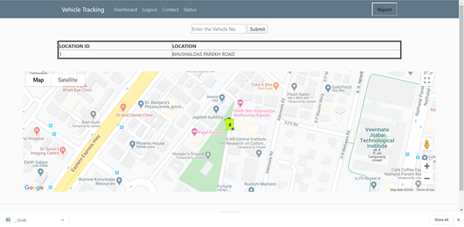

**KEY OBJECTIVES**

* The Main objective is to provide an efficient way to track the vehicle progress.
* Helps to track the location and status of the truck.
* System allows you to know which bins are been attended so far.
* To improve the current tracking of the waste collecting vehicles.
* The system provides the driver with a map that shows the route that is to be followed to collect the waste from the bin in a particular order.
* Reports are maintained for the analysis purpose.

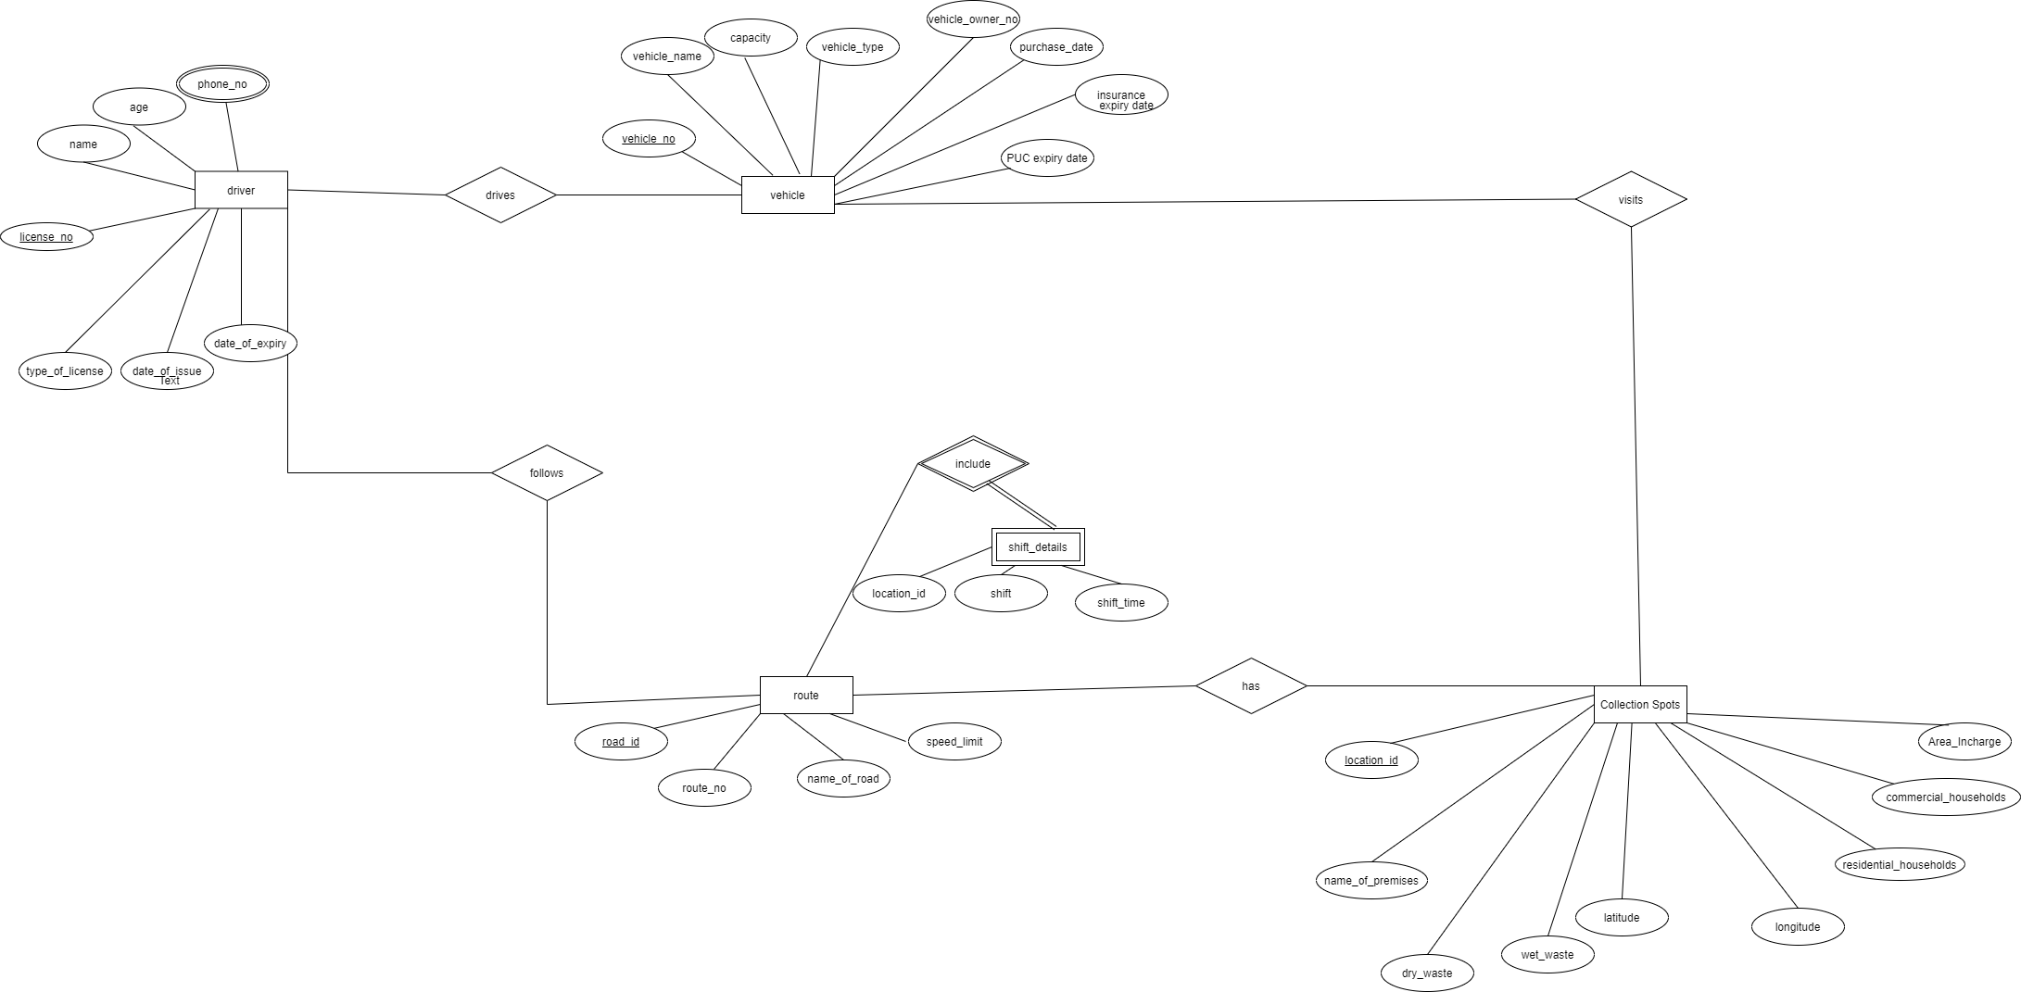

**Experiment No. 5**

**UML Model – Database Schema**

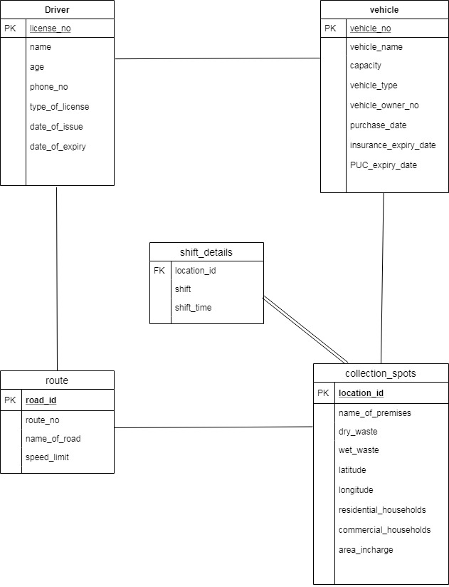

**EXPERIMENT 6**

|  |  |  |  |  |  |
| --- | --- | --- | --- | --- | --- |
| Table | Column | Data Type | References | Default | Not null |
| Driver | license_no | Varchar(50) |  | Identity | Y |
|  | name | Varchar(50) |  |  | Y |
|  | phone No | Int |  |  | Y |
|  | age | Int |  |  | Y |
|  | license_type | Varchar(50) |  |  | Y |
|  | license_issue_date | date |  |  | Y |
|  | license_expiry_date | date |  |  | Y |

|  |  |  |  |  |  |
| --- | --- | --- | --- | --- | --- |
| Table | Column | Data Type | References | Default | Not null |
| Vehicle | vehicle_no | Varchar(50) |  | Identity | Y |
|  | vehicle_name | Varchar(50) |  |  | Y |
|  | capacity | Int |  |  | Y |
|  | vehicle_type | Varchar(50) |  |  | Y |
|  | vehicle_owner_no | Int |  |  | Y |
|  | purchase_date | date |  |  | Y |
|  | insurance_expiry_date | date |  |  | Y |
|  | PUC_expiry_date | date |  |  | Y |

|  |  |  |  |  |  |
| --- | --- | --- | --- | --- | --- |
| Table | Column | Data Type | References | Default | Not null |
| Collection_  Spot | location_id | Int |  | Identity | Y |
|  | name_of_premises | Varchar(80) |  |  | Y |
|  | res_households | Int |  |  |  |
|  | com_households | Int |  |  |  |
|  | dry_waste | Int |  |  |  |
|  | wet_waste | Int |  |  |  |
|  | lat | Varchar(10) |  |  | Y |
|  | lon | Varchar(10) |  |  | Y |
|  | area_incharge | Varchar(40) |  |  | Y |

|  |  |  |  |  |  |
| --- | --- | --- | --- | --- | --- |
| Table | Column | Data Type | References | Default | Not null |
| Route Details | road_id | Int |  | Identity | Y |
|  | route_no | Int |  |  | Y |
|  | name_of_road | Varchar(50) |  |  | Y |
|  | speed_limit | Int |  |  | Y |

|  |  |  |  |  |  |
| --- | --- | --- | --- | --- | --- |
| Table | Column | Data Type | References | Default | Not null |
| Shift Details | location_id | Int |  | Identity | Y |
|  | shift | Varchar(10) |  |  | Y |
|  | timings | time |  |  | Y |

Unique keys

|  |  |  |  |
| --- | --- | --- | --- |
| Type | Table | Key | Columns |
| primary | Driver | pk_driver | license_no |
| unique | Driver | uk_phone_no | phone_no |
| primary | Vehicle | pk_vehicle_no | vehicle_no |
| unique | Vehicle | uk_vehicle_owner_no | vehicle_owner_no |
| primary | Collection Spot | pk_location_id | location_id |
| unique | Collection Spot | uk_lat | lat |
| unique | Collection Spot | uk_lon | lon |
| primary | Route Details | pk_road_id | road_id |

Foreign keys

|  |  |  |  |  |
| --- | --- | --- | --- | --- |
| Key | Table | Columns | Ref Table | Ref Column |
| fk_location_id | Shift Details | location_id | Collection Spot | location_id |

**EXPERIMENT 7**

Driver Table

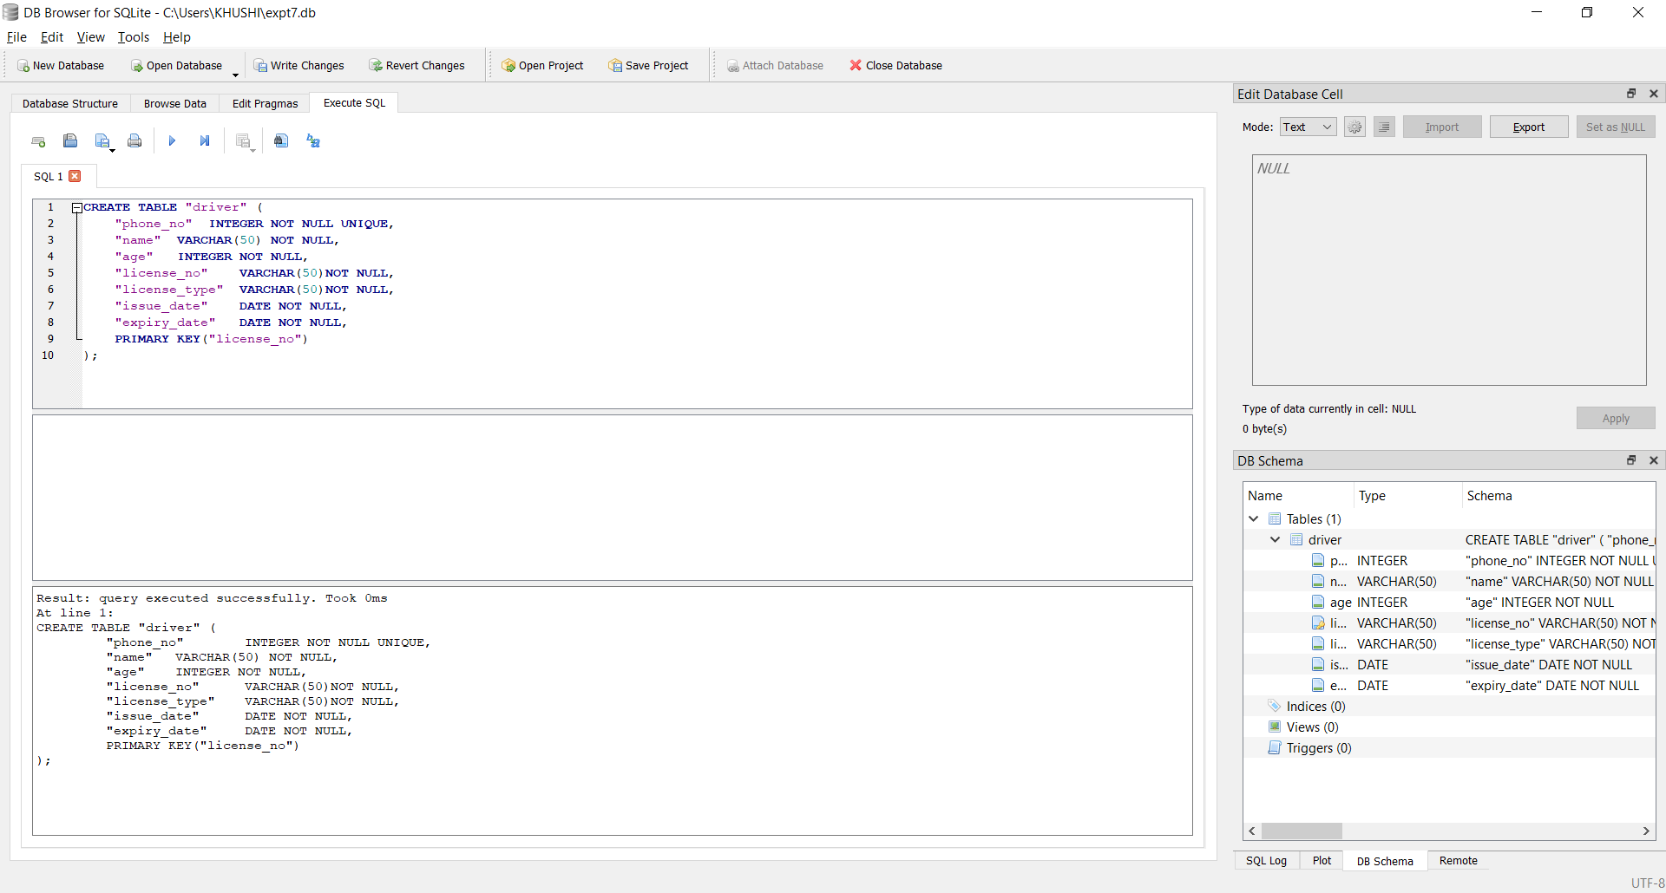

Collection Spot Table

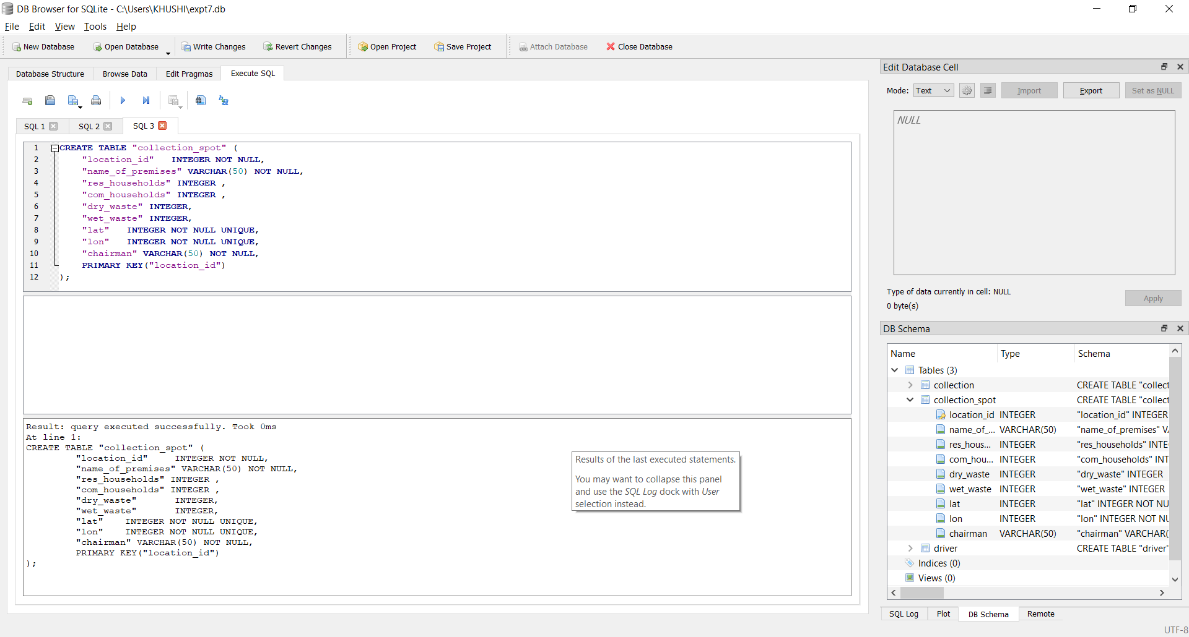

Vehicle Table

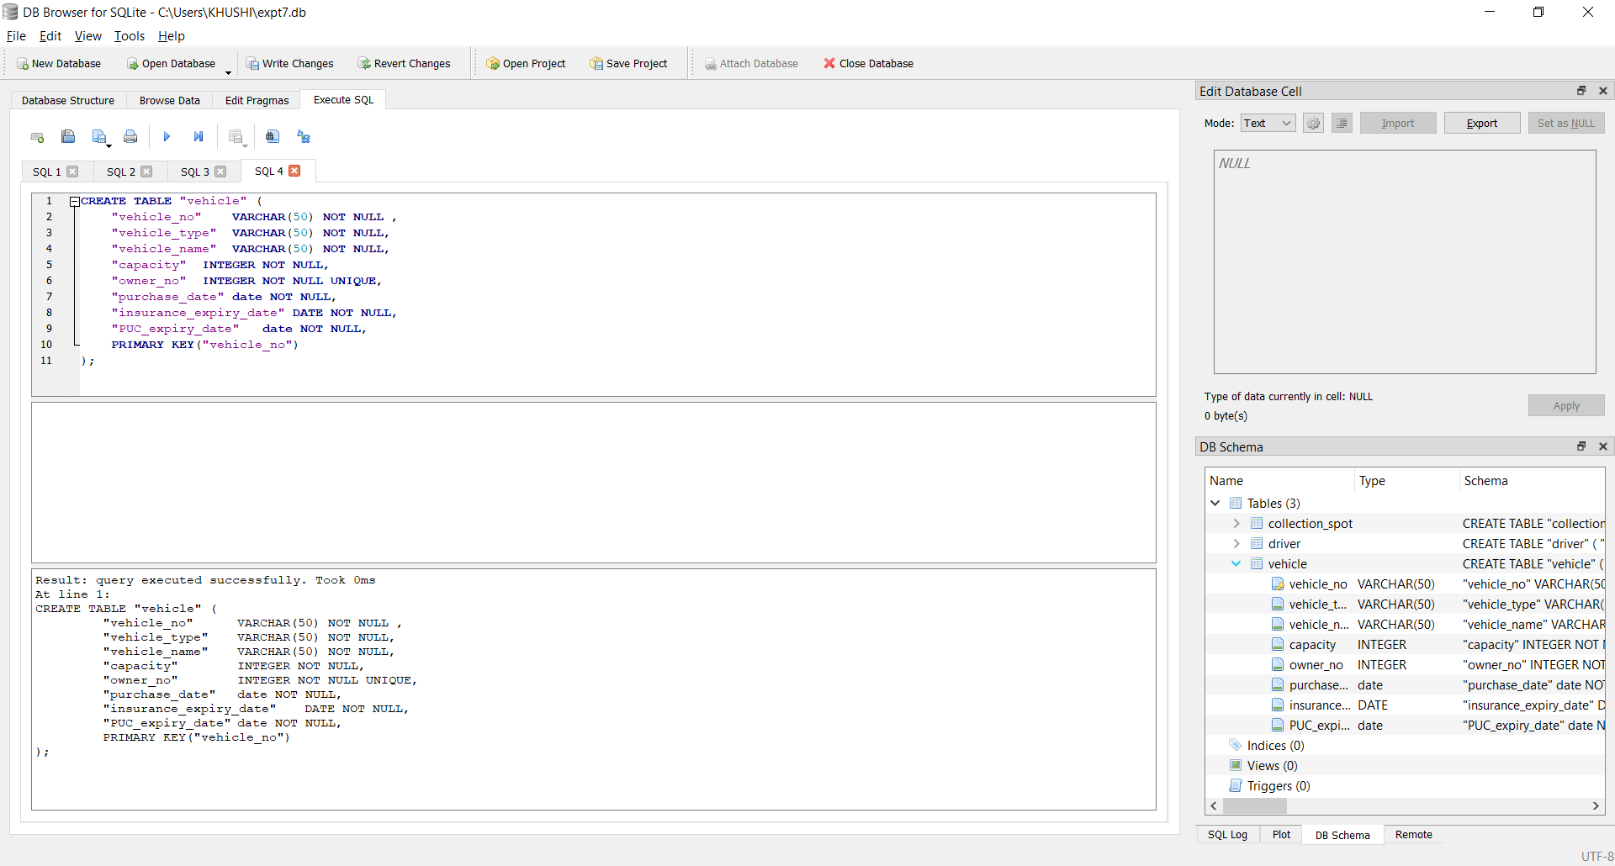

Route Details Table

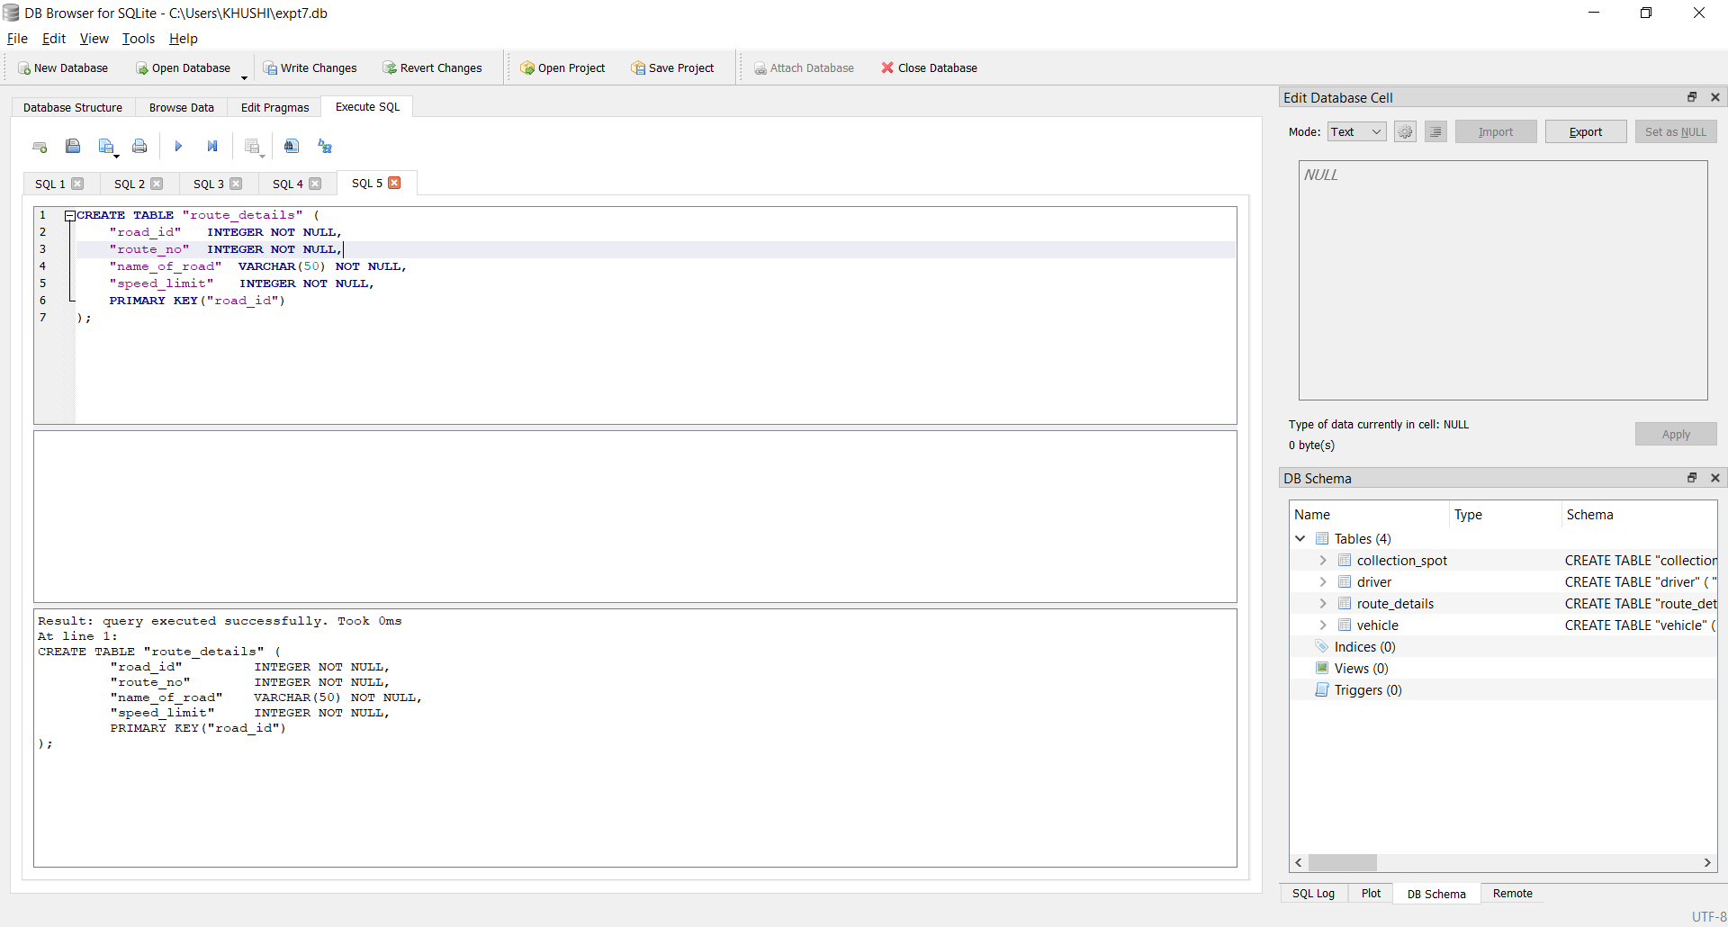

Shift Details Table

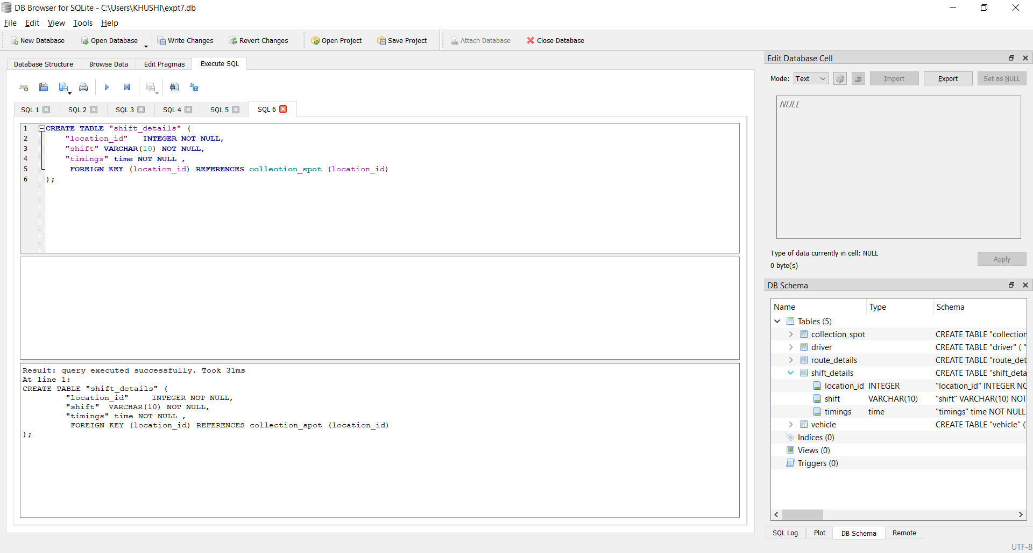

**EXPERIMENT 8**

**1)INSERT:**

INSERT INTO route VALUES (1,2,'RW Sawant Road',23);

SELECT *

FROM route;

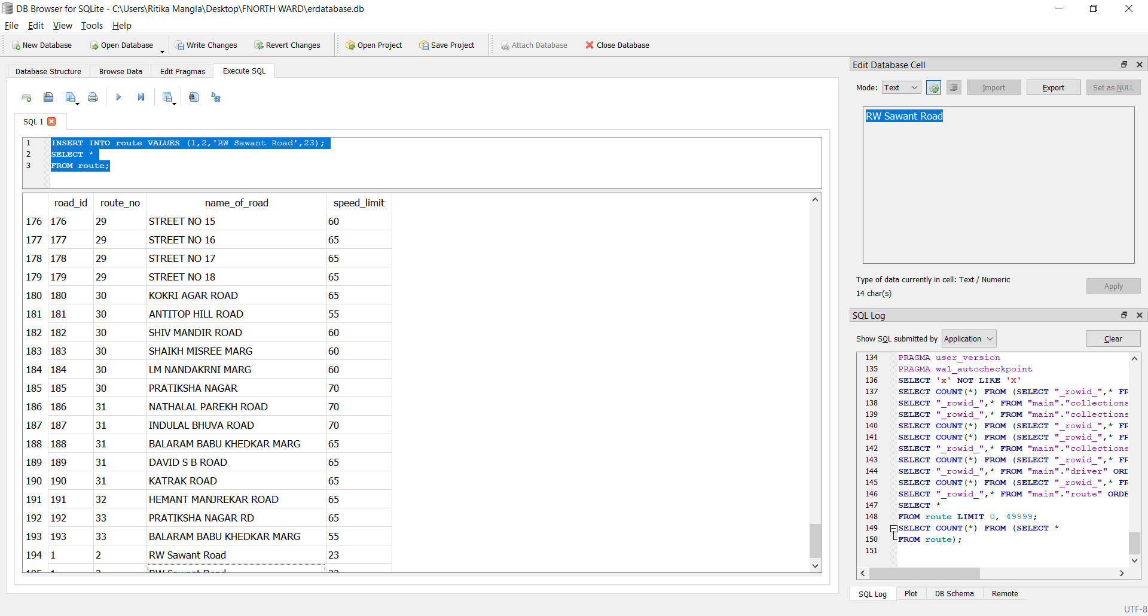

INSERT INTO shiftdetails VALUES (12007,'6:00 PM','T2');

SELECT *

FROM shiftdetails;

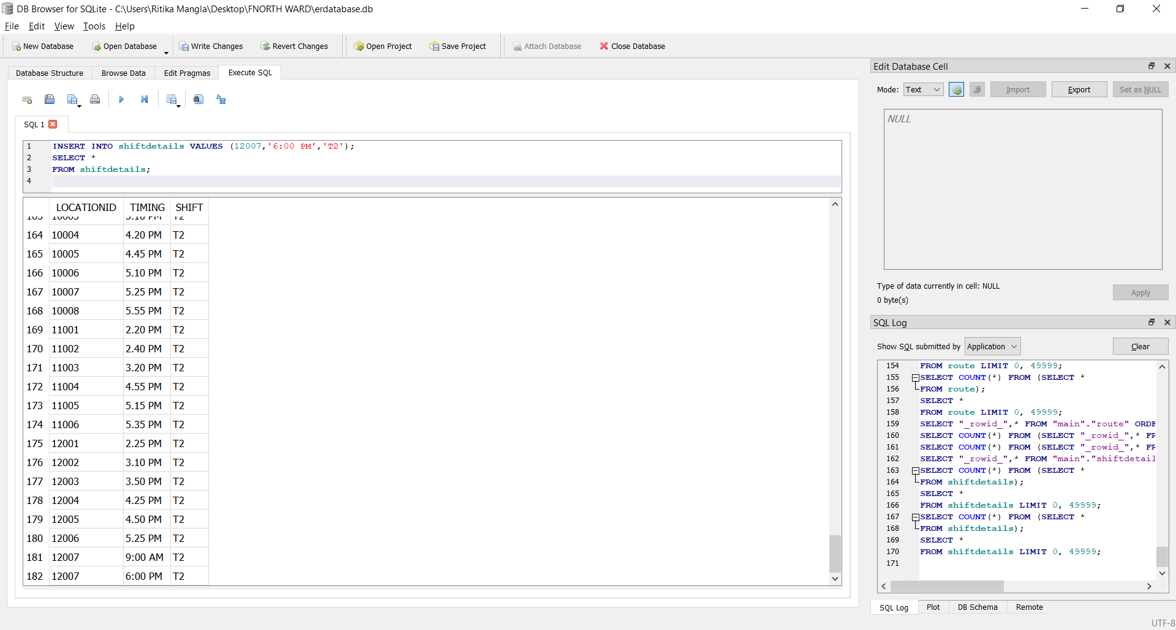

**2)UPDATE:**

UPDATE route SET name_of_road = 'VJTI Road' WHERE name_of_road='RW Sawant Road';

SELECT *

FROM route;

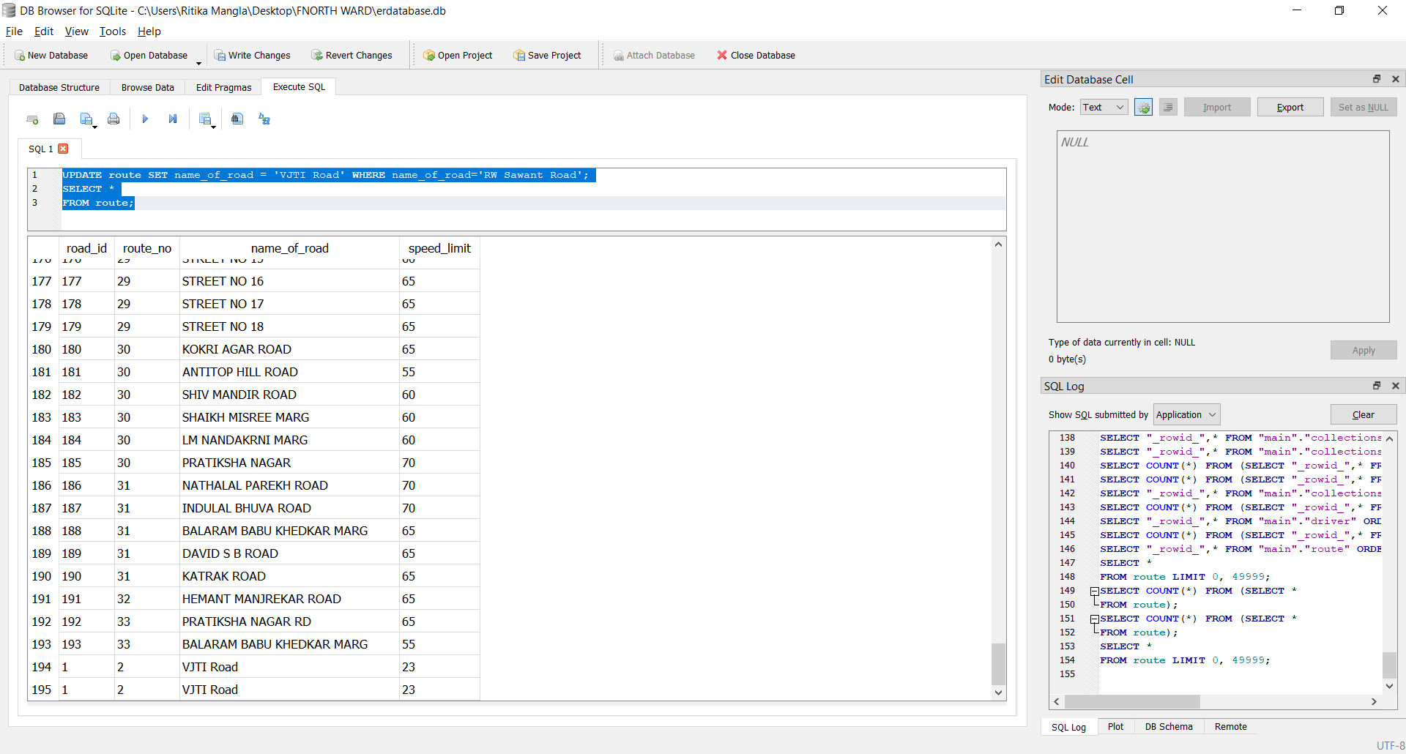

UPDATE shiftdetails SET timing = '6:05 PM' WHERE shift='T2';

SELECT *

FROM shiftdetails;

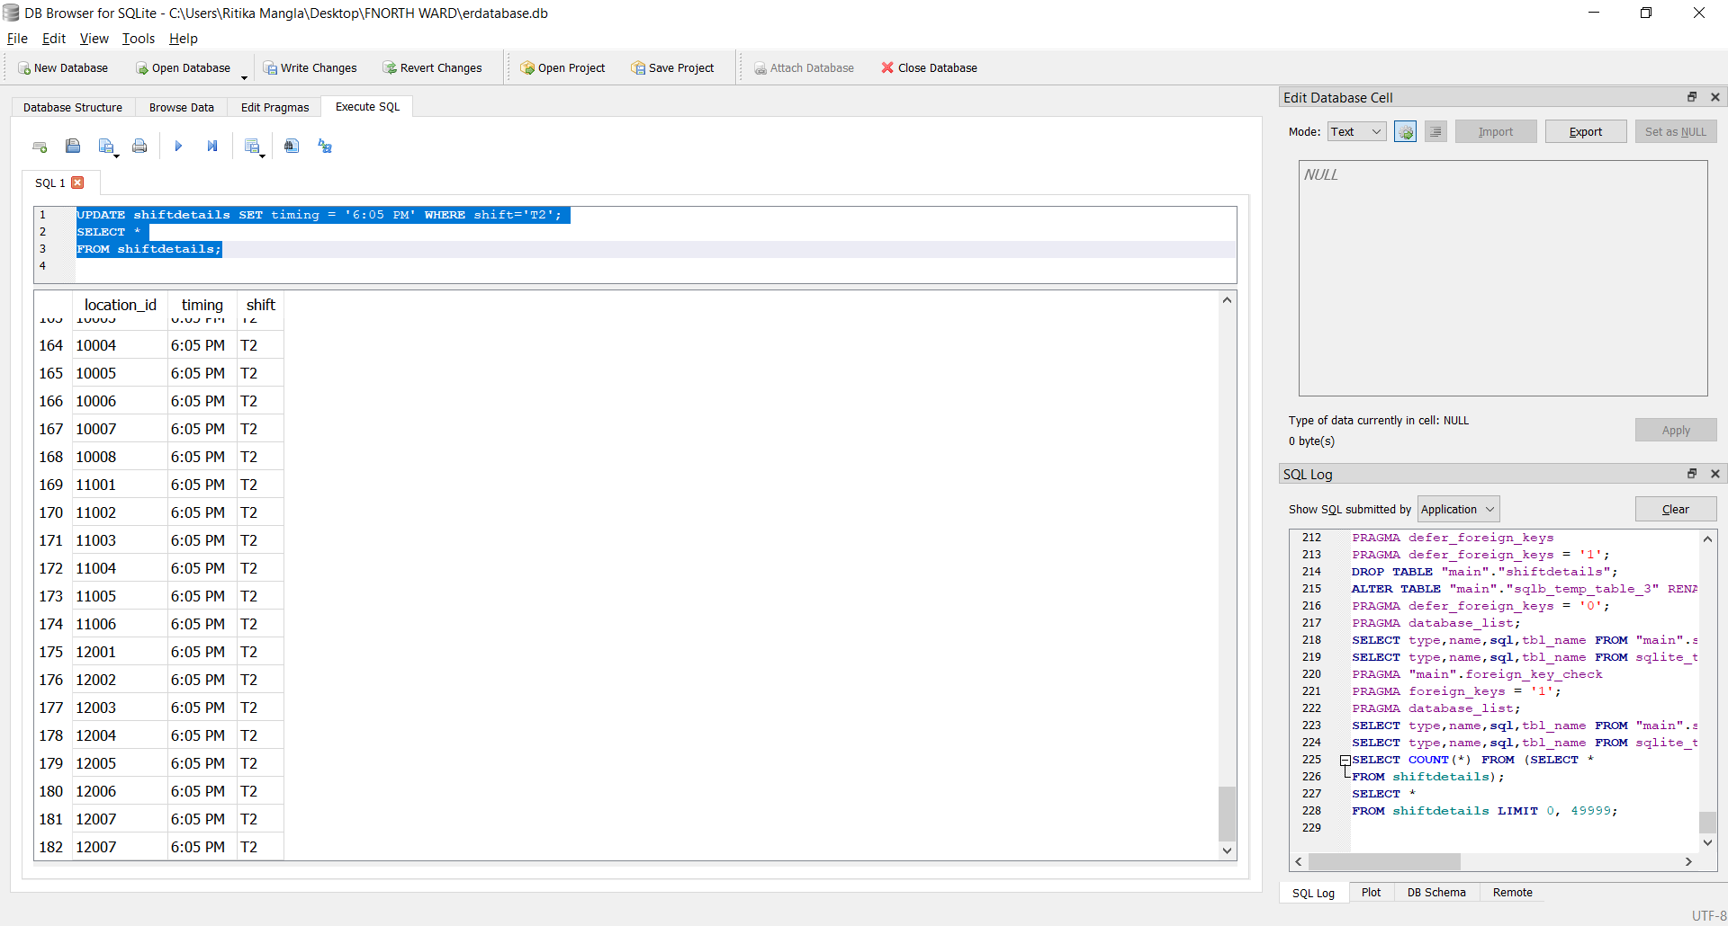

**3)DELETE**

DELETE FROM route WHERE name_of_road='VJTI Road';

SELECT *

FROM route;

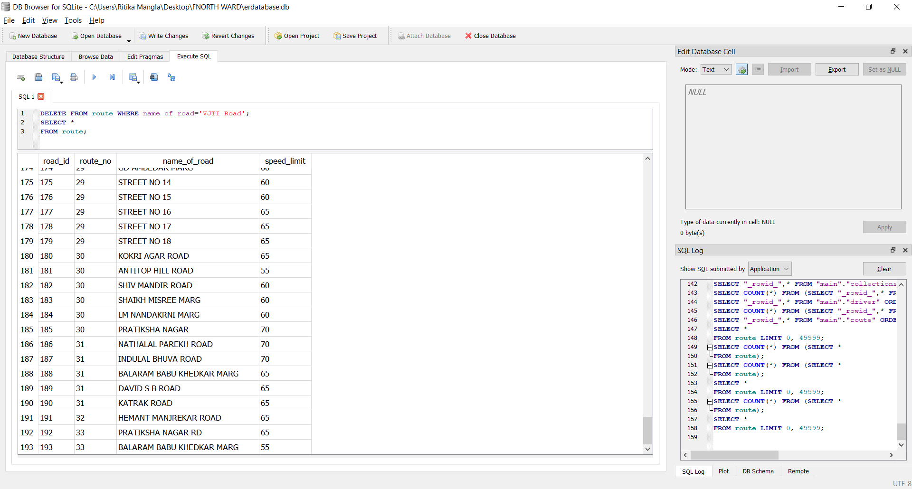

**4)COMMIT:**

DELETE FROM route WHERE name_of_road='VJTI Road';

COMMIT;



**SOME OF THE OTHER QUERIES IMPLEMENTED IN THE PROJECT:**

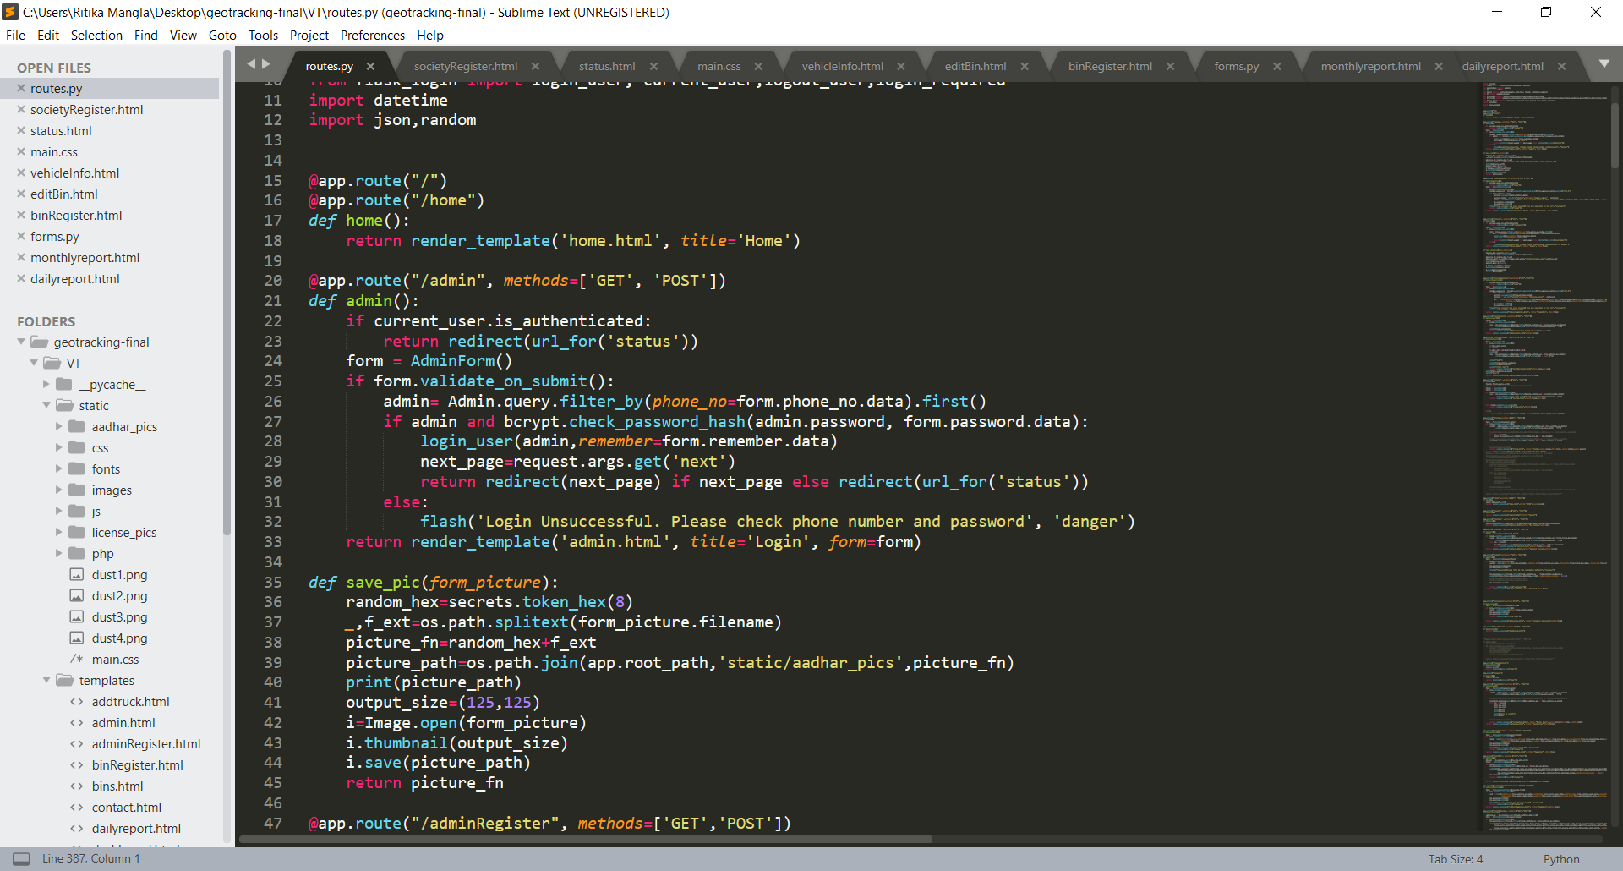

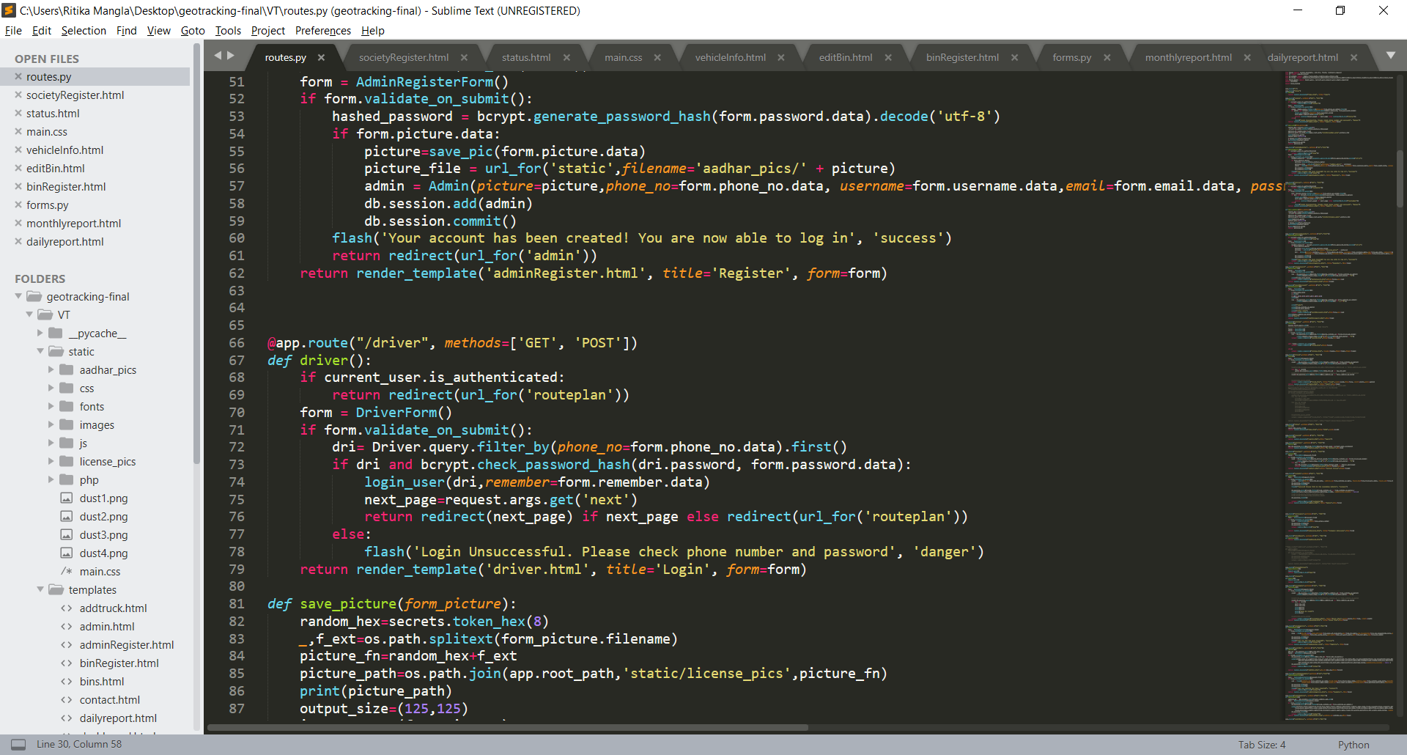

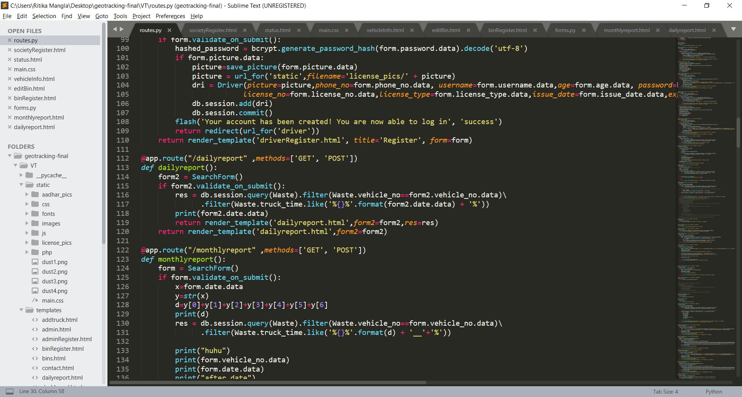

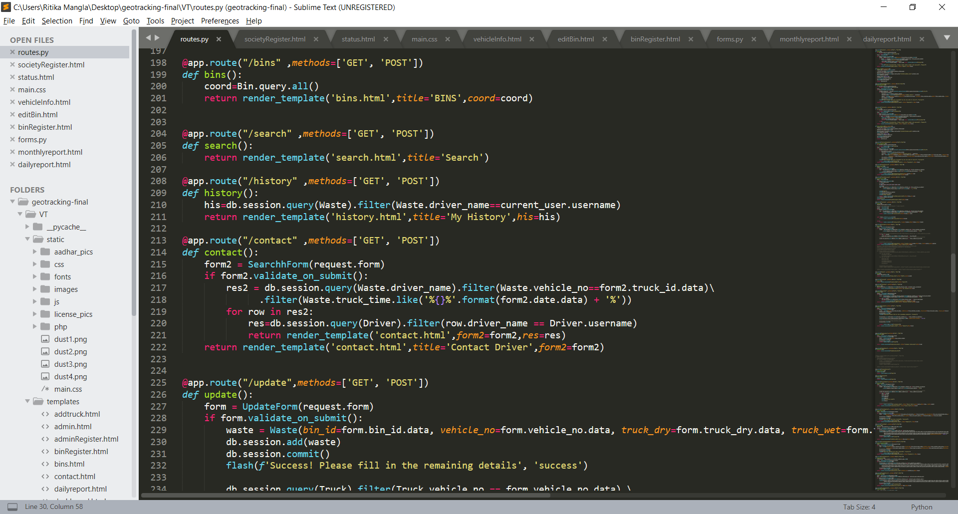

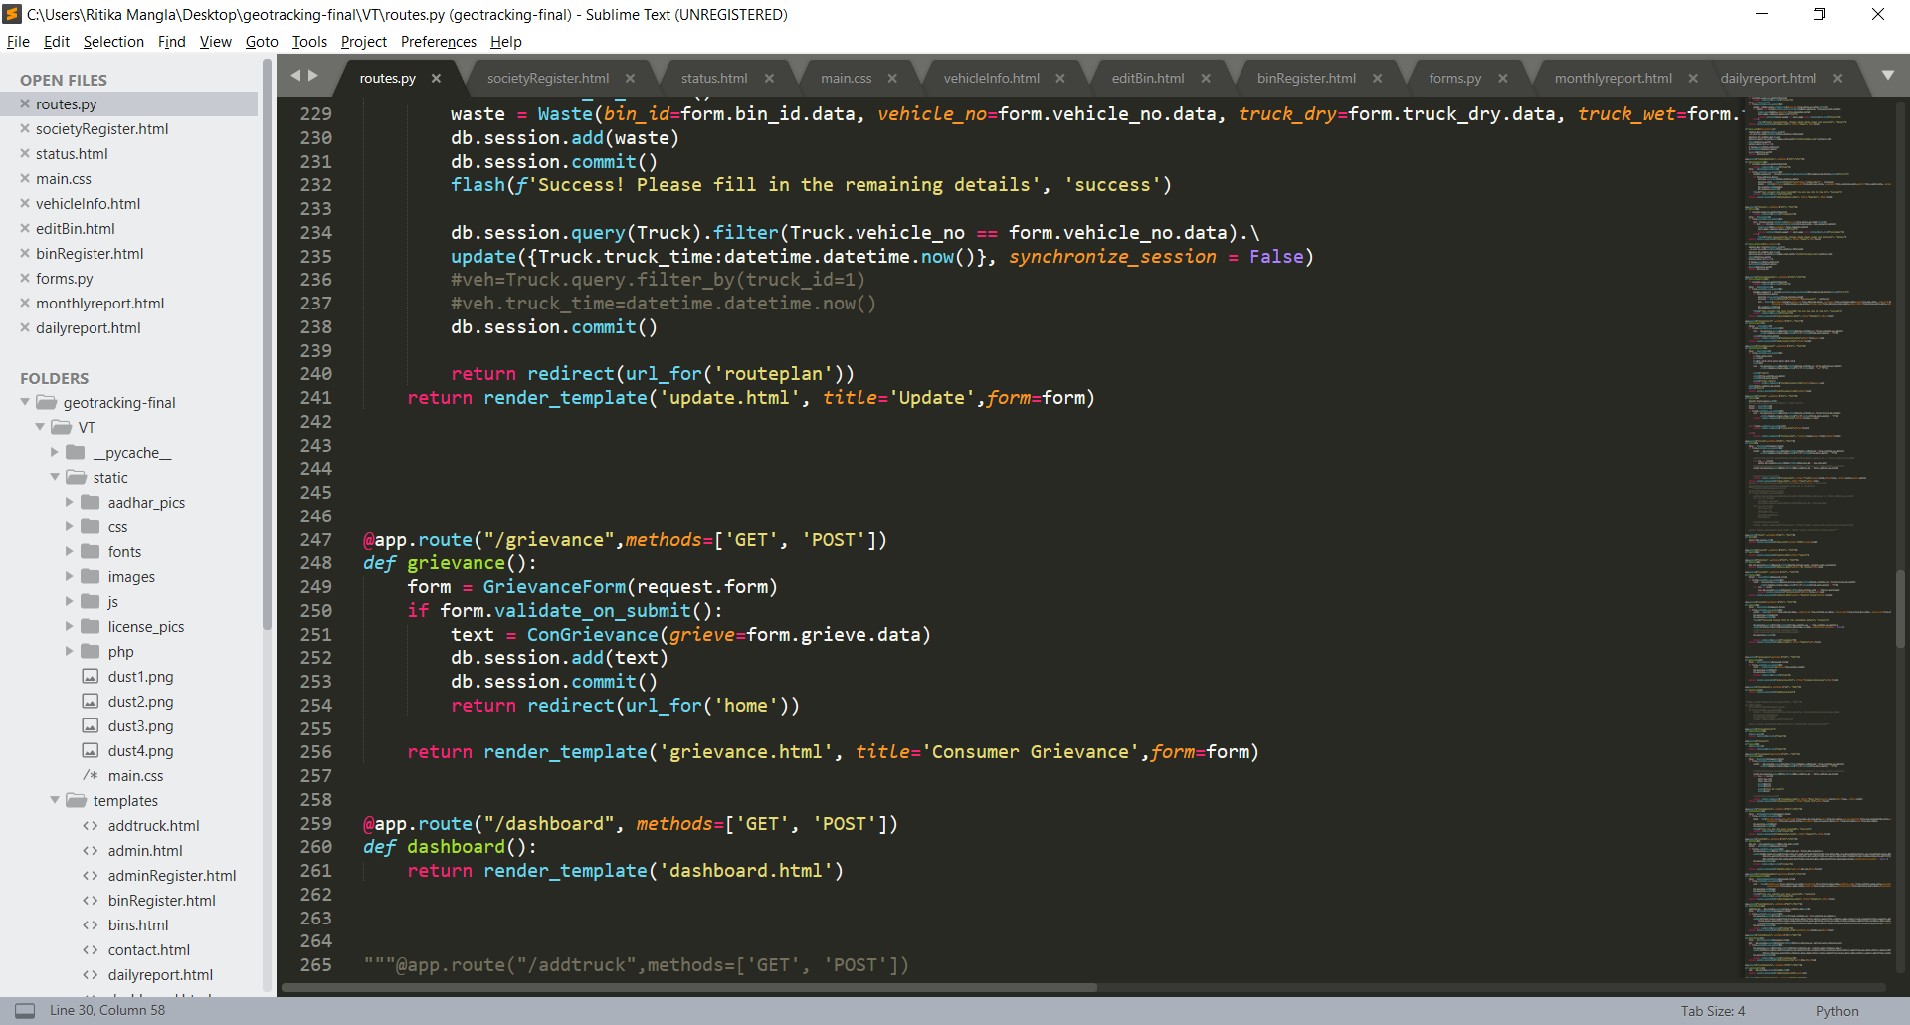

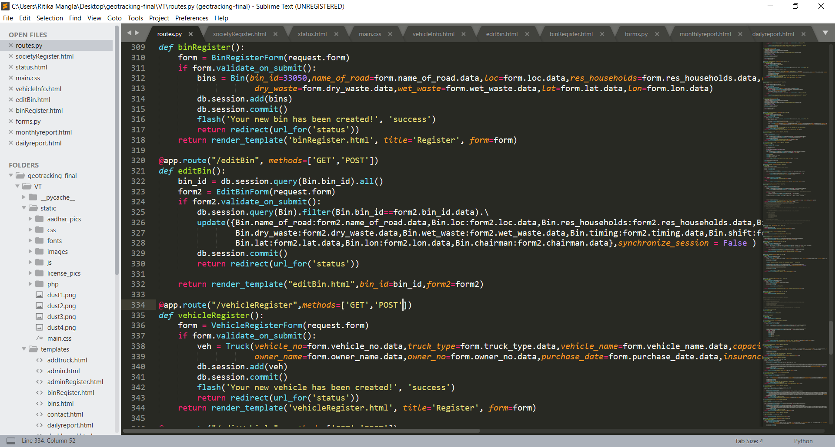

**EXPERIMENT 9**

Q1] Select the name, phone number & license number of drivers whose age is less than 35.

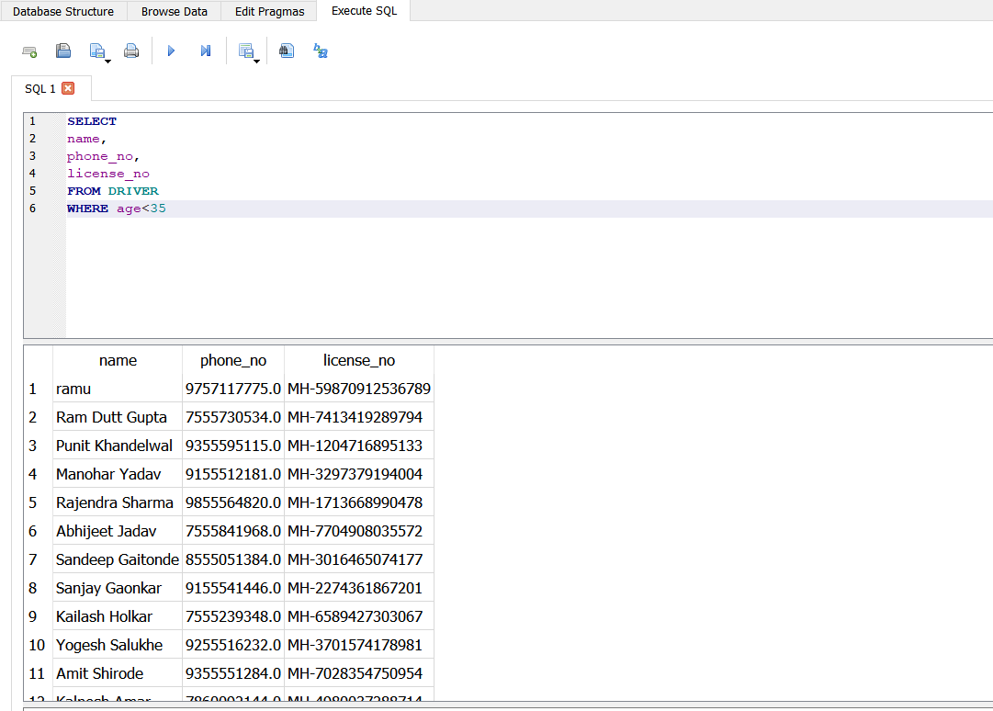

Q2] Create and display a view of the details license number, date of issue & expiry date of drivers whose license type is ‘HGMV’

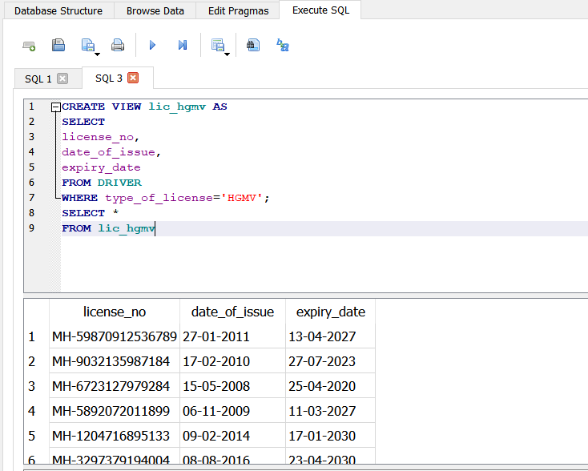

Q3] Select the name, phone number & age(after 10 years) of the drivers whose age after 10 years will be more than 50 years

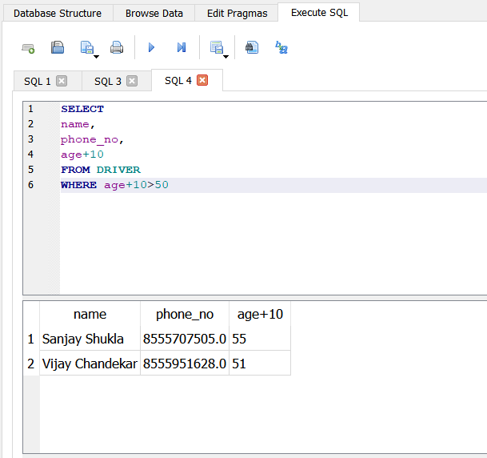

Q4] Delete all details of the drivers whose age is less than or equal to 30

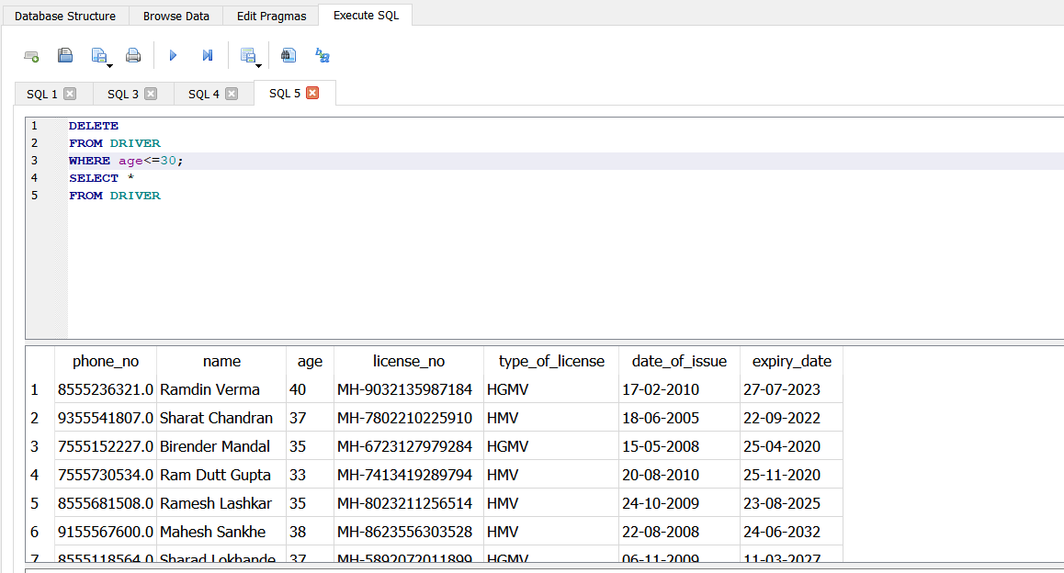

Q5] Create and display a view of the license expiry date of the drivers whose expiry date will cross 01-01-2020

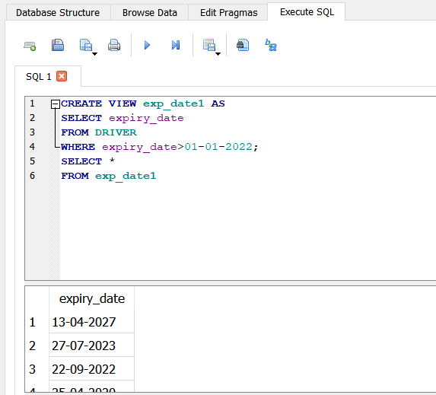

6]Which of the bins are attended in the afternoon shift.

SELECT * FROM collectionspots

WHERE location_id IN

(SELECT location_id

FROM shiftdetails

WHERE shift= “T2”);

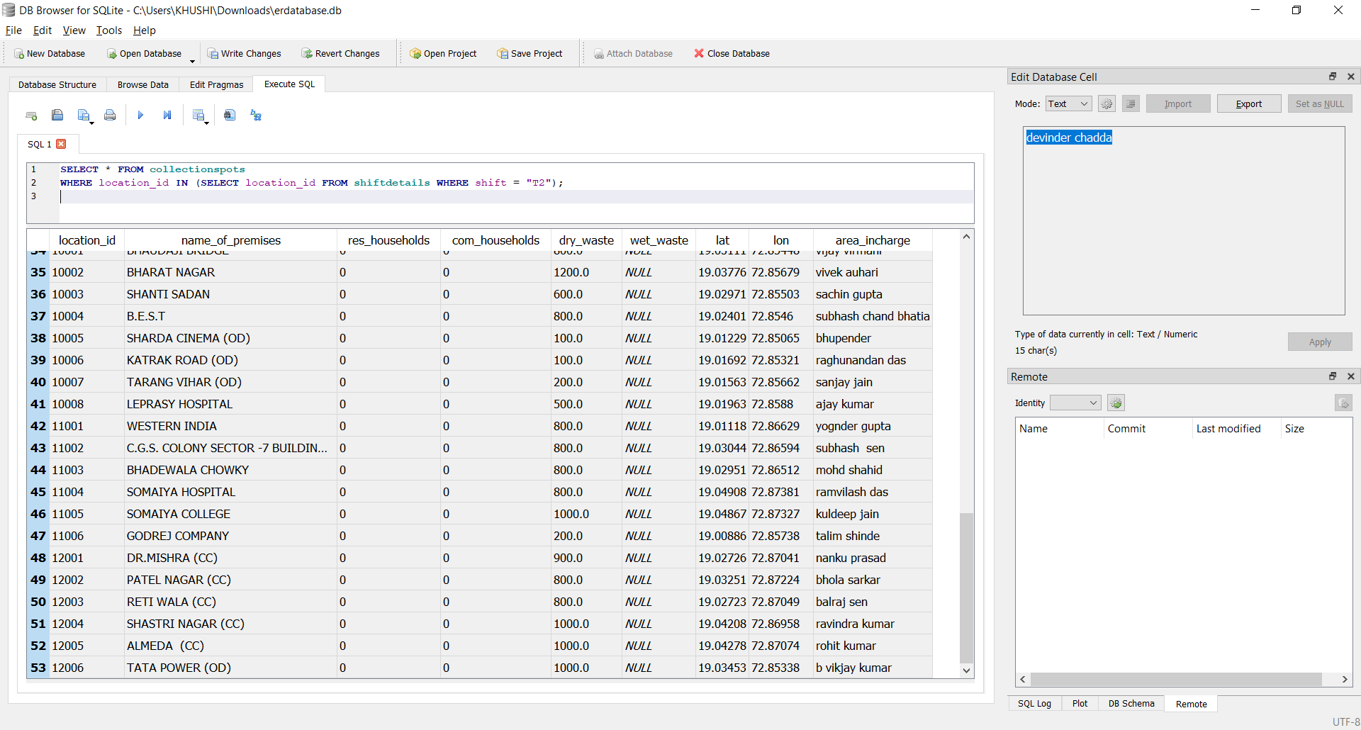

Q7] Create and display a view of the details name, phone number & license number of the drivers whose license has date of issue beyond 01-01-2010 &expiry date beyond 01-01-2020

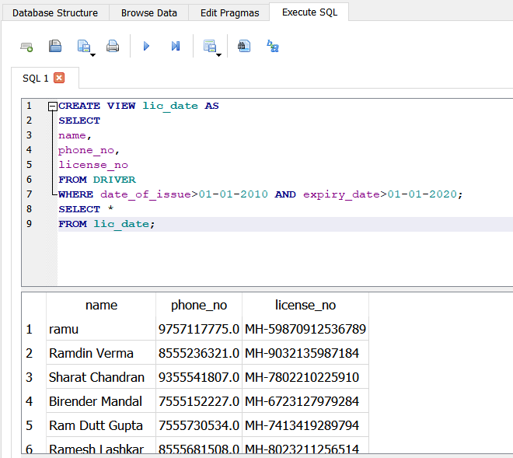

8] Selecting all the bins which are collected by driver ramu.

select * from bin where bin.bin_id in (select bin_id from waste where driver_name="ramu");

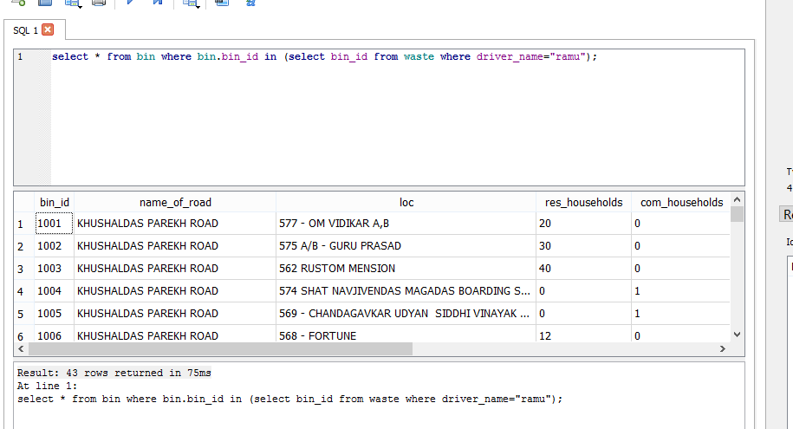

Q9] Create and display a view of location ID from shift details where timings are after 7.30AM and shift is T1

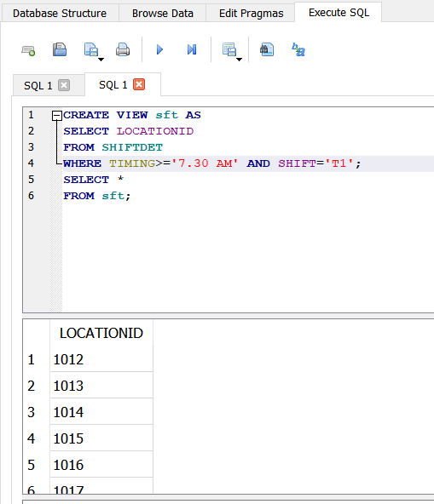

Q10] Create and display a view of location ID, timings and shift from the shift details whose route ID is 07

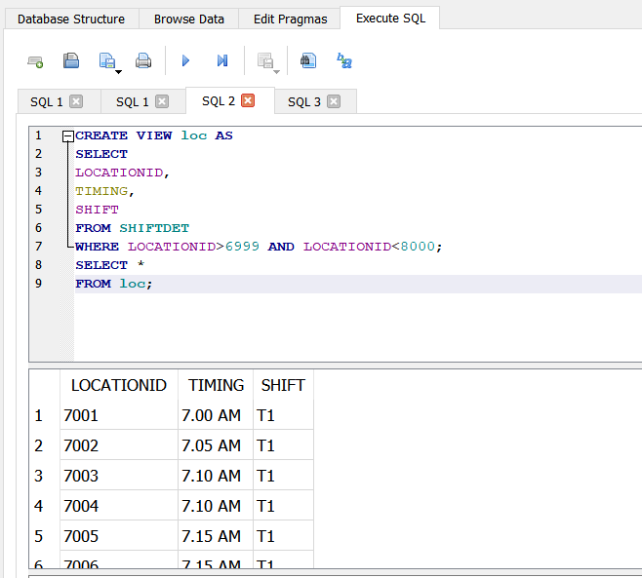

Q11] Count the distinct timings of shift details where the routes are 01,02,03,04 , timing is beyond 10.30AM and shift is not T1

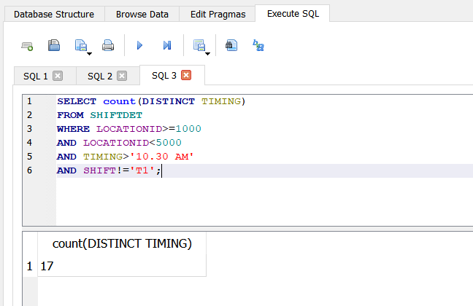

Q12] Create and display a view with all details whose route number is 11 and position of bin may vary

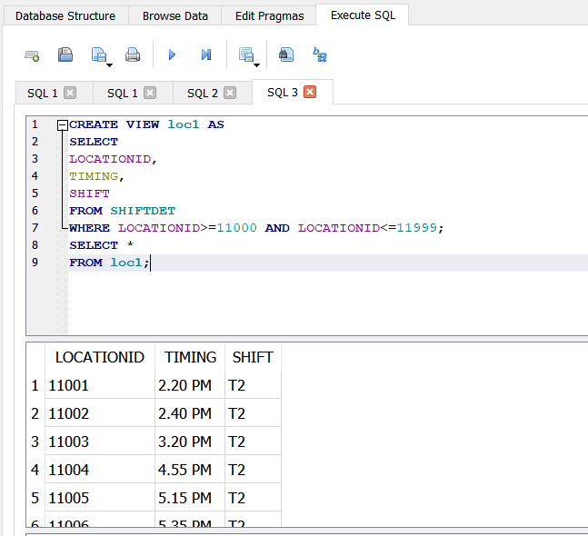

13] Select the name of the premises where the dry waste generated is greater than the avgdry waste generated in route 11

SELECT name_of_premises

FROM collectionspots

WHERE dry_waste> (SELECT AVG(dry_waste) FROM collectionspots WHERE location_id like "11___");

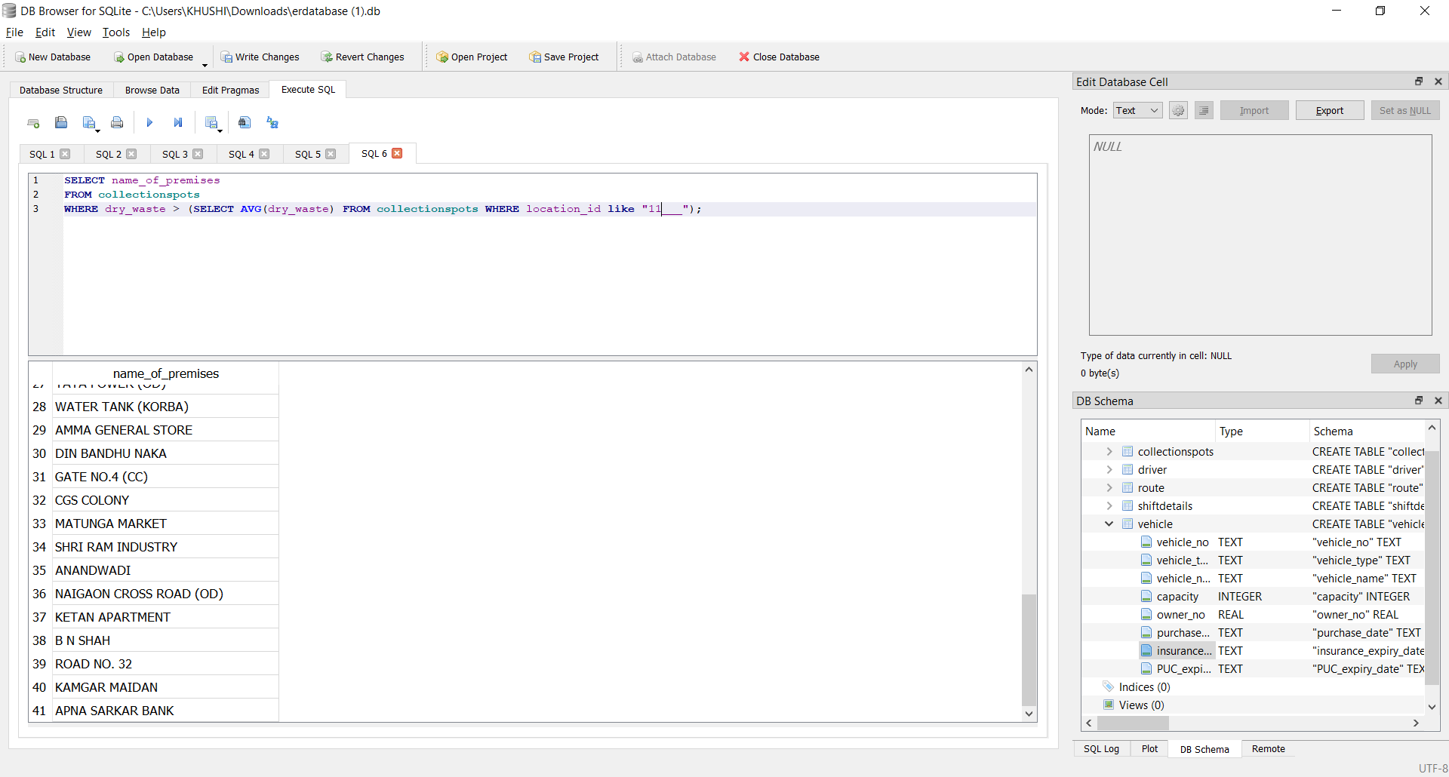

Q14] Create and display a view of details vehicle number and owner no. from vehicles whose insurance expiry date is beyond 01-01-2020 and PUC expiry date is beyon 31-12-2021

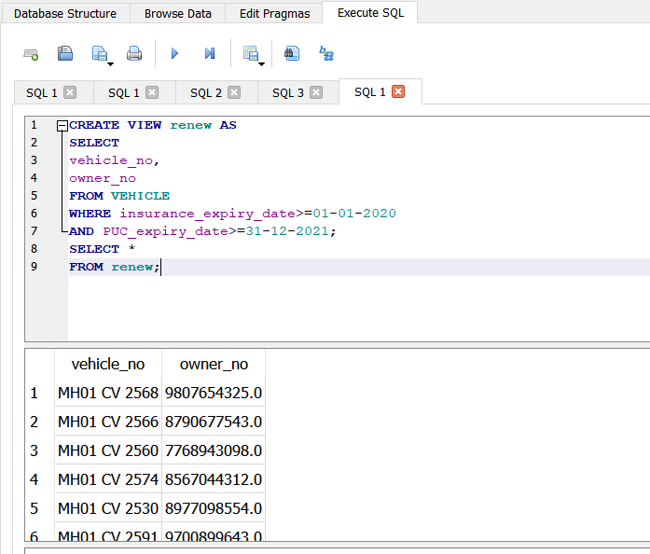

Q15]Create and display a view with details vehicle number, type, name and purchase date where the vehicle is either a BMC LARGE Tata Motor or BMC MINI Mahindra

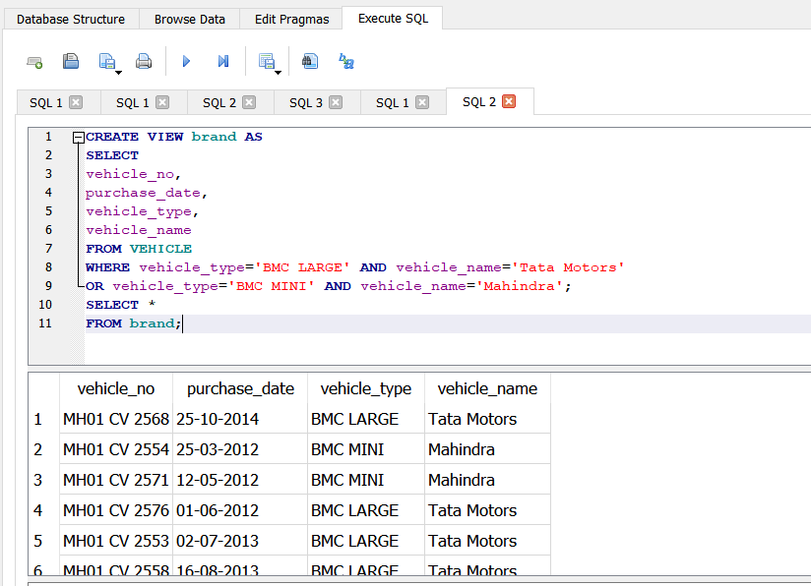

Q16] Create and display a view with detail vehicle number, name, purchase date and owner number of the vehicle type ‘PRIVATE LARGE’

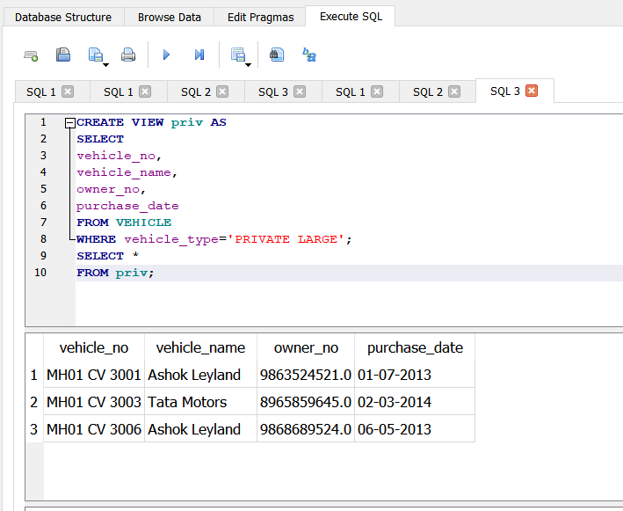

17]Arrange the bins which are attended in the morning shift in ascending order according to the dry waste collected

SELECT * FROM collectionspots

WHERE location_id IN

(SELECT location_id

FROM shiftdetails

WHERE shift ="T1")

ORDER BY dry_waste ASC;

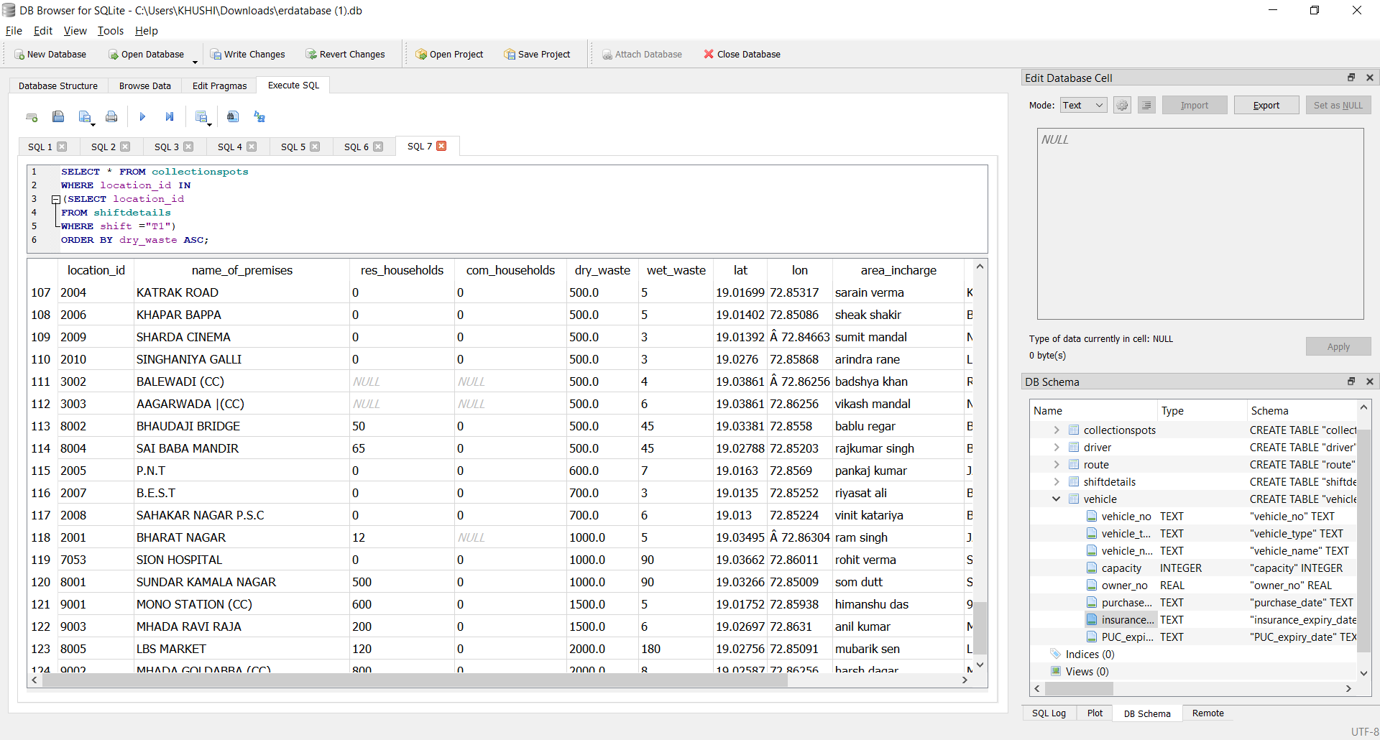

Q18] Create and display a view with details route number and road name for the routes where speed limit is more than or qual to 70 kmph

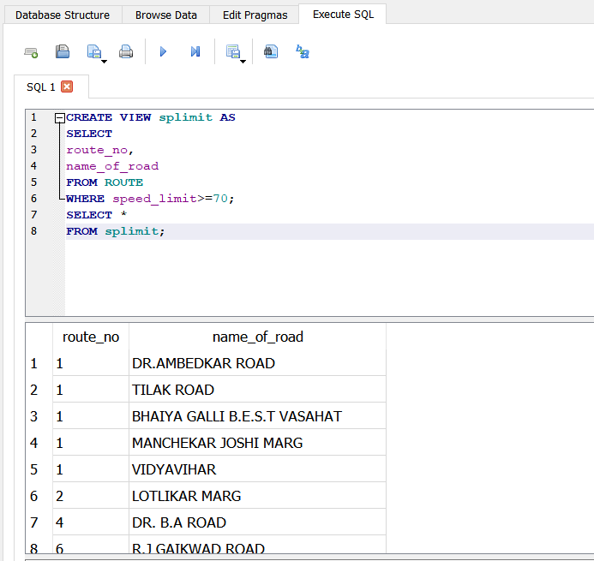

Q19] Create and display a view with details road ID, road name and speed limit for route number 13

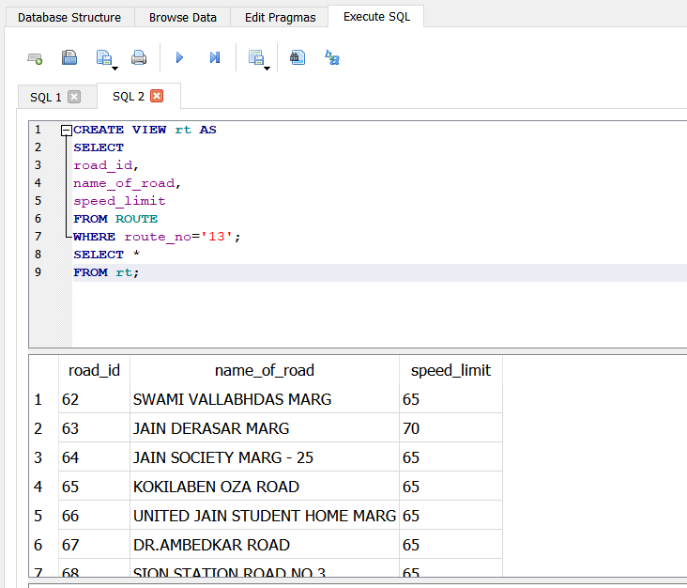

Q20 ] Create and display a view with details road ID and name of road for route no. 1 and speed limit 75kmph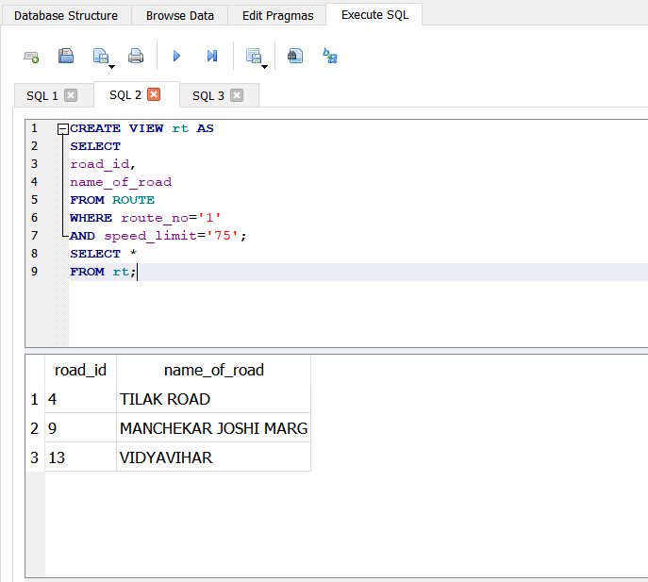

21] Count the number of bins which generate wet waste greater than 2.1 kg on route 33.

SELECT COUNT(location_id)

FROM collectionspots

WHERE wet_waste>2.1 AND location_id like “33___”;

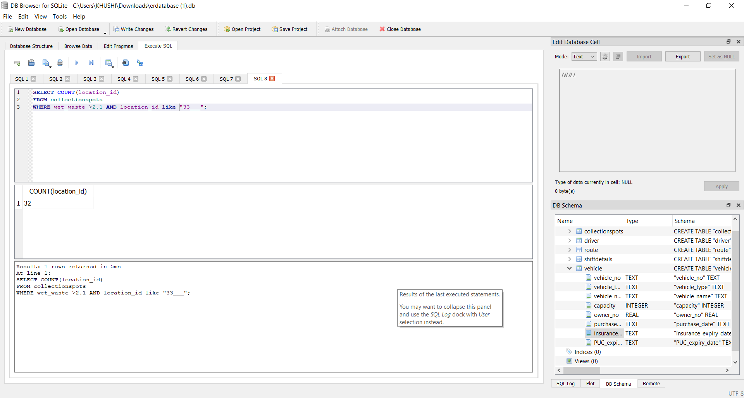

Q22] Create and display a view with details location ID, name of road and premises for residential households more than or equal to 10 and no commercial households

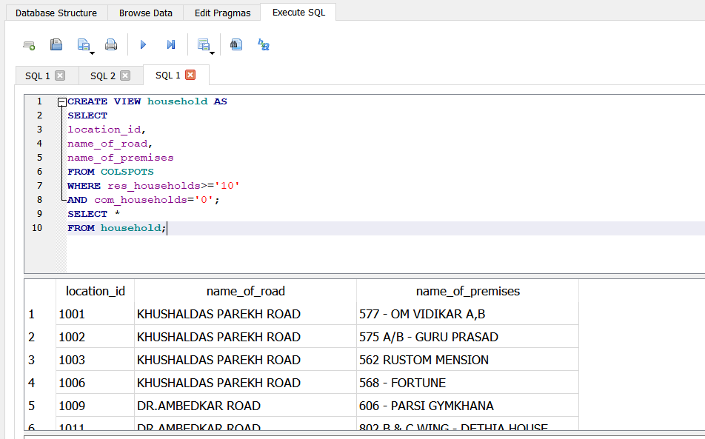

Q23]Select location ID, road and premise name, latitude and longitude of all the collection spots

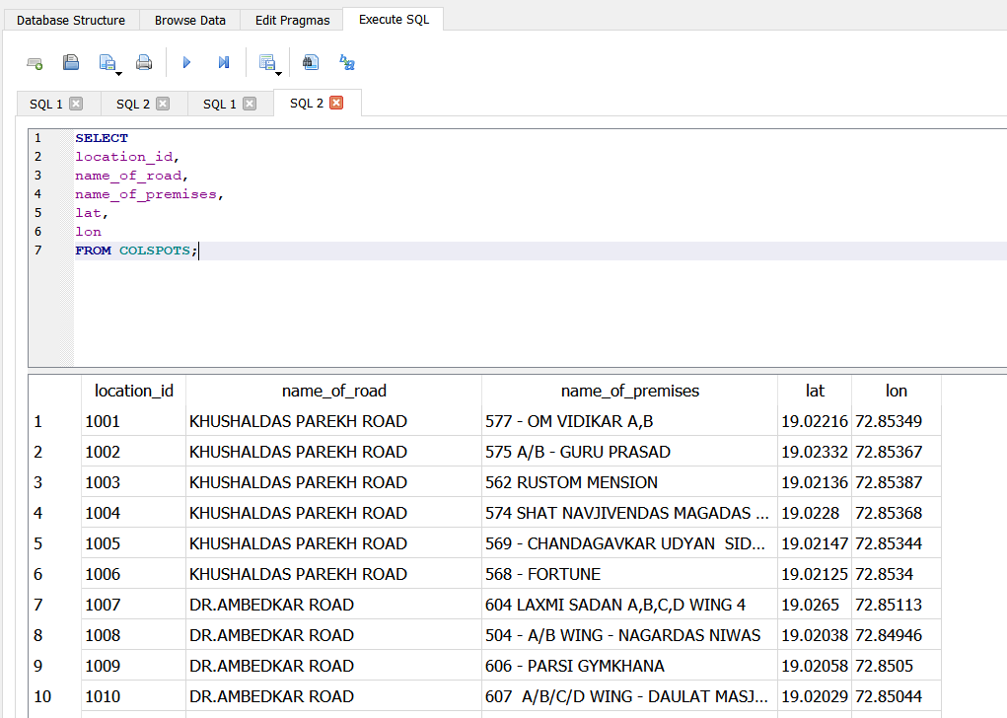

Q24] Create and display a view with details area incharge, name of premise, lat and longof collection spots whose road name is either ‘Dr BR Ambedkar Road’ or ‘Jain Society Marg 25’

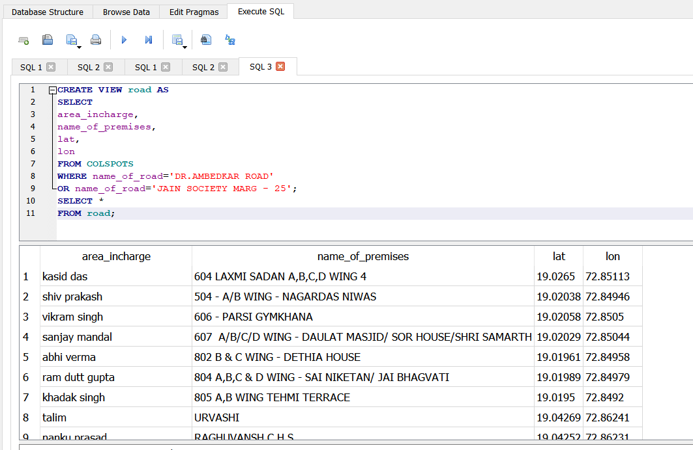

Q25] Count the number of shift details for the route ID 05

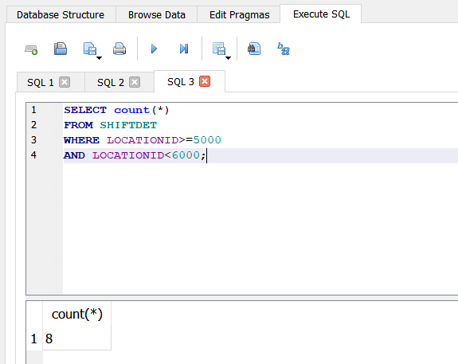

Q26]Create and display a view with details location ID, road name, residential and commercial households, dry and wet waste for collection spots with commercial households not equal to zero and wet waste more than 1 ton, or residential households more than or equal to 15 and dry waste less than or equal to 50 tonnes

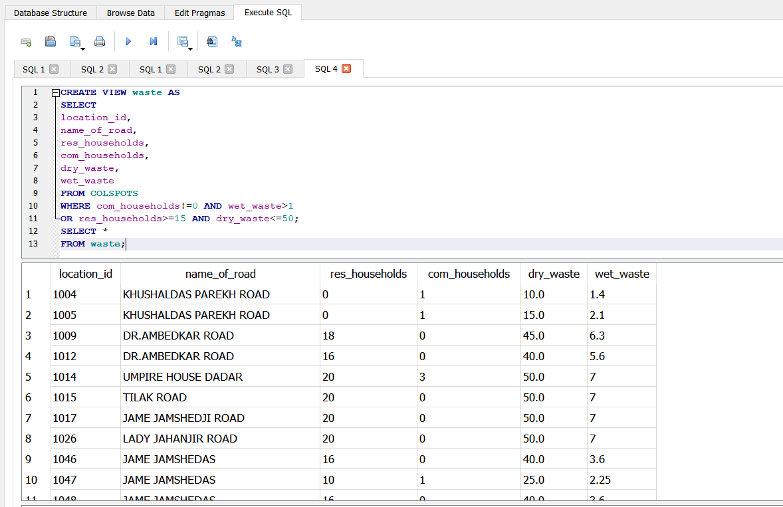

Q27] Select location ID, road and premise name, total number of households and total tonnes of waste(dry+wet) of collection spot whose area incharge is Yash Mittal

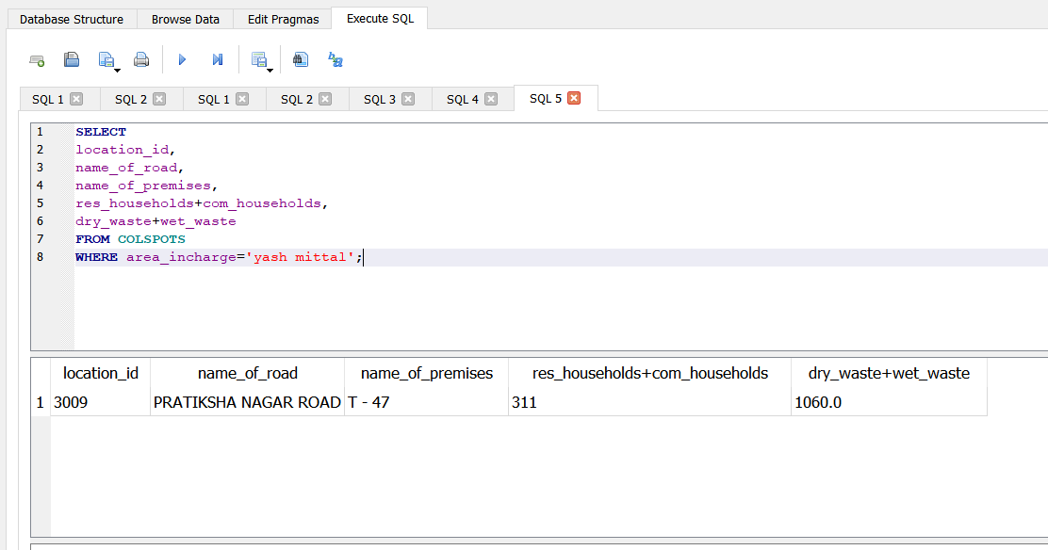

Q28]Create and display a view with details as road ID of the route, location ID and area incharge of the collection spot wherein road name of route is same as road name of the collection spot

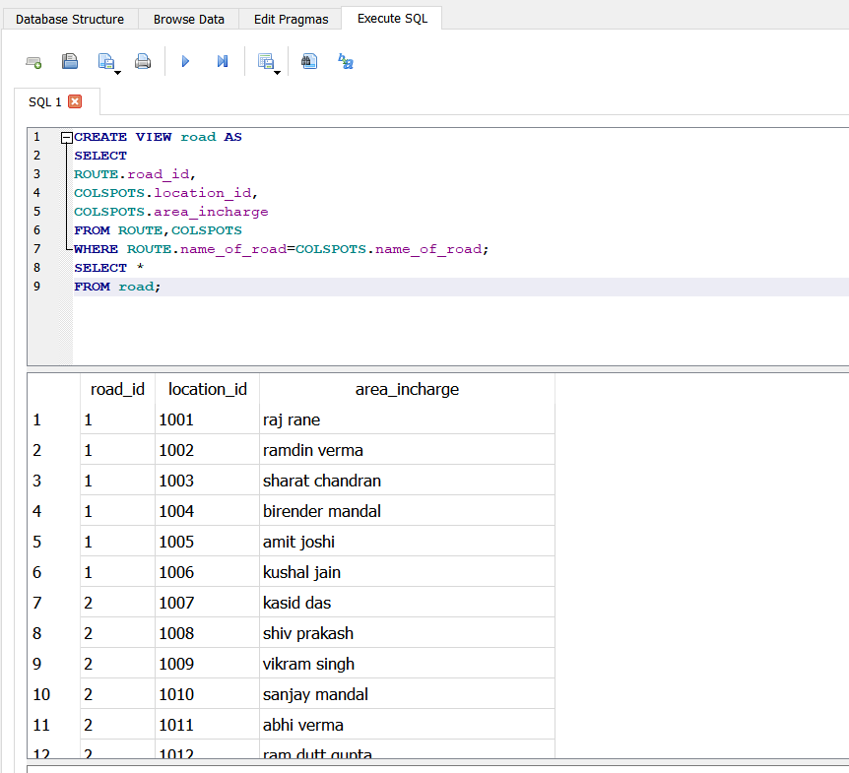

Q29] Create two views with first view as the union of route road name and collection spot road name and second view as select of route speed limit and collection spot location ID. Display the first view.

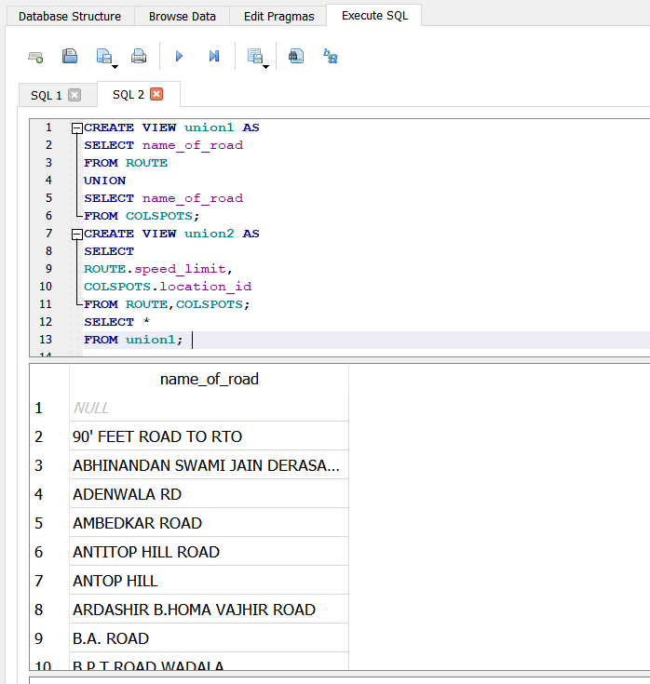

30] Select all the bins where the speed limit of the vehicle is less than 60kmph

SELECT * FROM collectionspots

WHERE name_of_road IN (SELECT name_of_road FROM route WHERE speed_limit<60);

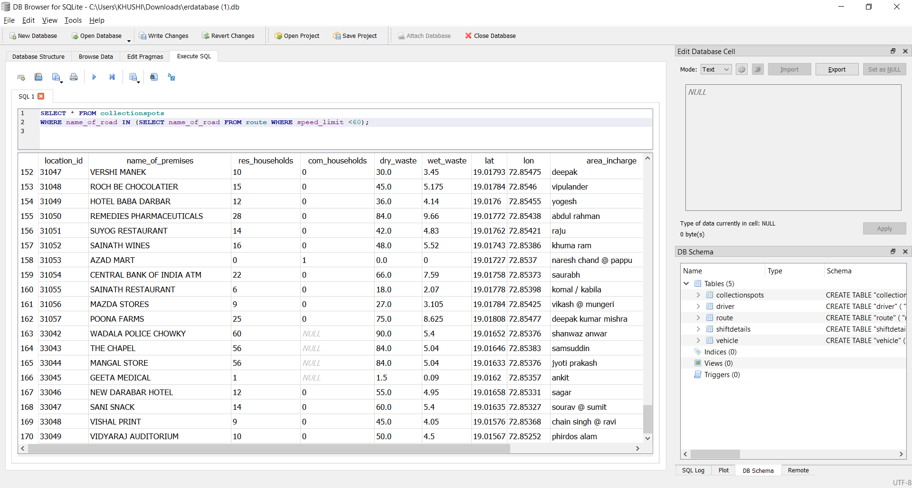

Q31] Create two views with first view as the union of route road name and collection spot road name and second view as select of route speed limit and collection spot location ID. Display the second view.

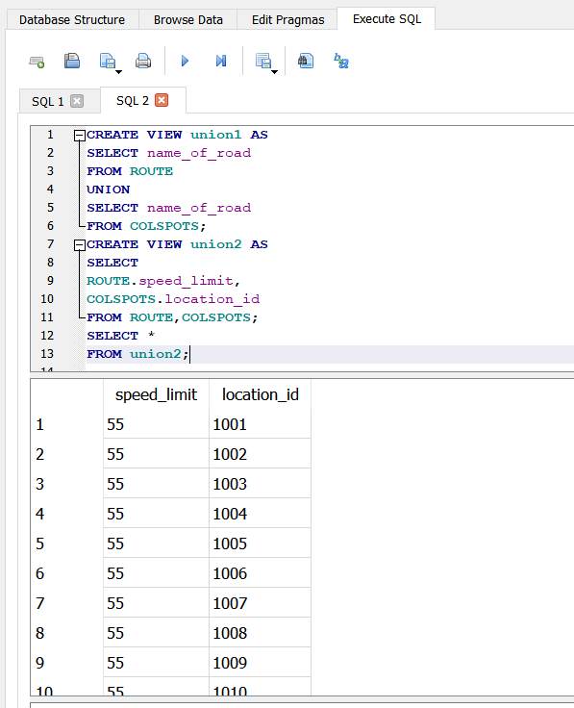

32] getting expiry date of vehicle driven by ramu.

SELECT insurance_expiry_date from truck where vehicle_no in (select vehicle_no from waste where driver_name="ramu");

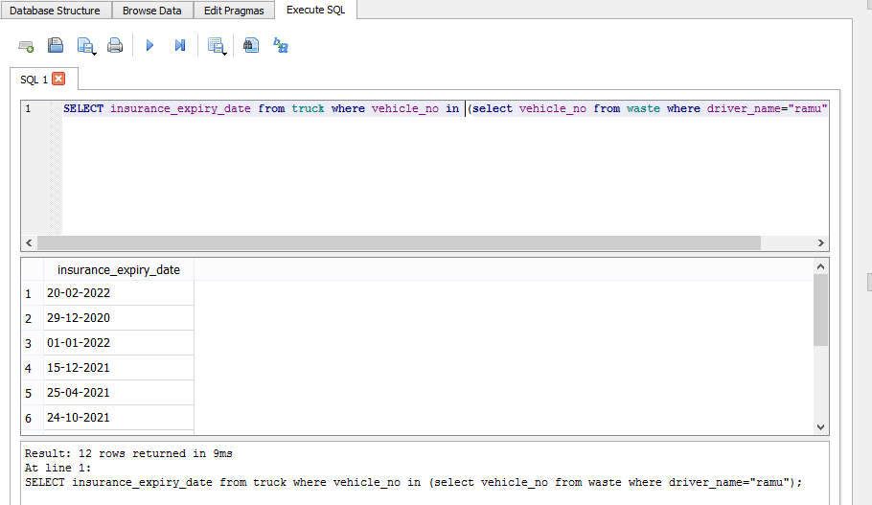

Q33] Select details license date of issue of driver along with purchase date of vehicle along with license expiry date of driver along with PUC expiry date of vehicle all in union

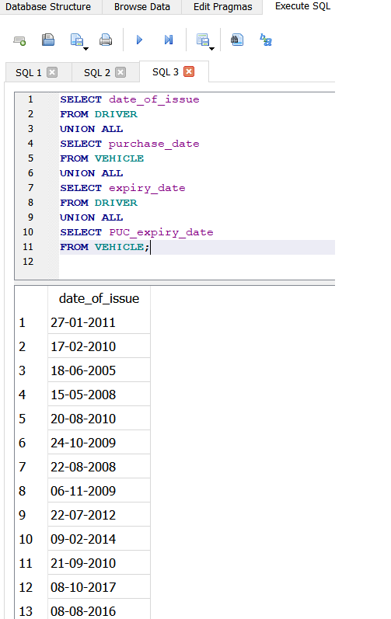

Q34] Create and display a view with location ID of shift details, driver name and license number and vehicle number

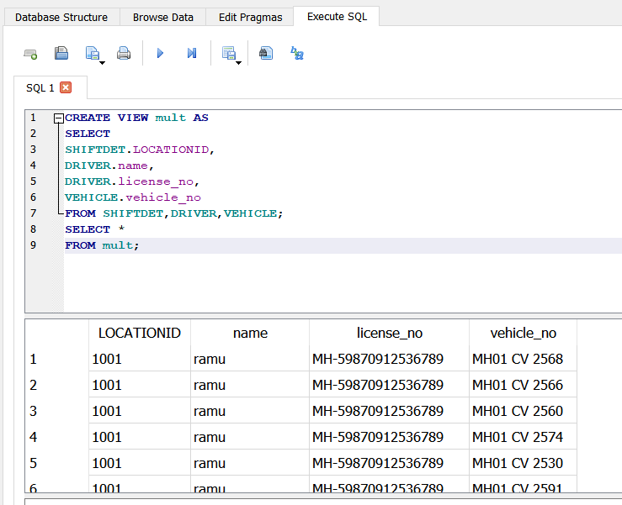

Q35] Count the number of driver between age 20 & 40 and having ‘HGMV’ type of license

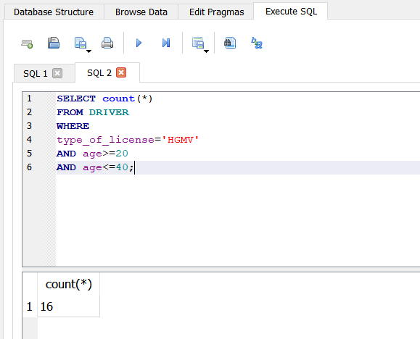

Q36] Count the number of driver of age less than 25 and havinglicense date of issue beyond 01-01-2010 and expiry date beyong 31-04-2020

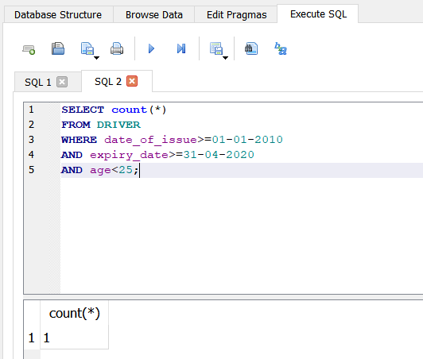

37] selecting owner name of truck that collects bin no 2001.

select owner_name from truck where truck.vehicle_no=(select vehicle_no from waste where bin_id=2001 );

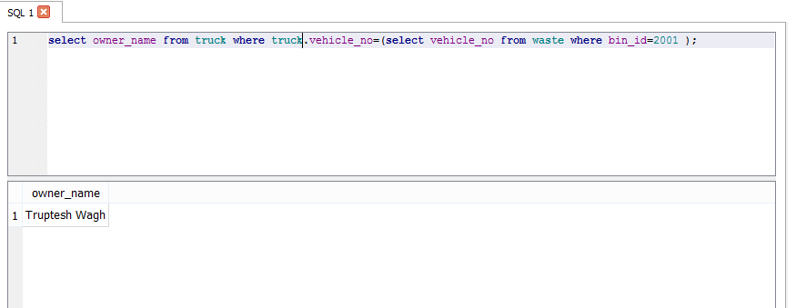

Q38] Count the distinct timings of shift details where the shift is T1

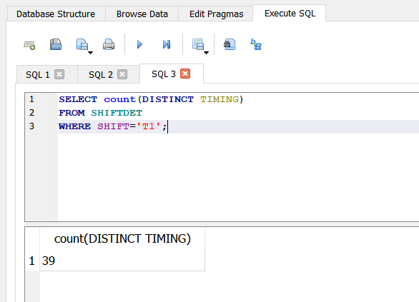

Q39] Count the distinct vehicle numbers for Tata Motor vehicles or for vehicles whose capacity is 12 tonnes

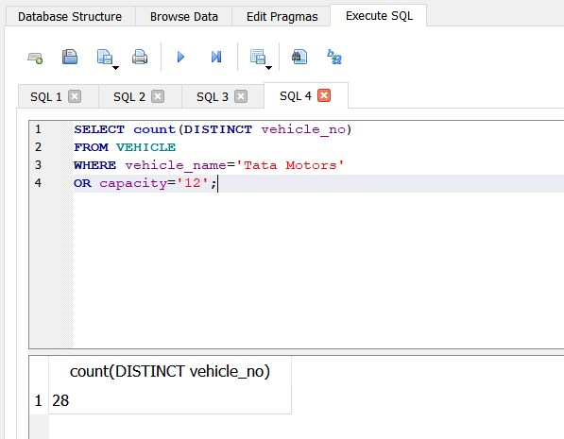

40] selecting owner no of the truck driven by ramdin verma.

SELECT owner_no from truck where vehicle_no in (select vehicle_no from waste where driver_name="Ramdin Verma");

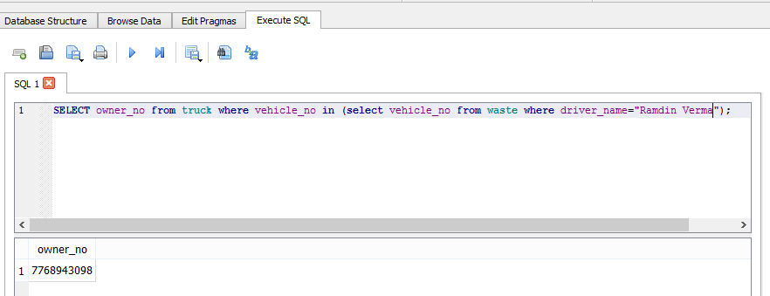

Q41] What is the sum of capacities of all Ashok Leyland vehicles?

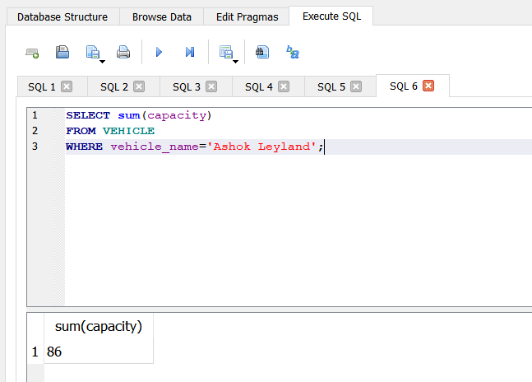

Q42] How many vehicles are of type ‘BMC MINI’, of Mahindra and with purchase date beyond 01-01-2012

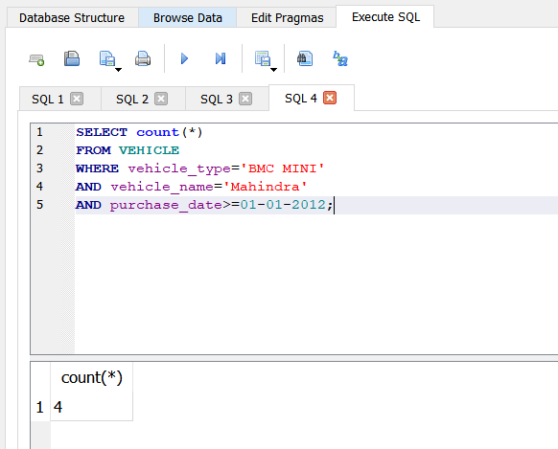

Q43] How many distinct speed limits are there for route with route number less than 11?

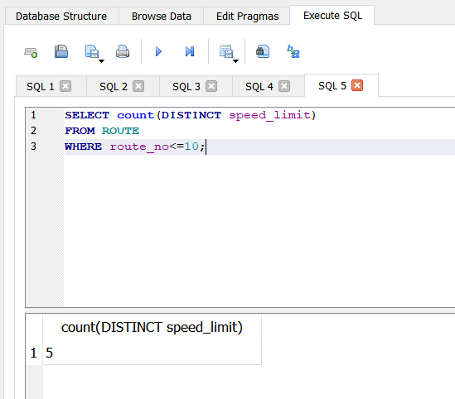

Q44] How many collection spots have location ID 01, residential households more than or equal to 15 and no commercial households?

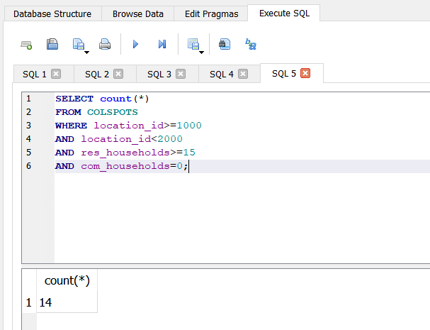

Q45] Find the minimun age of the drivers with HGMV type of license

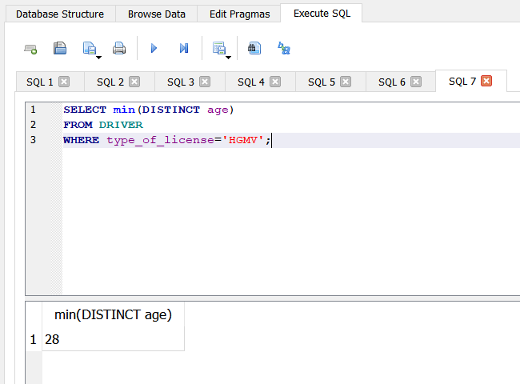

Q46] Count the distinct area incharges of collection spots with location ID not as 01,02,03,04 or commercial households greater than 0.

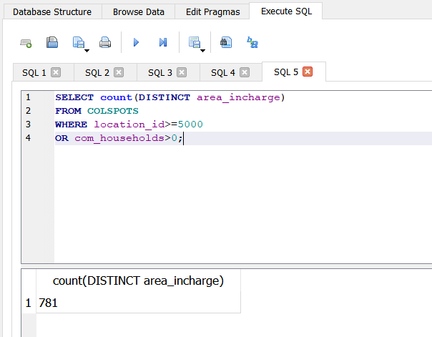

Q47] Count number of collection spots where amount of dry waste is more than 5 times that of wet waste or number of residential households is more than 10 times that of commercial households

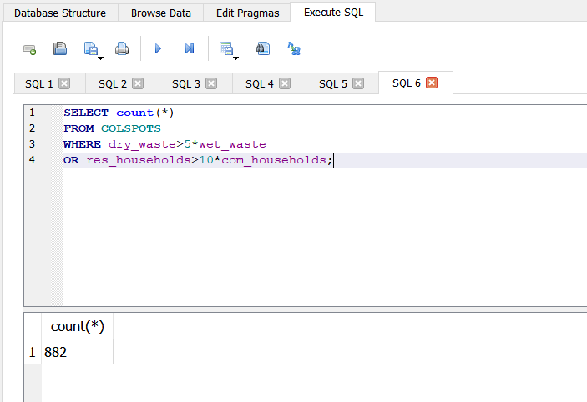

Q48] Find sum of wet waste of collection spots of location ID as 01,02,03 , residential households more than or equal to 5 and 0 commercial households

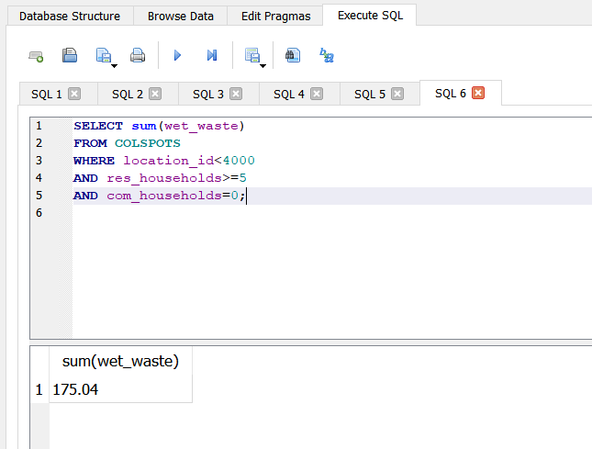

Q49] Select location ID of shift details of routes whose roadname have speed limit 65 kmph or route number 01

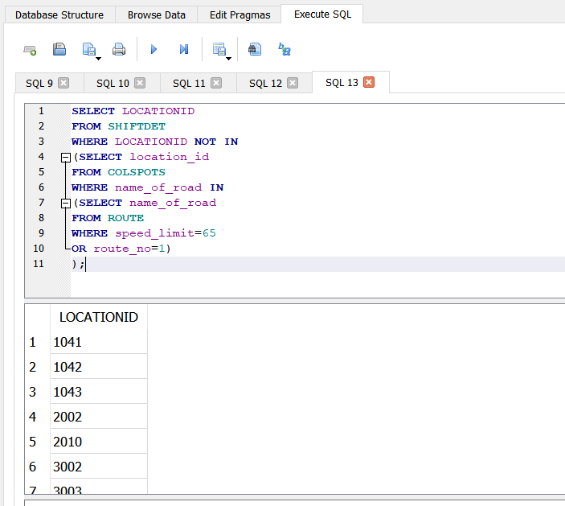

50] Calculate the number of residential households on route 3

SELECT SUM(res_households)

FROM collectionspots WHERE location_id like "3___";

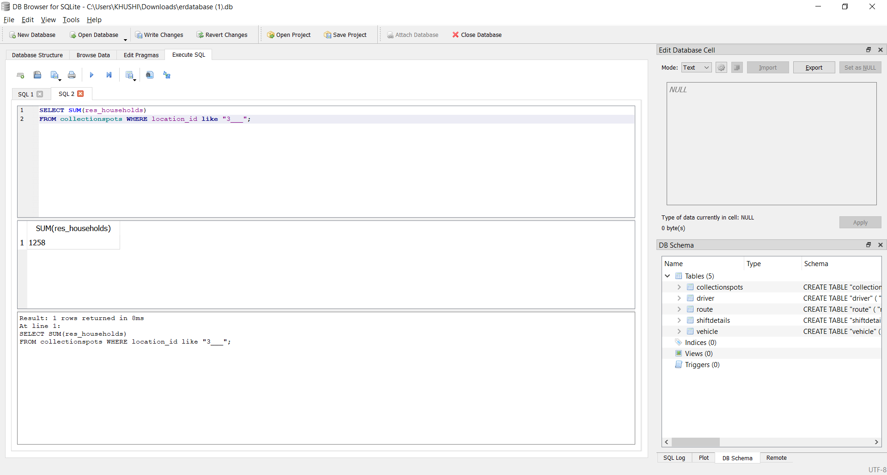

Q51] What is the maximum amount of total waste at collection spots with residential households less than or equal to 50 and 0 commercial households?

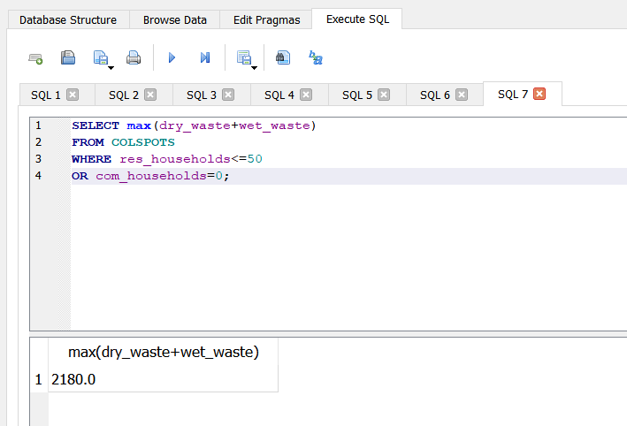

Q52] What is the average age of all the vehicle drivers?

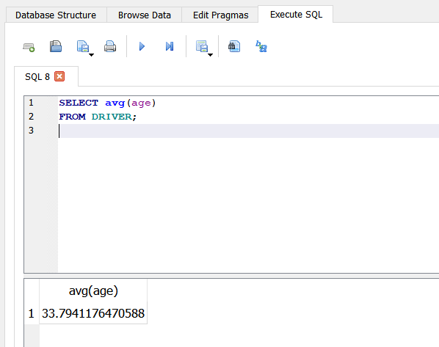

Q53] Select total amount of waste of road names which have speed limit more than or equal to 65 kmph and route ID as either 01 or 08

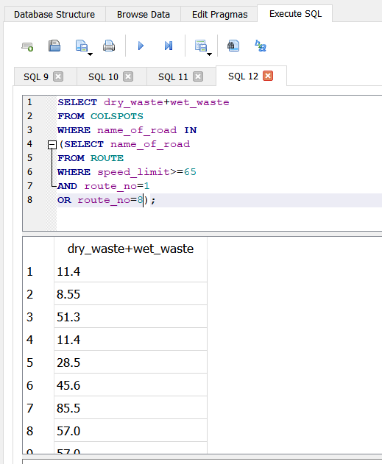

Q54] What is the average of total no. of households at collection spots whose route ID lies between 10 and 29?

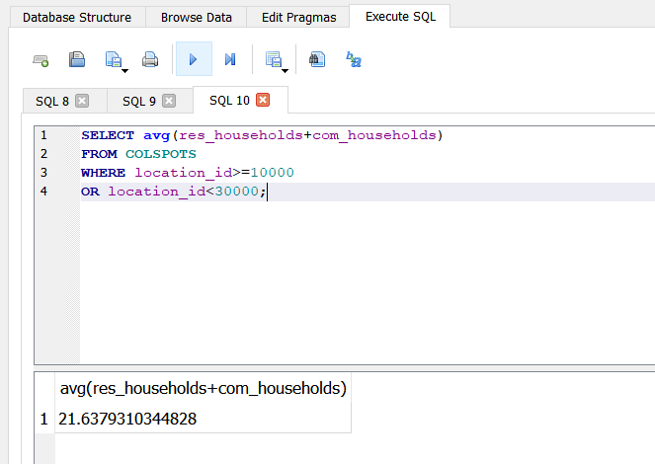

55] selecting the bin whose dr_waste is between 10 and 20 from the FIRDOSI MARG.

select * from bin where (dry_waste>10 and dry_waste<20) and name_of_road="FIRDOSI MARG" ;

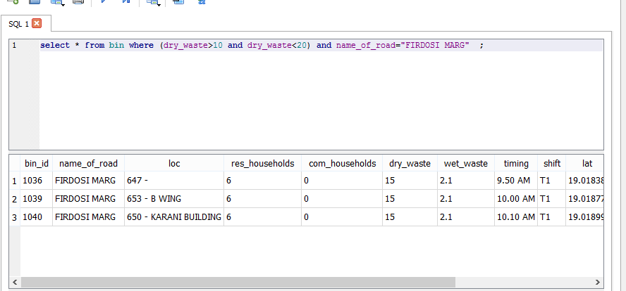

Q56] What is the average of total waste at collection spots with less than 40 residential households and no commercial households?

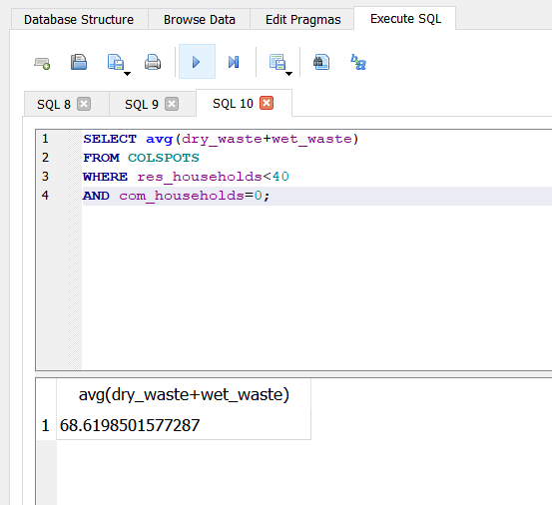

Q57] What are location coordinates of collection spots when location ID of shift details is same as that of collection spots and timing is beyond 10.00AM

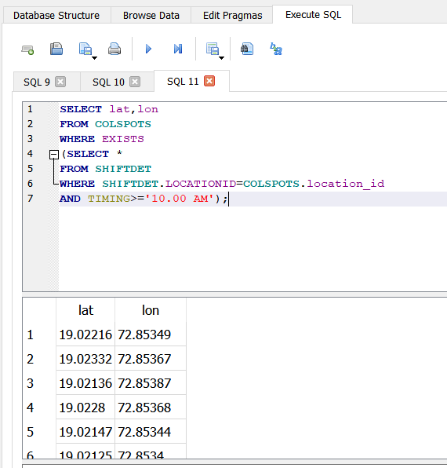

Q58] Select shift, road ID of route, name of road and area incharge of collection spots where roadname of route is same as that of collection spots or number of residential households is more than 20

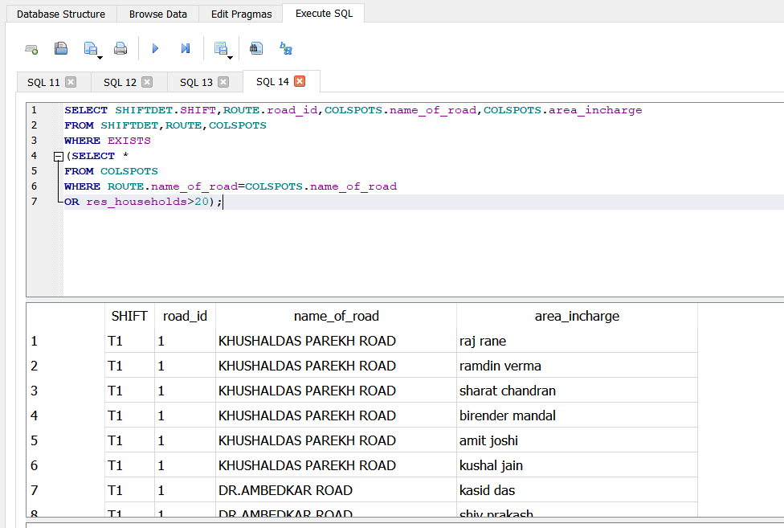

Q59] Select location ID of shift detail, route road ID and route no. for collection spots whose roadname of route and that of collection spot are same.

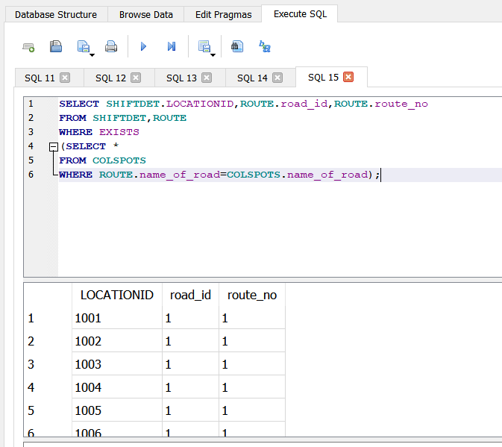

Q60] Select total amount of waste where road name of route is Tilak Road and location ID is not of dry waste

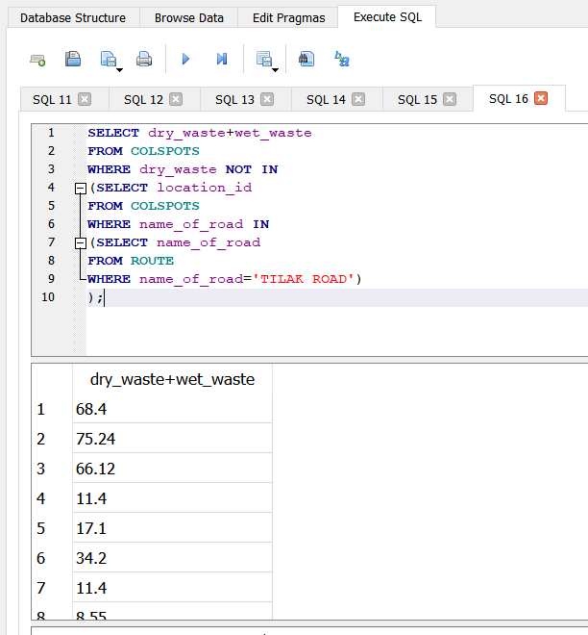

61]Find maximum wet waste collected on route 31.

SELECT MAX(wet_waste)

FROM collectionspots WHERE location_id LIKE "31___";

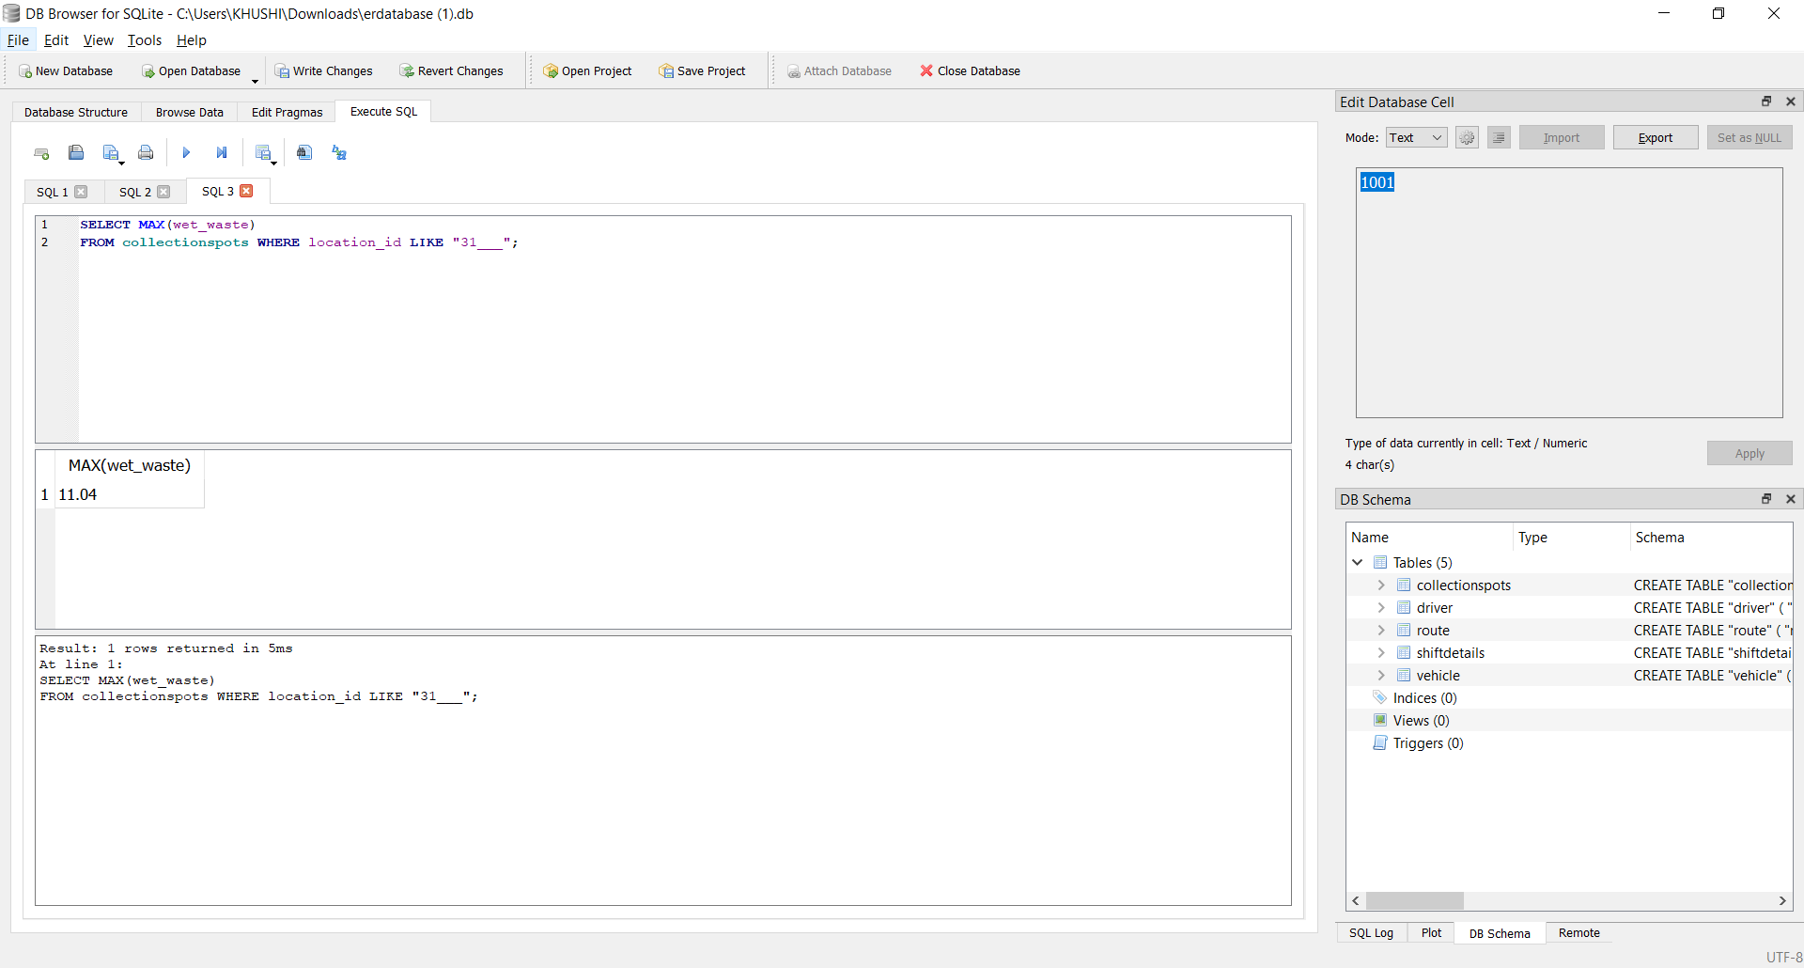

Q62] Select residential and commercial household for same name of road of route and collection spot and area of incharge as Amit Joshi

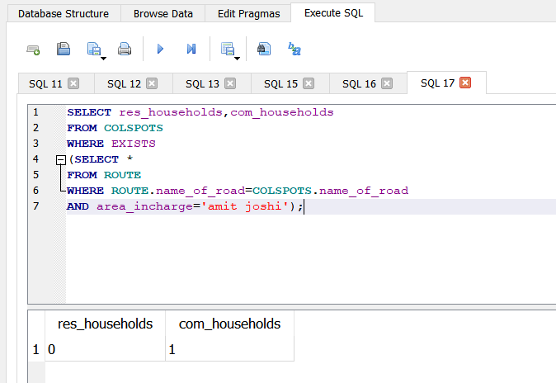

Q63] Select location ID and area incharge of collection spot where road name has amount of dry waste more than 50 and that of wet waste more than 10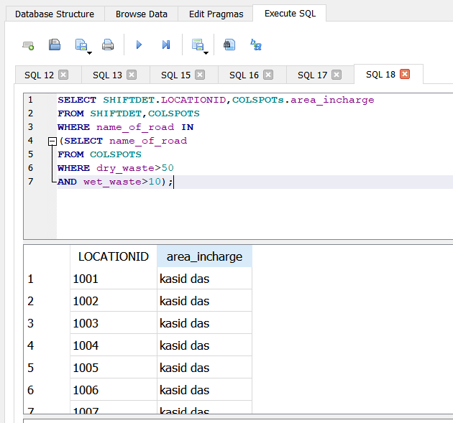

64]Find the total number of residential and commercial households distributed over particular roads in route 1

SELECT name_of_road ,SUM(res_households), SUM(com_households)

FROM collectionspots

WHERE location_id like "1___"

GROUP BY name_of_road;

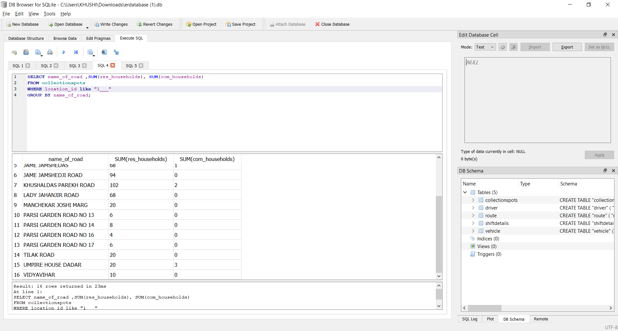

Q65] Select location ID and wet waste quantity whose roadmane does not have speed limit less than 65 and name of road of route is not Vidyavihar

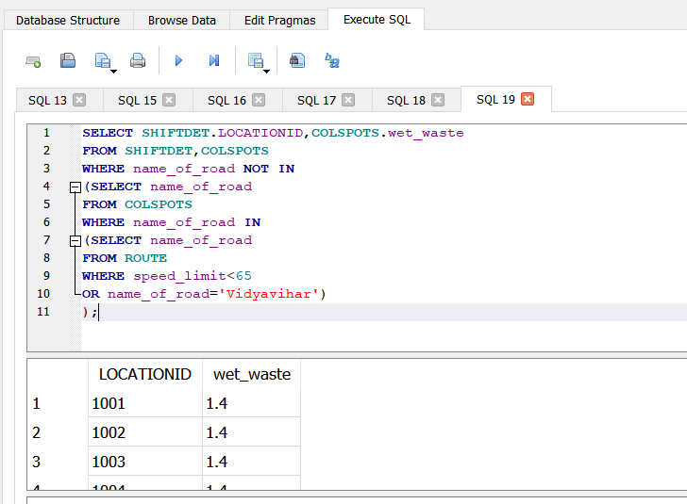

66]select * from bin where dry_waste > (select avg(dry_waste) from bin) ;

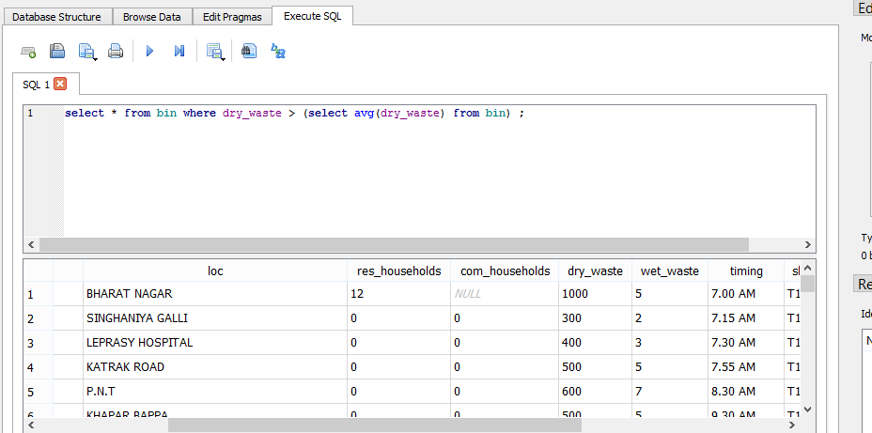

Q67] Create and Display a view with details license number and type of license of driver where its expiry date exceeds 01-01-2030

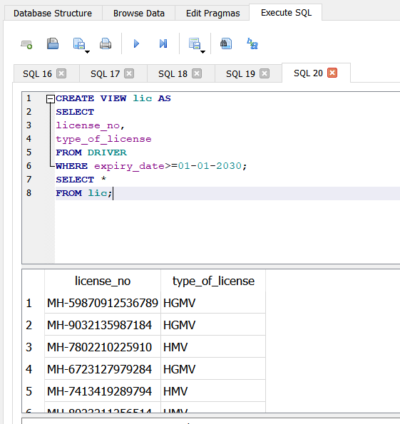

Q68] Select common name of roads of the routes and collection spots

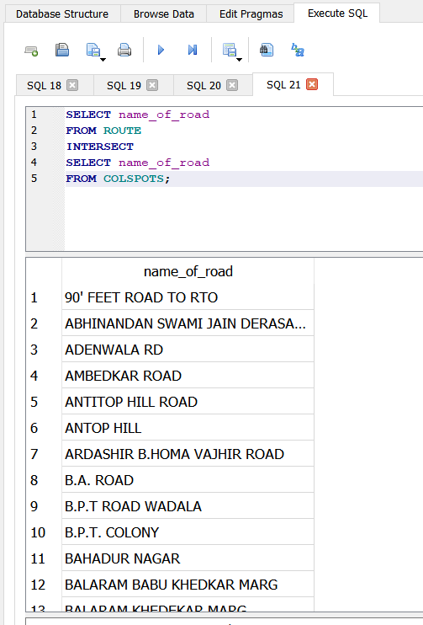

69]Find the owner’s phone no whose vehicle’s insurance expires in the year 2021.

SELECT owner_no

FROM vehicle

WHERE insurance_expiry_date like "%2021";

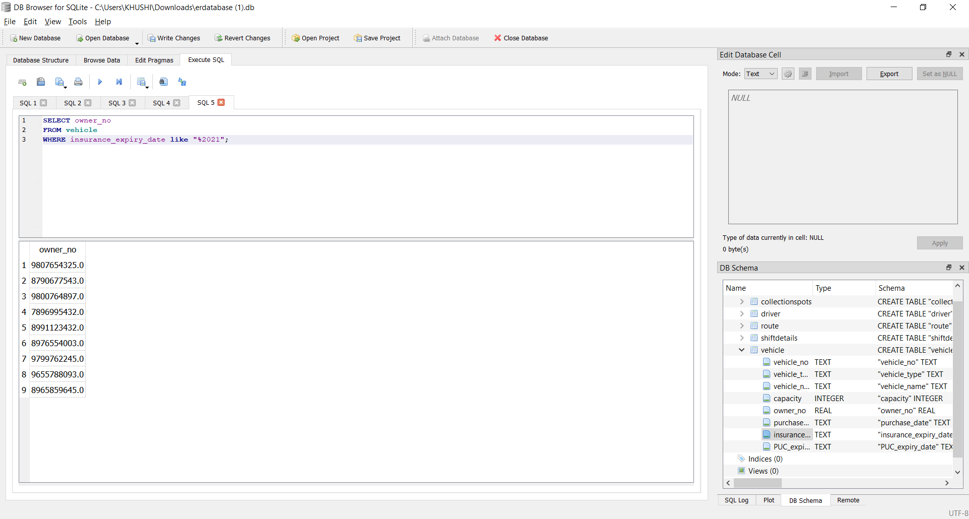

Q70] Select route number and name of road with dry waste quantity more than 50 or more than 1 commercial households.

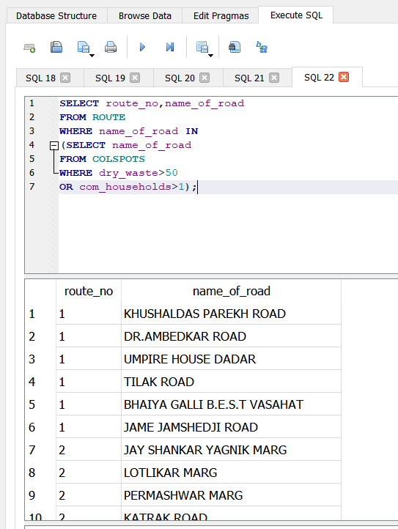

71] selecting bins whose wet waste is greater than max dry waste from DR.AMBEDKAR ROAD

select * from bin where wet_waste > (select max(dry_waste) from bin where name_of_road="DR.AMBEDKAR ROAD") ;

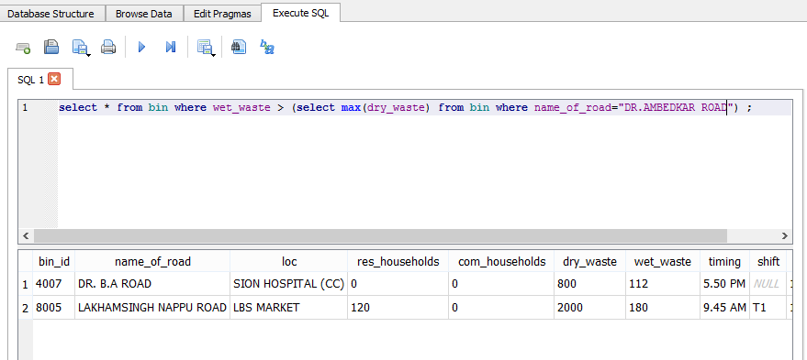

Q72] Select dry and wet waste ,residential and commercial households of collection spots with same location ID of routes and collection spots and name of premise as 562 RUSTOM MENSION.

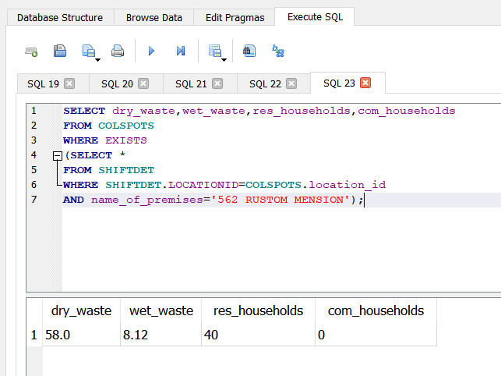

**EXPERIMENT 10**

Triggers :

A trigger is an event-driven action that is run automatically when a specified change operation ( INSERT, UPDATE, and DELETE statement) is performed on a specified table. Triggers are useful for tasks such as enforcing business rules, validating input data, and keeping an audit trail.

Uses for triggers:

* Enforce business rules
* Validate input data
* Generate a unique value for a newly-inserted row in a different file.
* Write to other files for audit trail purposes
* Query from other files for cross-referencing purposes
* Access system functions
* Replicate data to different files to achieve data consistency

Benefits of using triggers in business:

* Faster application development. Because the database stores triggers, you do not have to code the trigger actions into each database application.
* Global enforcement of business rules. Define a trigger once and then reuse it for any application that uses the database.
* Easier maintenance. If a business policy changes, you need to change only the corresponding trigger program instead of each application program.
* Improve performance in client/server environment. All rules run on the server before the result returns.

Syntax:

CREATE [TEMP | TEMPORARY] TRIGGER trigger-name

[BEFORE | AFTER] database-event ON [database-name .]table-name

trigger-action

trigger-action is further defined as:

[FOR EACH ROW | FOR EACH STATEMENT] [WHEN expression]

BEGIN

trigger-step; [trigger-step;] *

END ;

We have used a trigger after insert dml statement that will automatically update the records in the shift details table whenever bin table is updated.

Trigger:

CREATE TRIGGER upshift AFTER INSERT ON bin

BEGIN

INSERT INTO shiftdetails(location_id,shift,shift_time)

VALUES(NEW.bin_id,NEW.shift,NEW.timing);

END;

Before insert

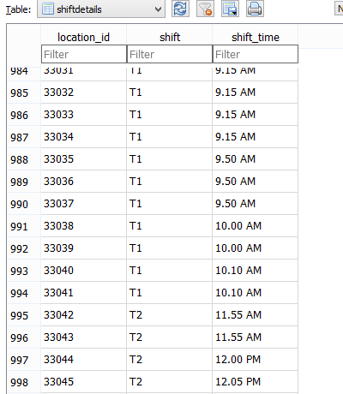

After insert statement: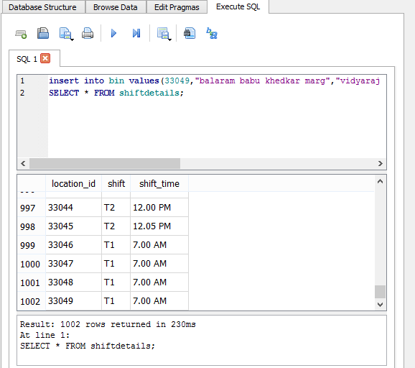

**EXPERIMENT 11**

**HOME PAGE:**

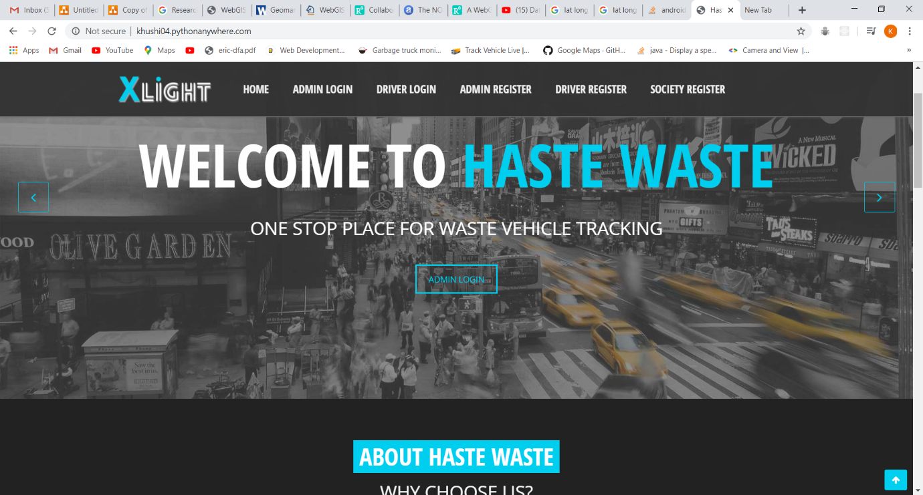



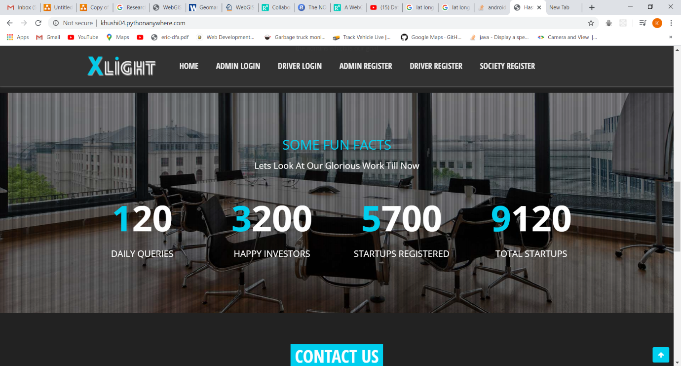

**DRIVER SIDE:**

1)DRIVER REGISTER

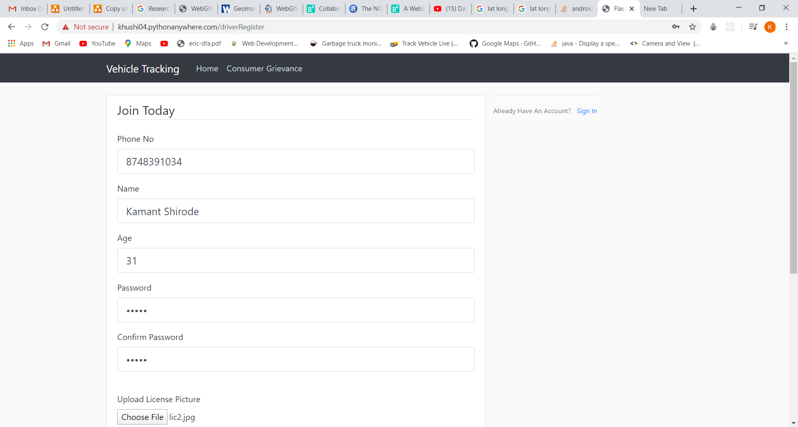

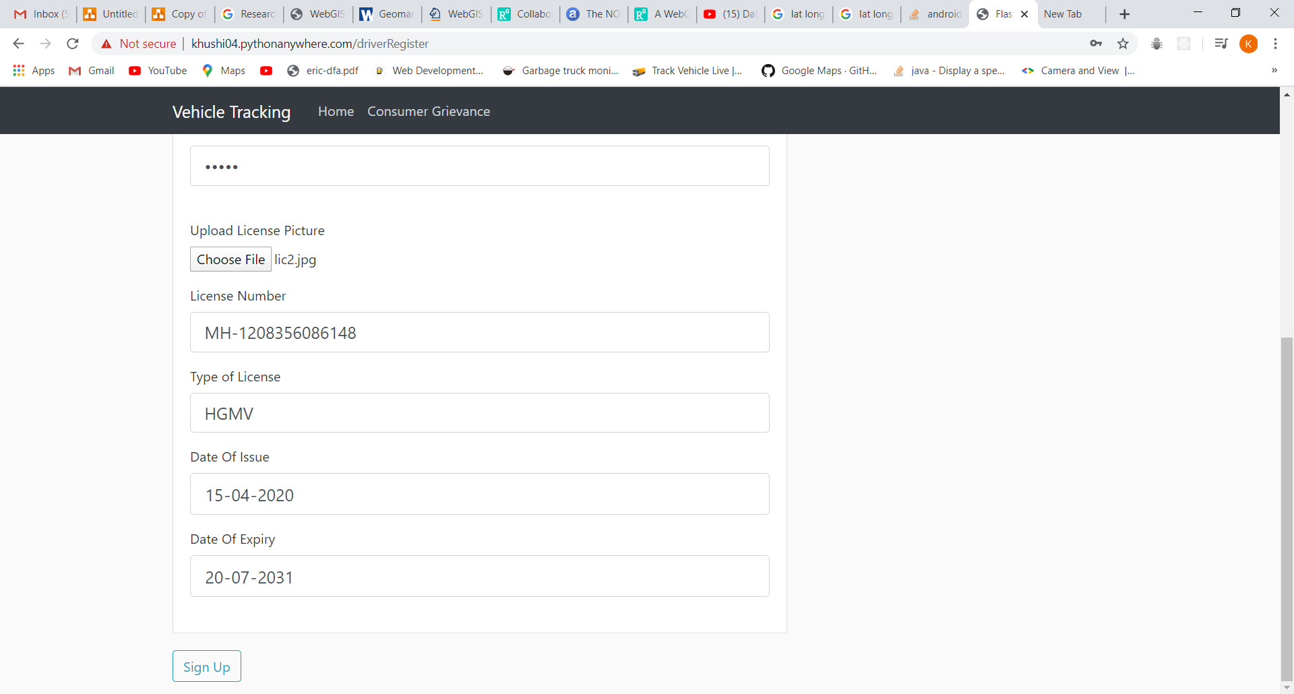

2)DRIVER LOGIN

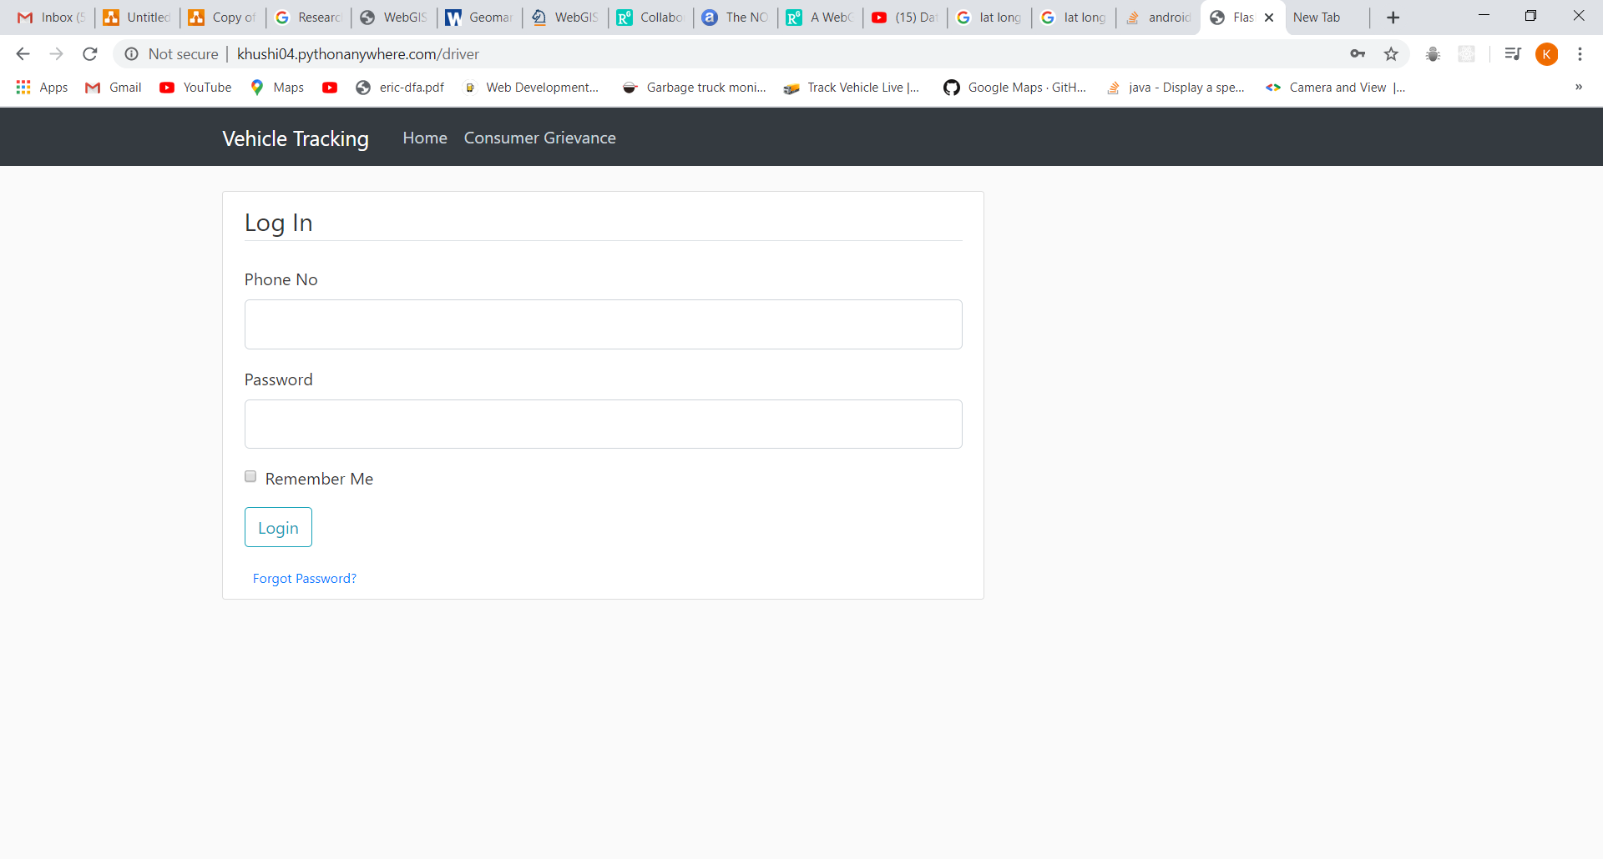

4)ROUTE PLAN PAGE FOR THE DRIVER

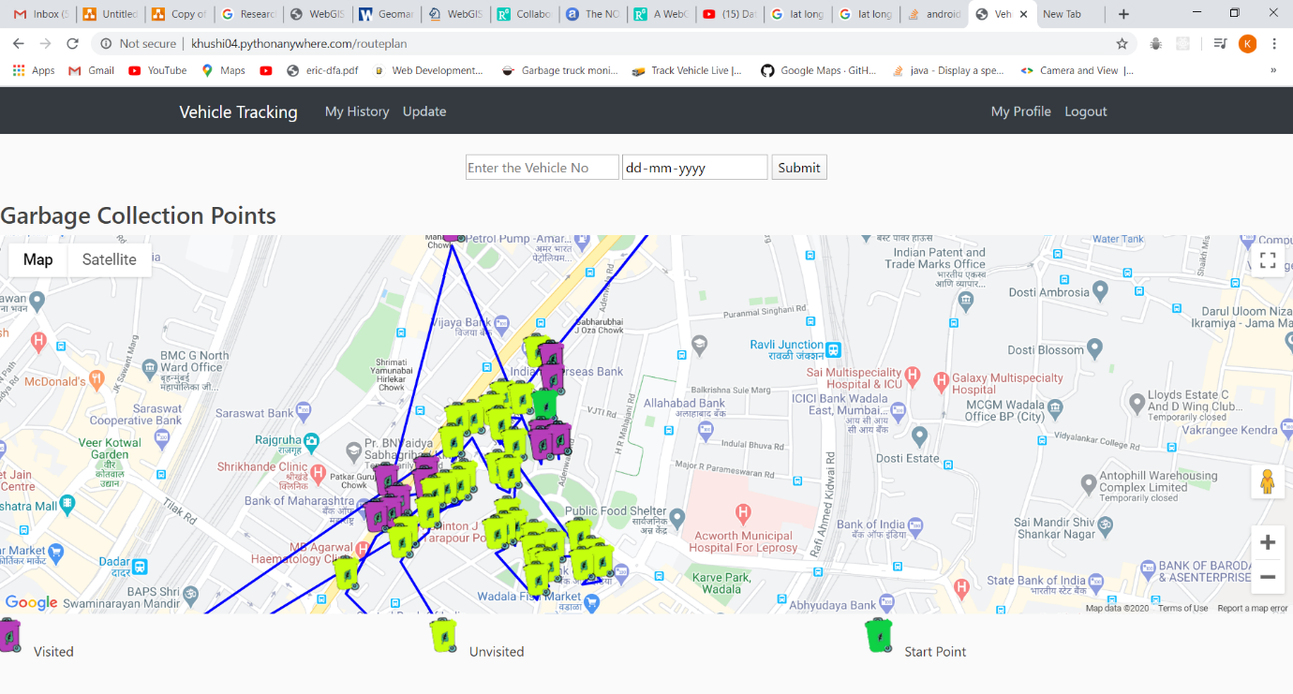

5)PROFILE OF THE DRIVER

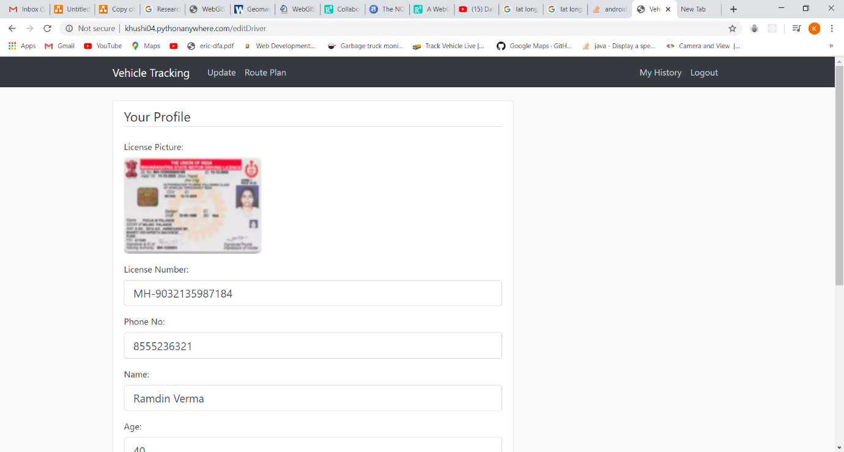

6)HISTORY OF THE DRIVER

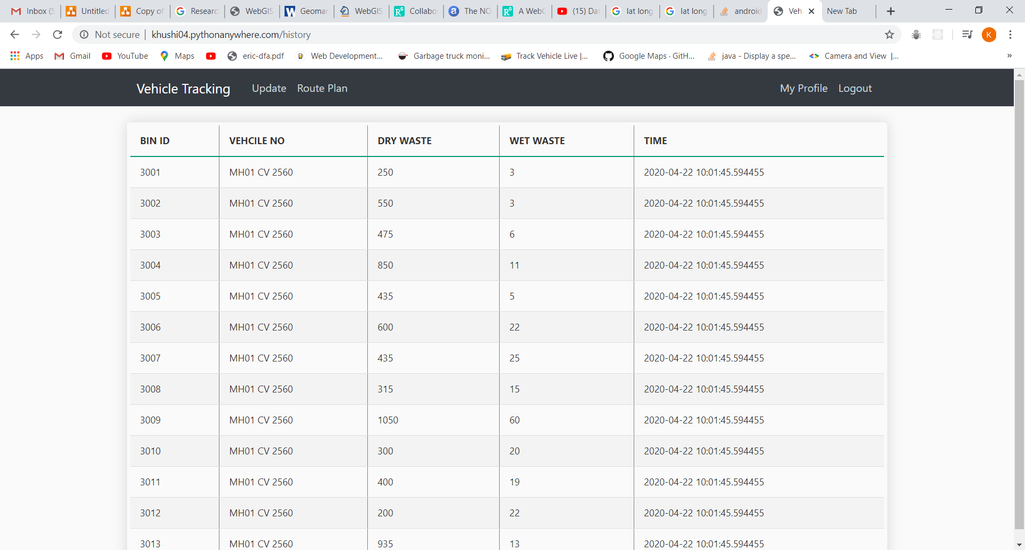

7)UPDATE PAGE FOR THE DRIVER

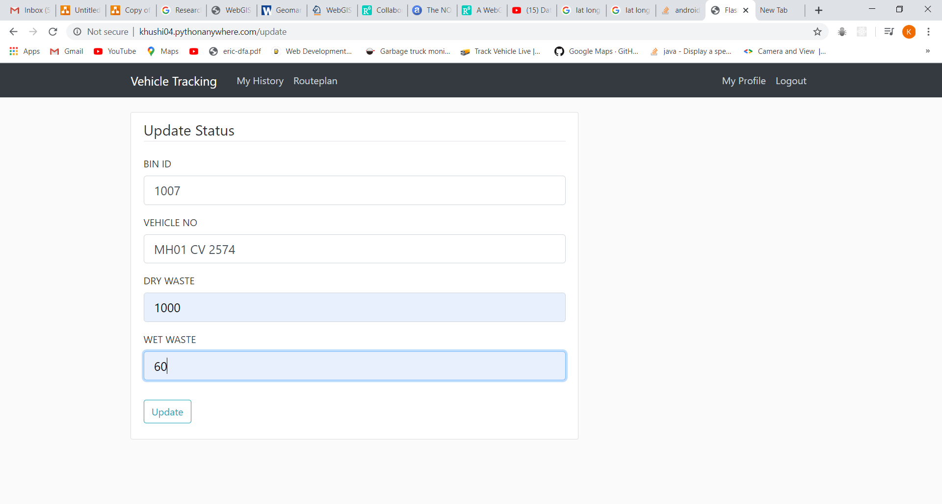

**ADMIN SIDE:**

1)ADMIN REGISTER

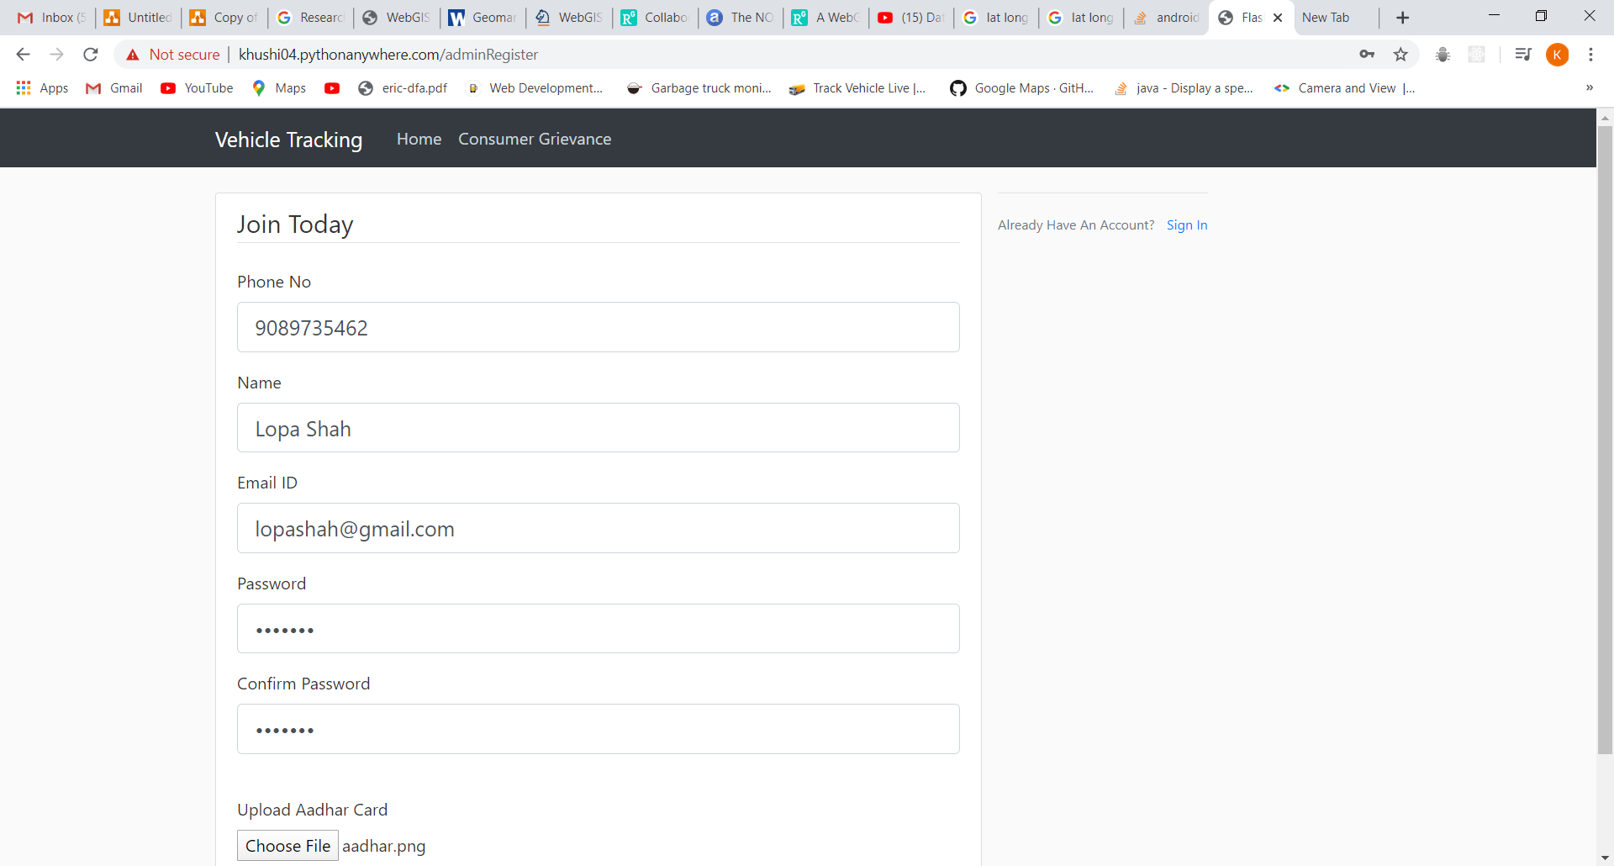

2)ADMIN LOGIN

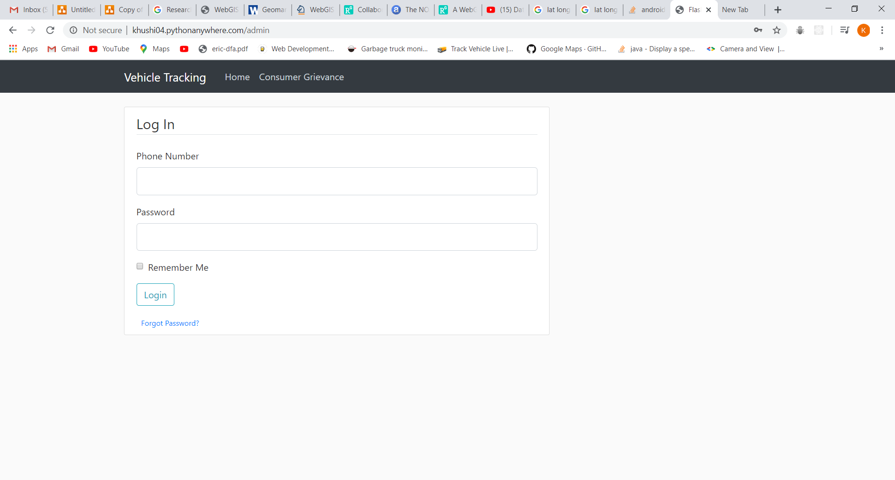

3)STATUS PAGE

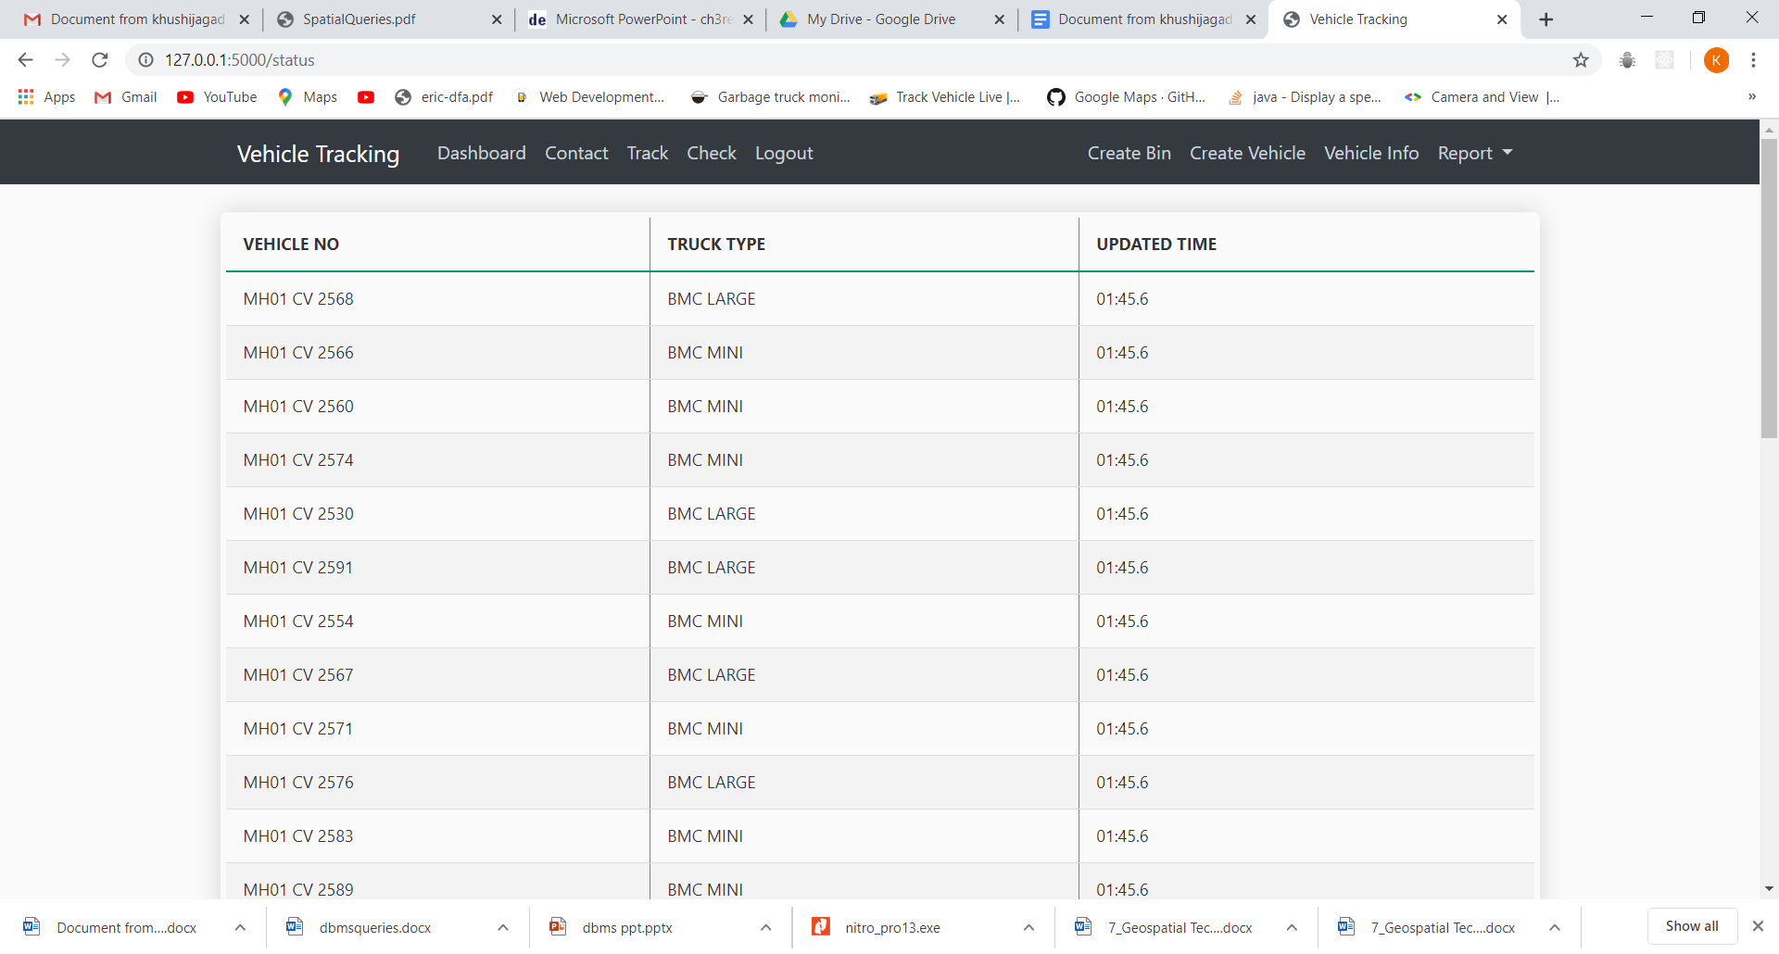

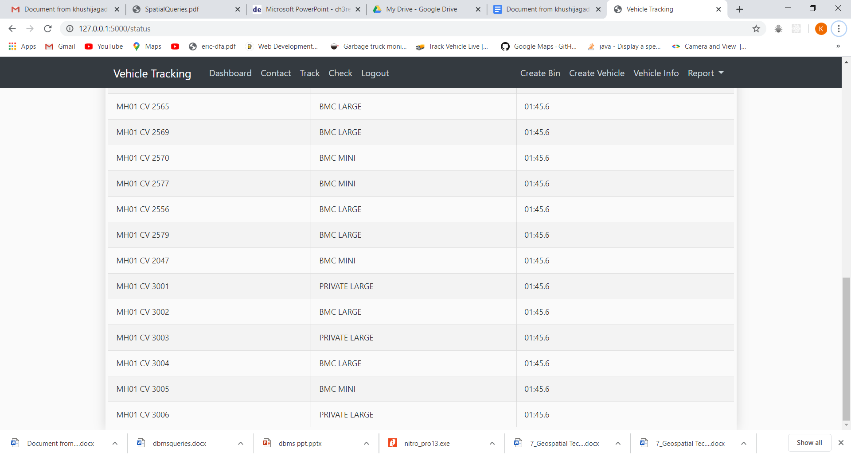

4)TRACK PAGE TO TRACK THE DRIVER

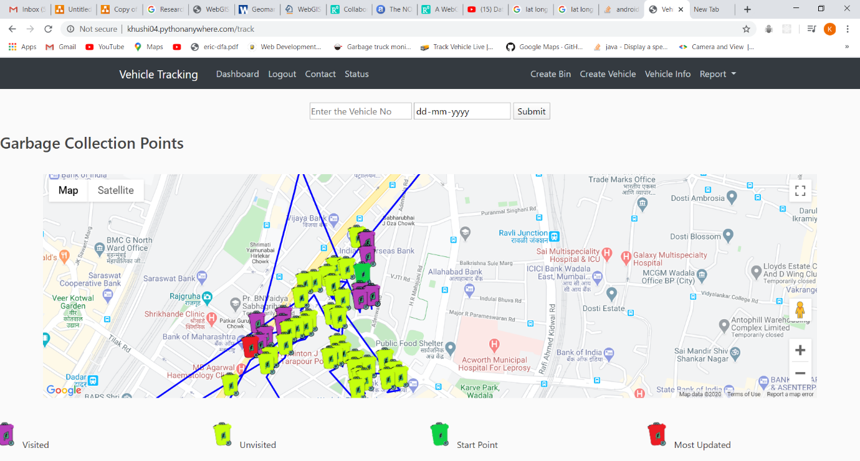

5)CREATE NEW BIN

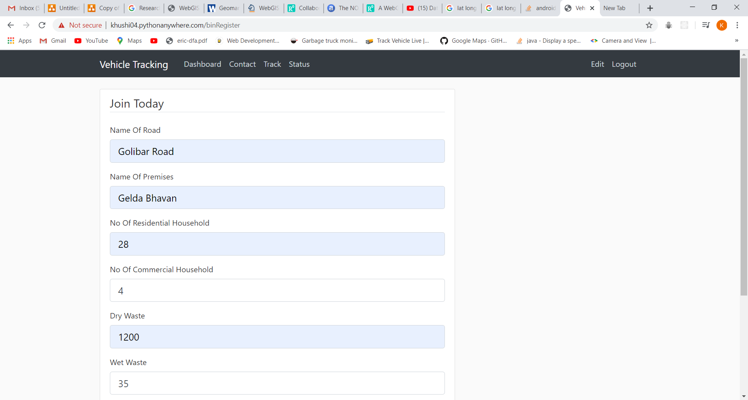

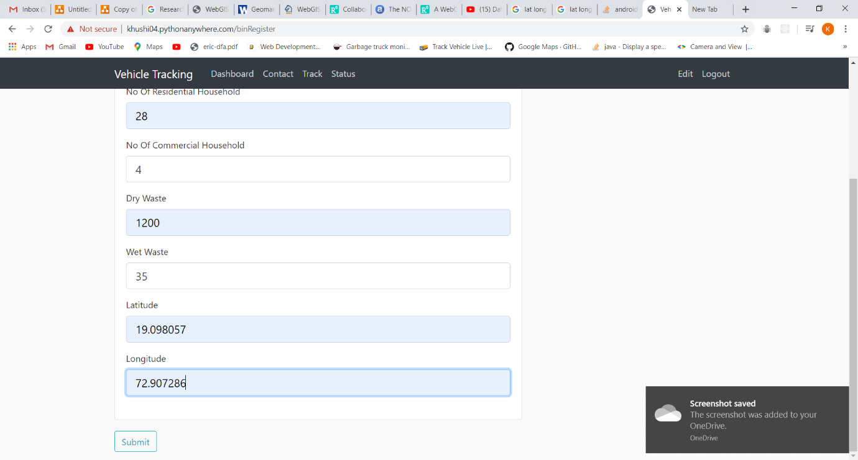

6)EDIT EXISTING BIN

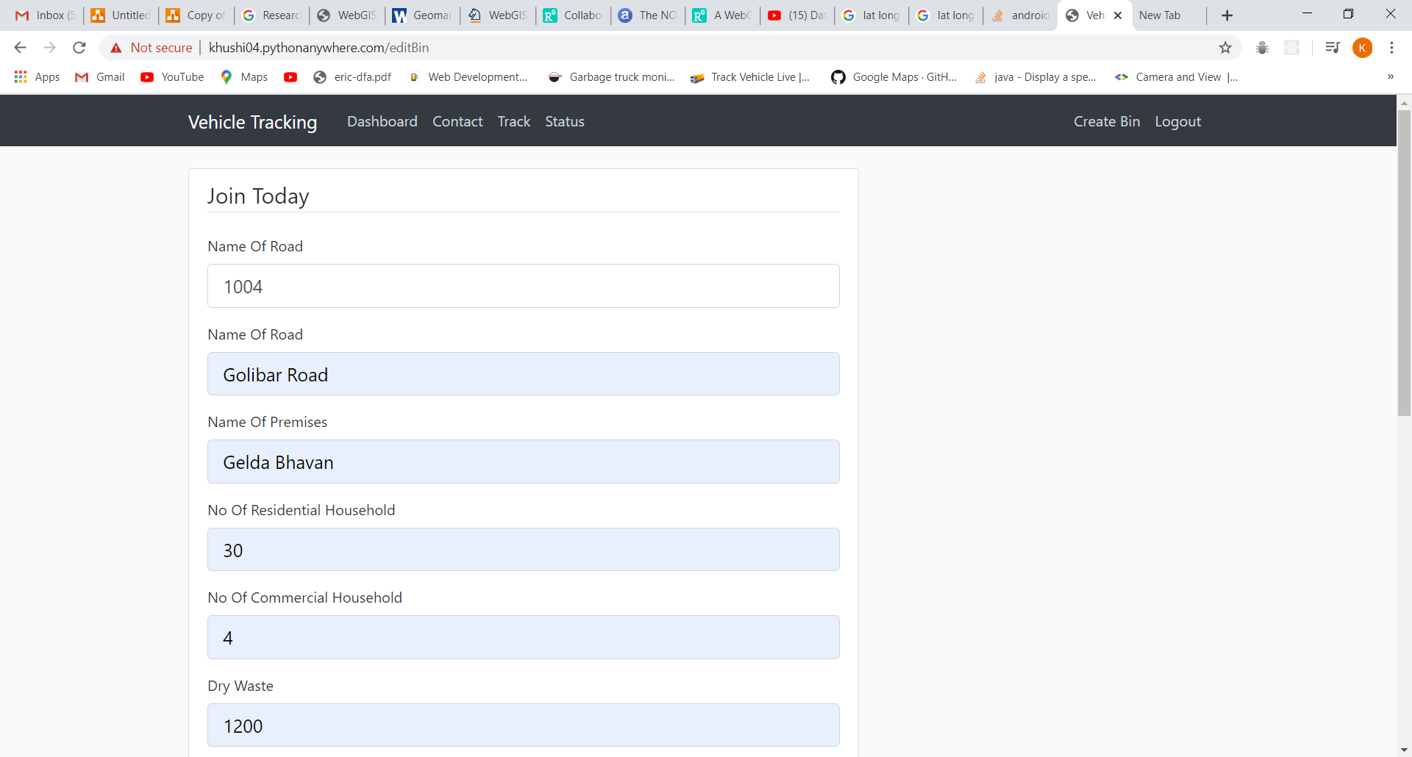

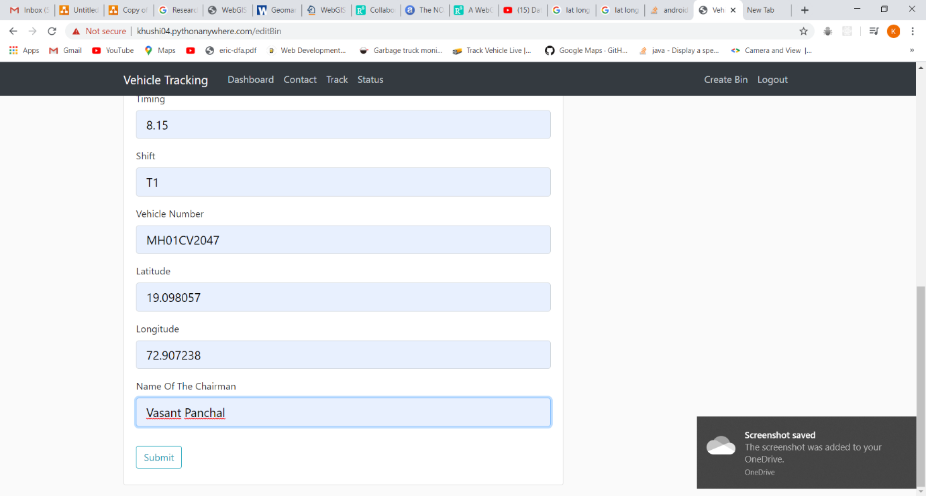

7)REGISTER NEW VEHICLE

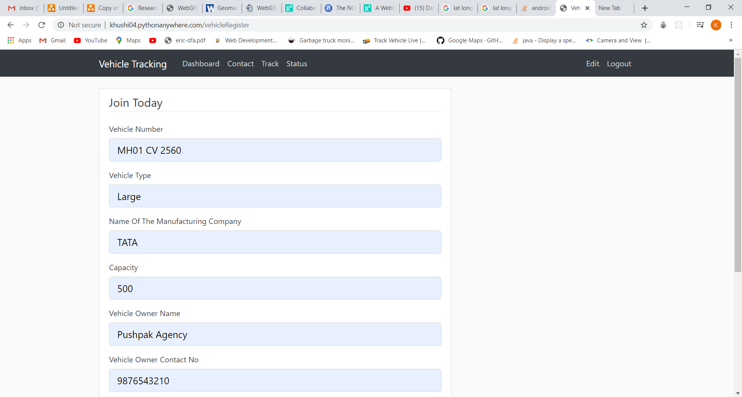

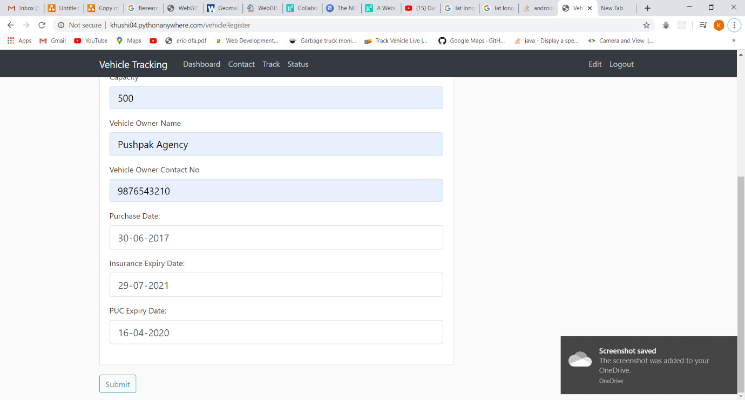

8)EDIT EXISTING VEHICLE

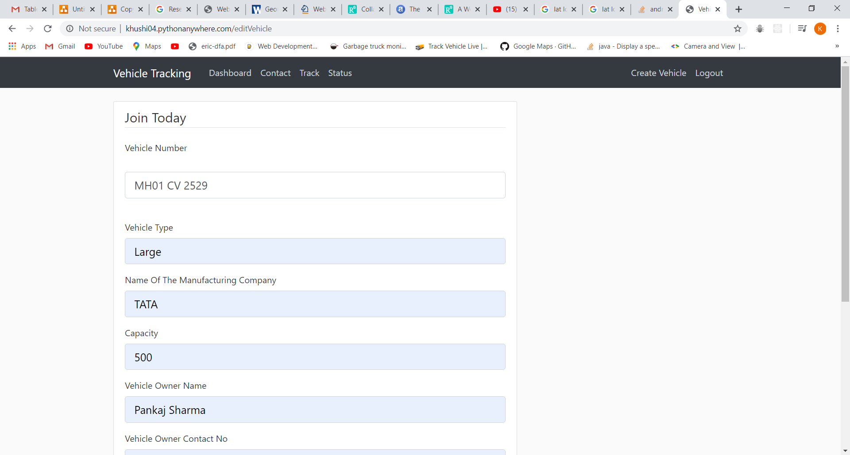

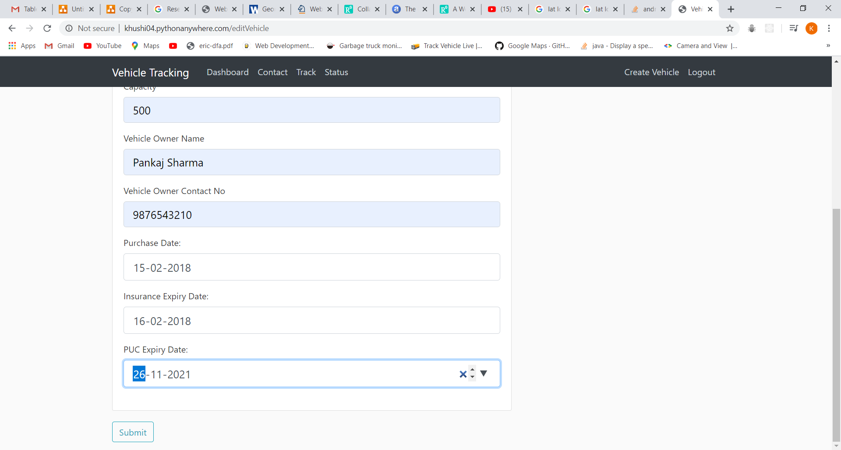

9)INFORMATION OF REGISTERED VEHICLE

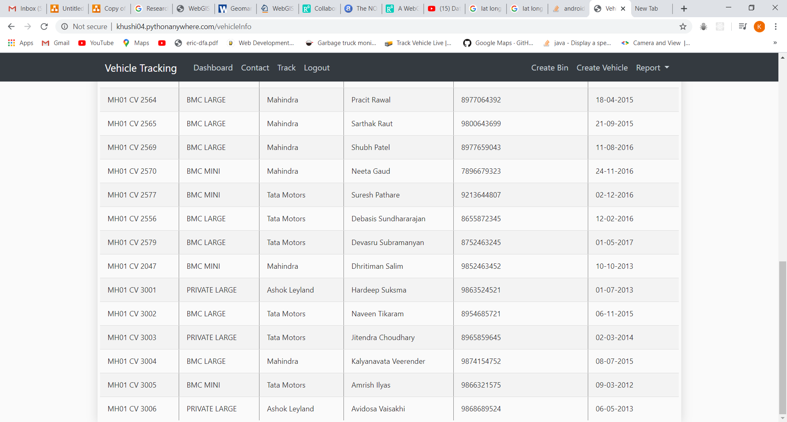

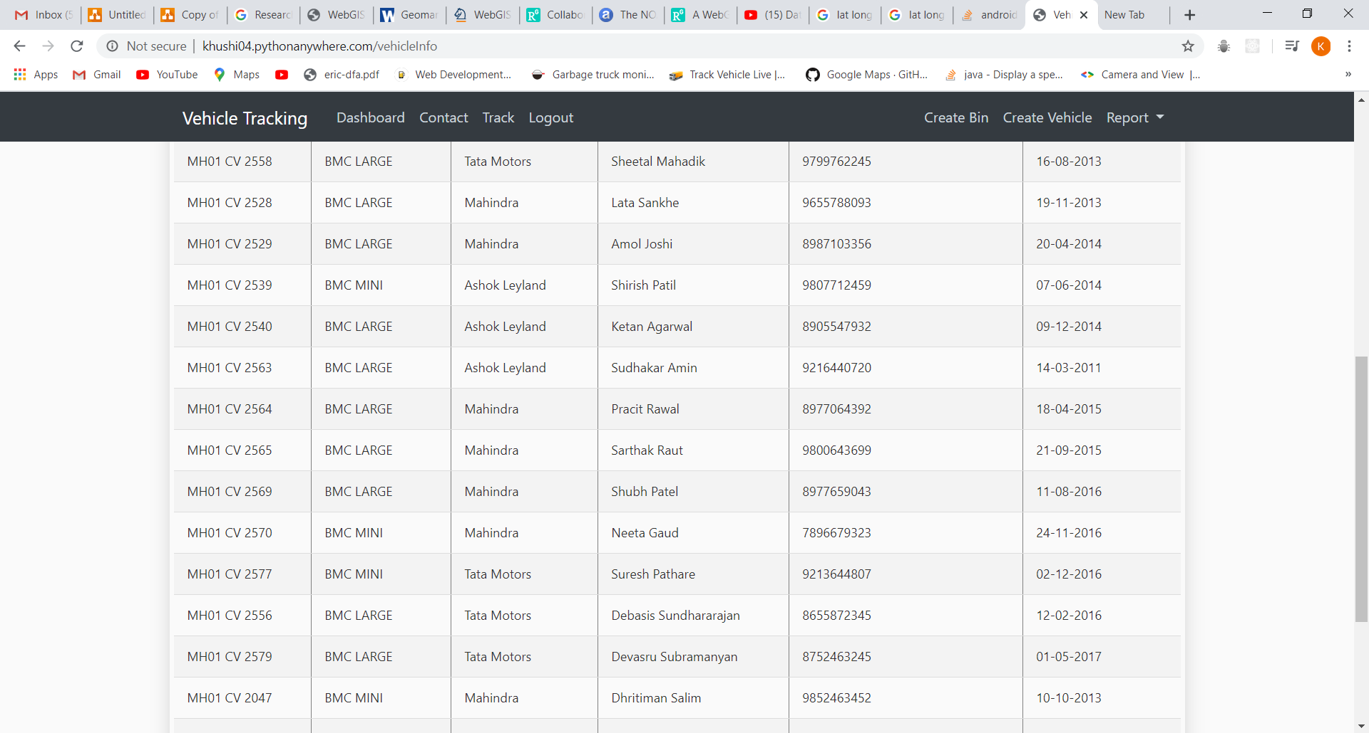

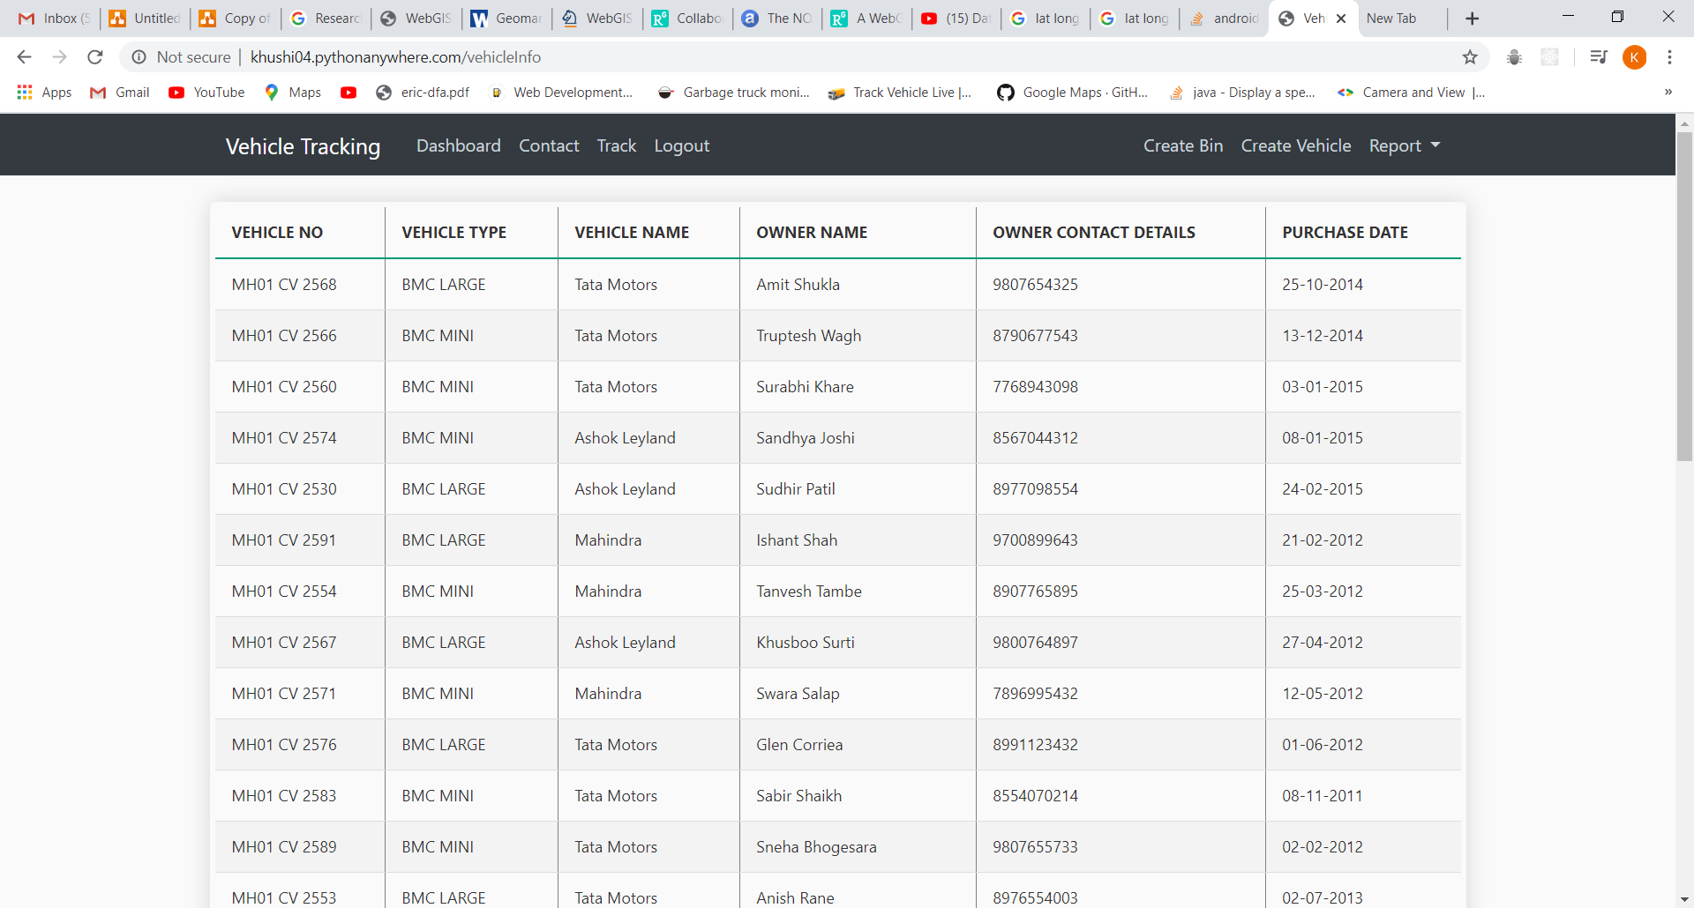

10) DASHBOARD

1) RESIDENTIAL HOUSEHOLDS

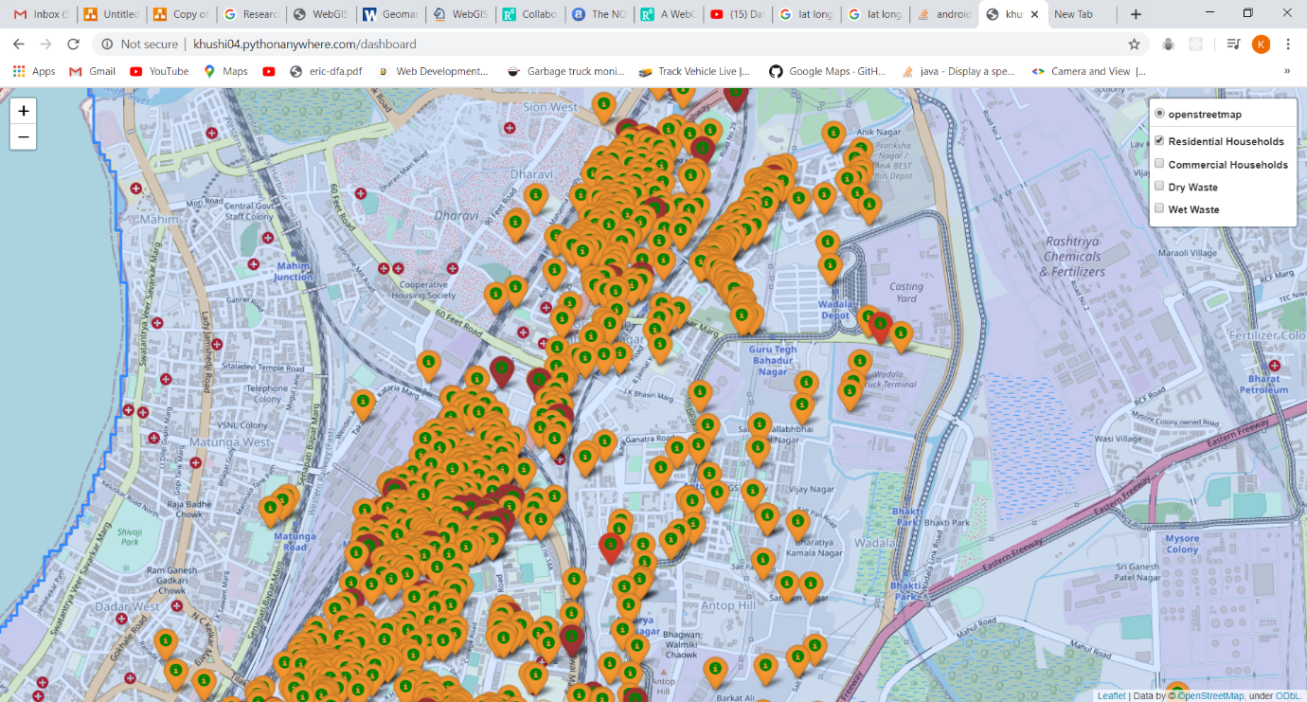

2)COMMERCIAL HOUSEHOLDS

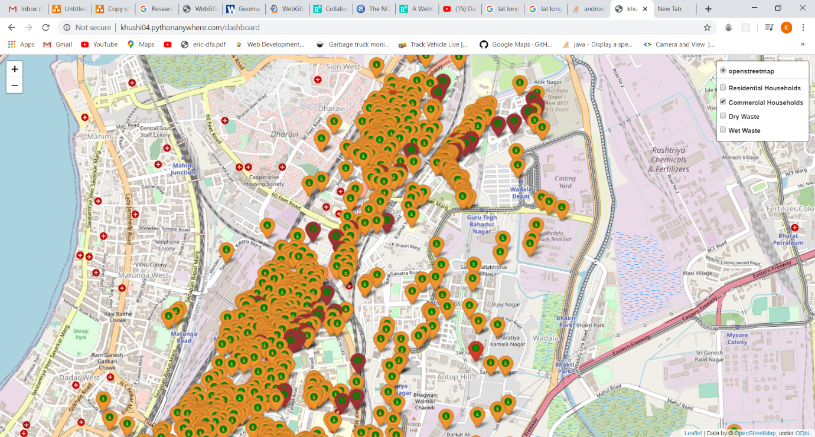

3)DRY WASTE

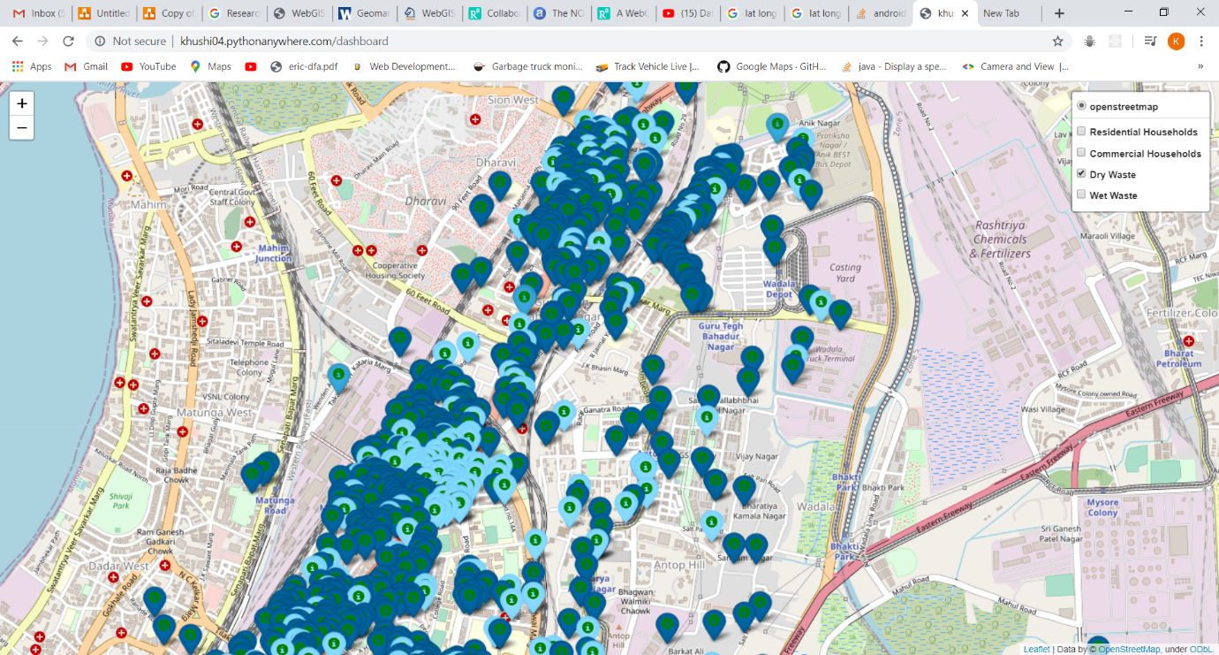

4)WET WASTE

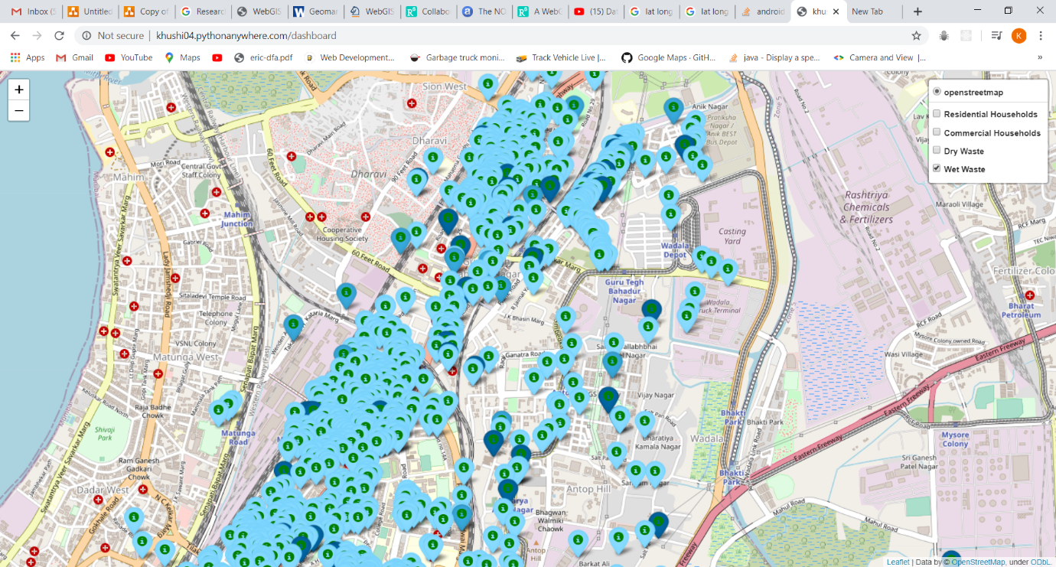

11)CONTACT THE DRIVER

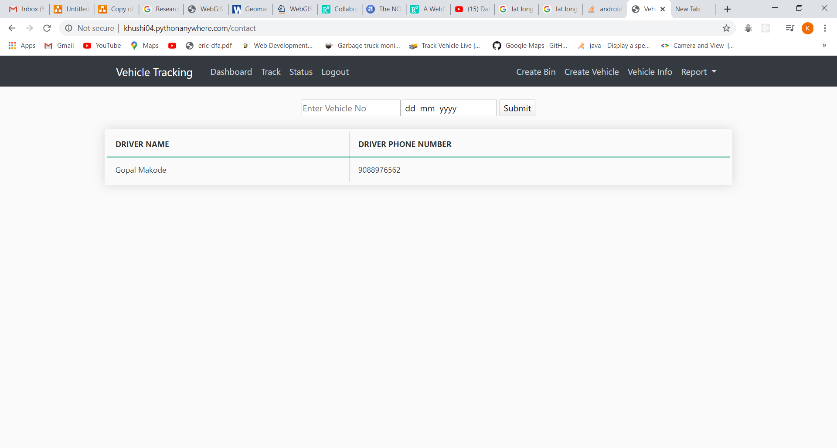

**SOCIETY REGISTER:**

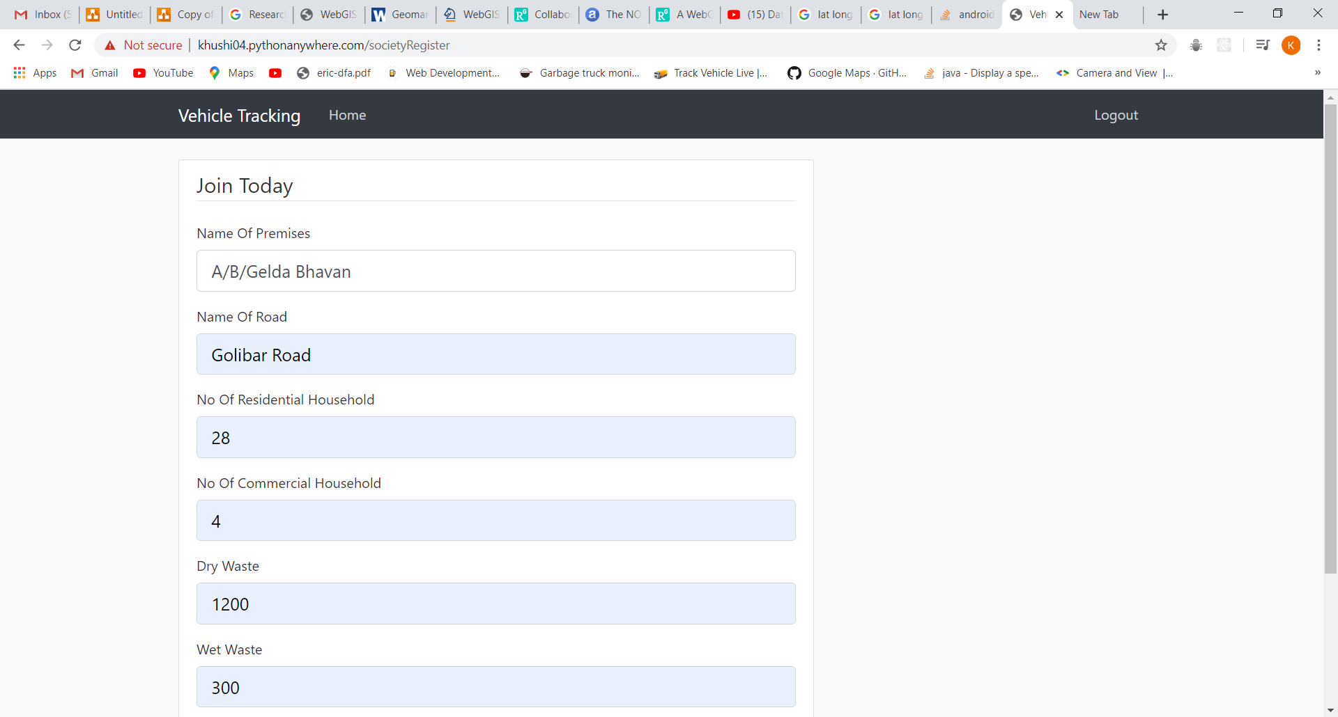

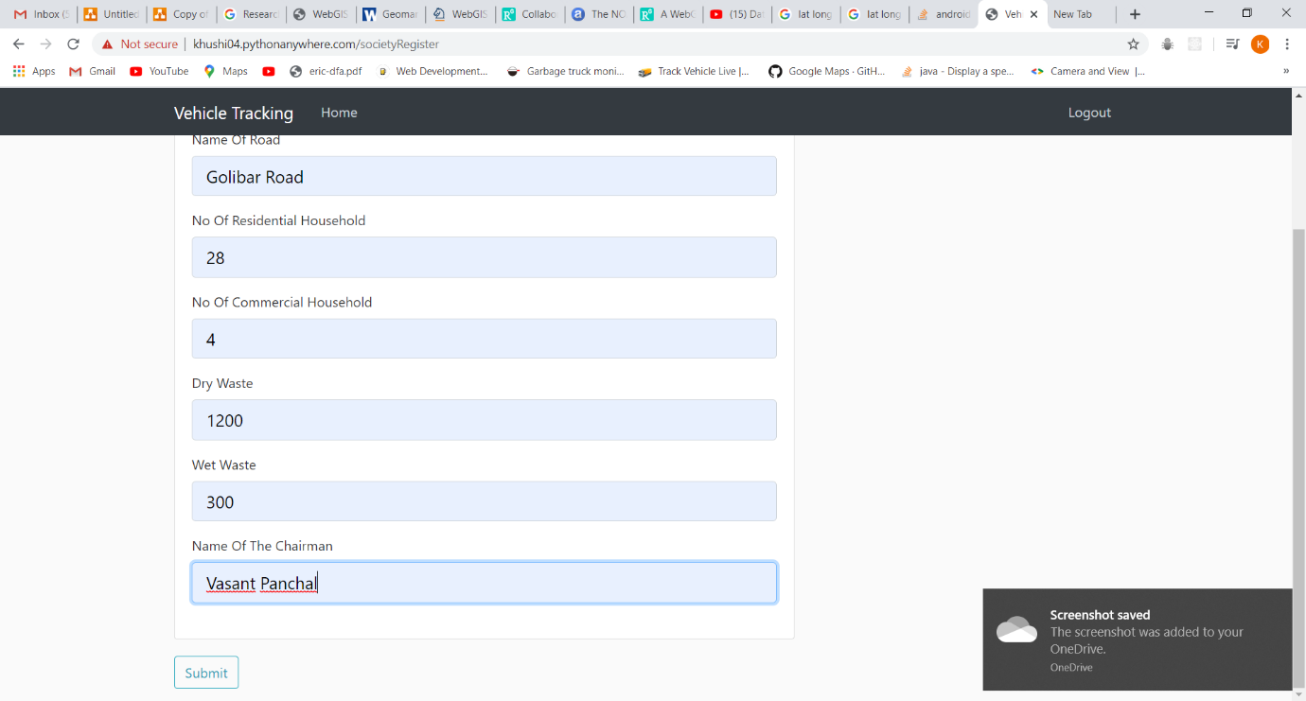

**CHECK PAGE FOR ADMIN:**

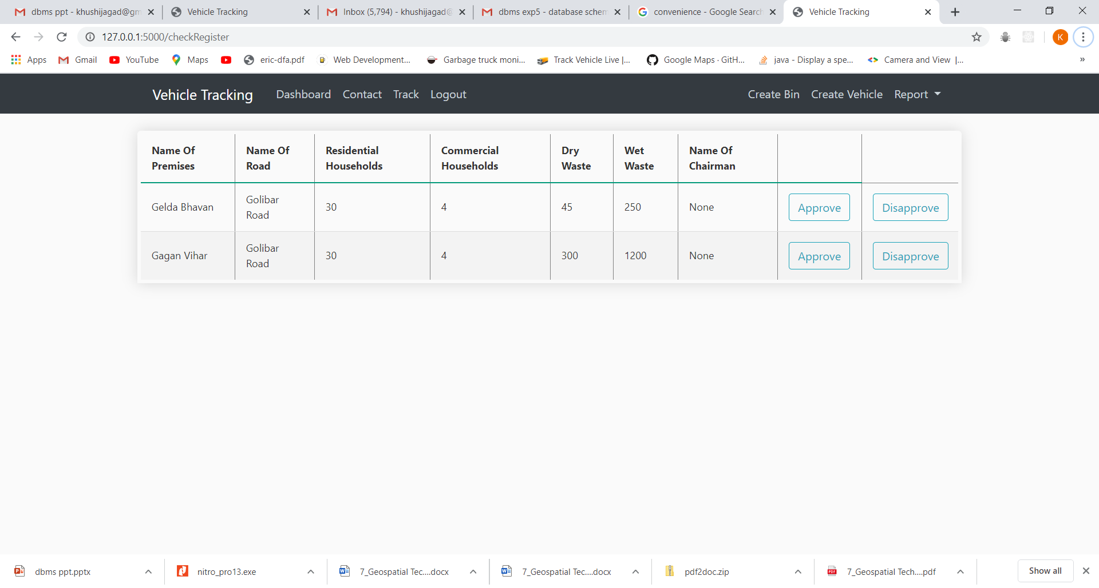

**CONSUMER GRIEVANCE FOR DRIVER AND ADMIN:**

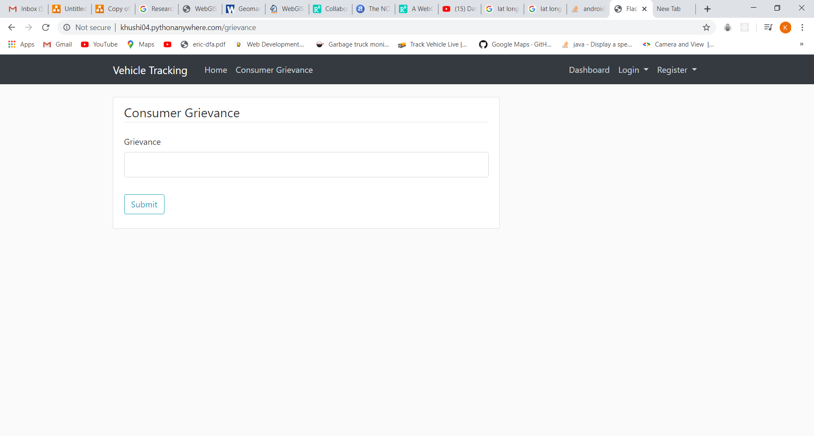

**EXPERIMENT 11 AND 12**

12)DAILY REPORT

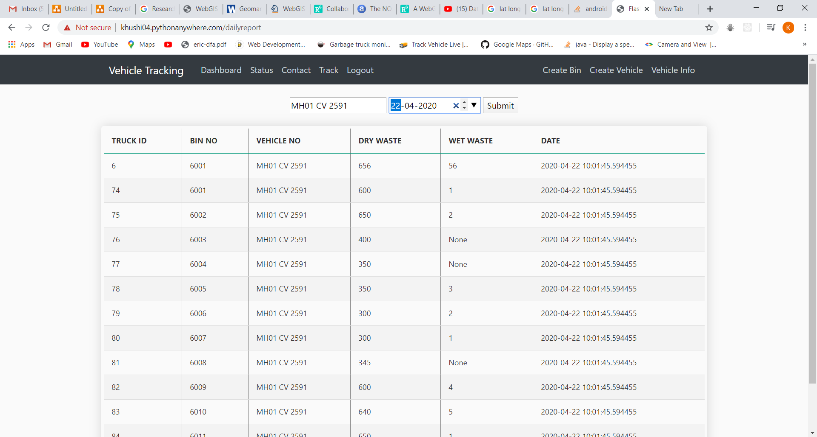

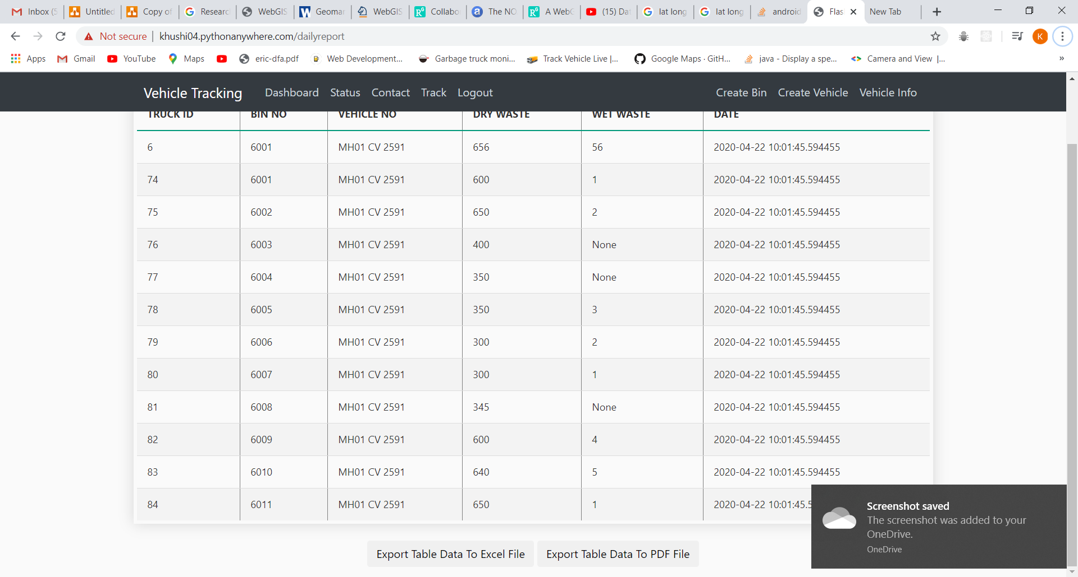

1)EXPORT DAILY REPORT TO EXCEL

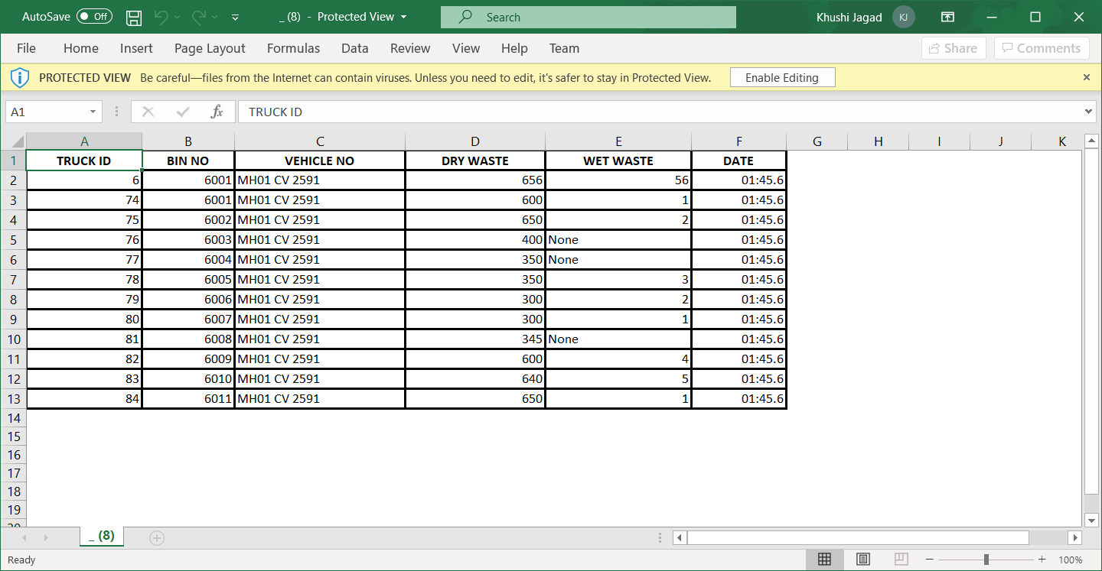

2)EXPORT DAILY REPORT TO PDF

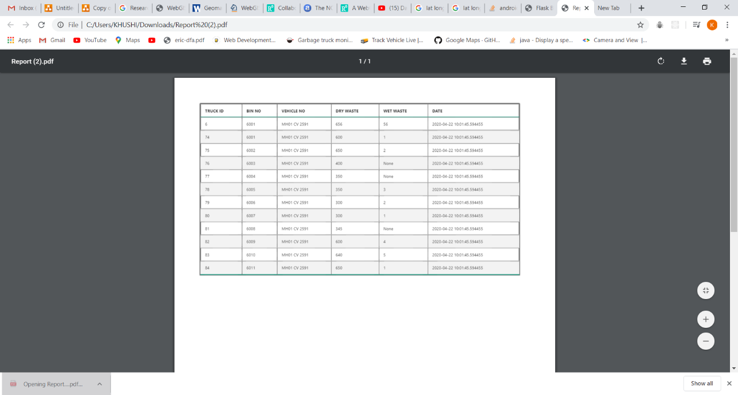

13)MONTHLY REPORT

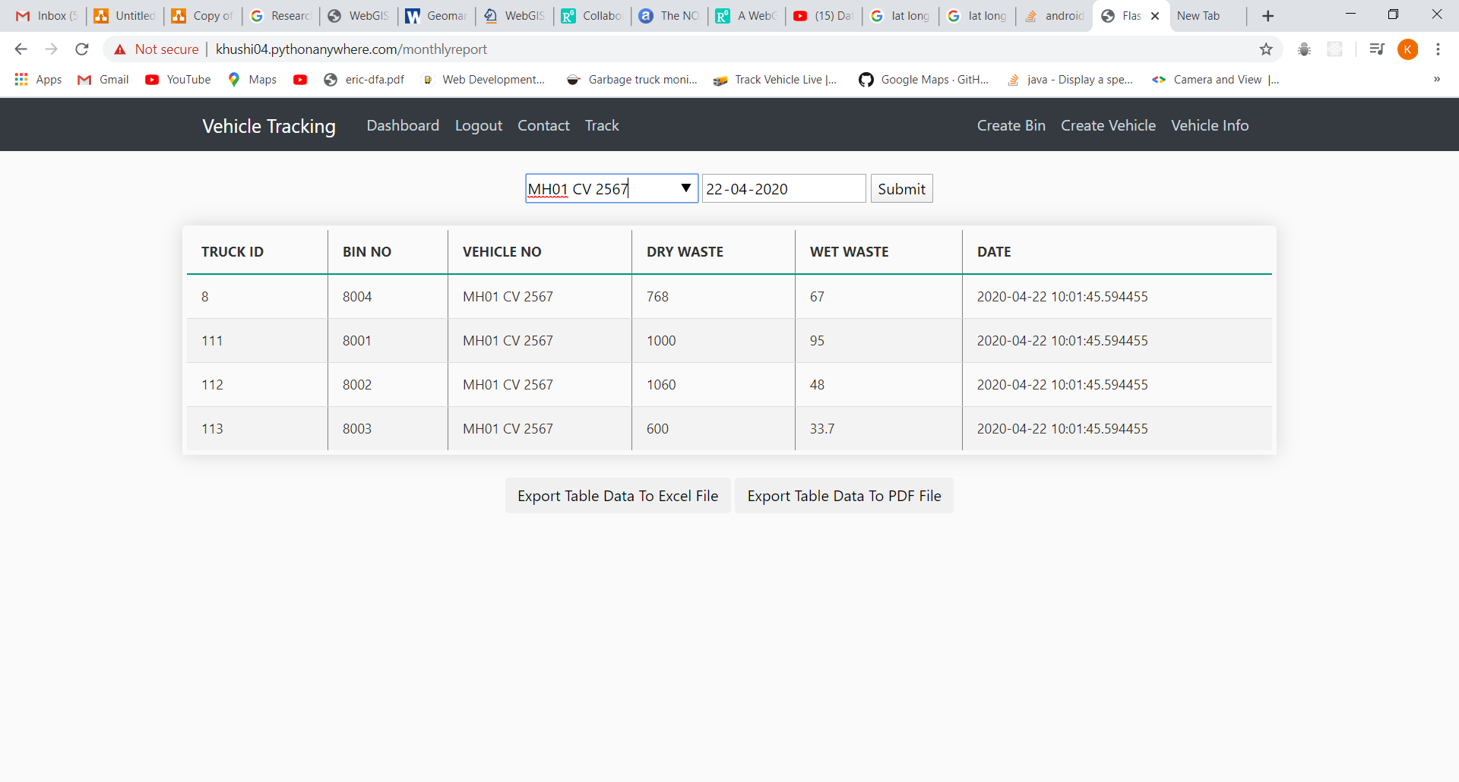

1)EXPORT MONTHLY REPORT TO EXCEL



2)EXPORT MONTHLY REPORT TO PDF

